# logo.png

# Team Portfolio

# **Team Members**

**Prasanna Shrestha**

**Sakriya Bajracharya**

**Sujan Pariyar**

**Swastika Adhikari**

**Utsav Sapkota**

***Table of contents***

|  |  |  |
| --- | --- | --- |
|  |  | Page |
| 1. Initiation Phase |  |  |
|  | **Project Charter** |  |
|  | Project Charter Version 1 |  |
|  | Project Charter Version 2 |  |
|  | **Team Contract** |  |
| 1.2 | **Meeting Minutes** |  |
| 2. Planning Phase |  |  |
| 2.1 | **Belbin’s Analysis** |  |
|  | Team Belbin’s Analysis |  |
|  | Individual Belbin’s Analysis |  |

|  |  |  |
| --- | --- | --- |
| 2.2 | Skill Audit |  |
|  | Team Skill Audit |  |
|  | Individual Skill Audit |  |
| 2.3 | **Project Management (MS Project)** |  |
|  | Gantt Chart |  |
|  | Network Diagram |  |
|  | Timeline |  |
|  | Calendar |  |
|  | Resource Sheet |  |
|  | Project Task |  |
|  | Change Working Time |  |
| 2.4 | **Communication Tool Used** |  |
|  | Slack |  |
|  | GitHub |  |

|  |  |  |
| --- | --- | --- |
|  | Gmail |  |
|  | Trello |  |
| 3. Execution​ Phase |  |  |
| 3.1 | **Entity Relation Diagram** |  |
|  | EERD |  |
|  | ERD |  |
|  | Final Composite |  |
|  | Logical |  |
| 3.2 | **Use Case Diagram** |  |
|  | Overview Use Case Diagram |  |
|  | Trader Use Case Diagram |  |
|  | Admin Use Case Diagram |  |
|  | Customer Use Case Diagram |  |
| 3.3 | **Requirement Catalogue** |  |
|  | Function Requirement |  |
|  | Non-Functional Requirement |  |
| 3.4 | **Logo Design** |  |
| 3.5 | **Wireframes** |  |
| 3.6 | **Product Development** |  |
|  | Login Web Page |  |
|  | Register Web Page |  |
|  | Cart Web Page |  |

INITIATION PHASE

**Project Charter**

**Project Charter Version 1**

|  |
| --- |
| Project Title: *Cleckhuddersfax E-Convenient Store*  Project Sponsor: *The British College, Thapathali, Kathmandu*  Project Manager: *Rohit Pandey Sir*  Team Leader: *Swastika Adhikari*  Date prepared: *2020-02-23*  Project Customer: *Citizens of Cleckhuddersfax* |

Version Control

|  |  |  |
| --- | --- | --- |
| Version | Date | Summary of changes |
| 1 | *2020-02-23* | *Initial project*  *All the vital things have been done for future scope.* |
|  |  |  |
|  |  |  |

Project Justification

|  |
| --- |
| *A group of traders or businesspersons of Cleckhuddersfax are intending to organize and build up an internet business site i.e. ecommerce website. The business website is being created to help and inspire local traders to compete against the larger supermarket and convenience stores. Their aim is to provide an advantage to the trader with a new emerging technology which appears to be useful for both trader and customer. They are planning to provide a great chance to customers to order and purchase things in a relatively brief period of time from the ease of their comfort zone. This ecommerce platform incorporates all five traders: butchers, greengrocer, fishmonger, bakery and delicatessen within the Cleckhuddersfax area in UK. This ecommerce platform provides an ideal space for all types of traders to show the best of their self on the internet to grab the attention of their target customers and beat the heated competition. This platform helps the local trader to grow as well as benefit the client in the certain area. The website helps to promote the local tradition of area as well as help the local traders to compete against the bigger business-like supermarket and stores without losing their valuable times for their family and friends. This website has three interfaces. One for customer, one for traders and one for management (admin).An admin login can access any of trader accounts. Every five trades have different login credentials which help them to access their database. Trader can also view every day report and update the details of their trader account. Trader will be provided with weekly finance report of all the orders that are delivered only. This website will have cart functionality where customer will get an option to add favourite products to cart. The payment method is a PayPal which is convenience and more secure way to pay online. The site will assist the customer to shop easily without worrying about running out of products. They don’t need to physically move around and waste valuable time to buy one specific product. This ecommerce website provides convenience to buy goods or services without causing any physical restrictions to the costumers and even helps to save money as well as precious time.* |

Project Scope

|  |
| --- |
| *Objectives*   * *Attract local people who cannot shop during a normal opening hour to order and purchase things in a brief period of time.* * *Help the local traders to compete against the bigger business without losing their family time.* * *Promote the local tradition of area.* * *Introduce the customers to high quality limited as well as unique products and fresh goods.* * *Expand trade by adding more traders within a group.* * *Three days a week to collect the products ordered.* * *Provide a wonderful opportunity to customers to browse and buy products from the ease of the comfort zone.* * *Eliminate the travel time and cost for customers.* * *Create simple user interface to understand by all types of user, trader and accessible through web interface and most popular browsers.* |
| *Customer Interface*   1. *Select the products from 5 traders in the initial phase.* 2. *Sort the products by shop or by product type.* 3. *Capture the heritage of the Cleckhuddersfax area.* 4. *Interface viewable on all major browsers and will be compatible in both mobile and desktop view.* 5. *A cart function that can hold the products from all the traders.* 6. *Registration system in order to place an order.* 7. *Login system in order to access their basket/cart by customers.* 8. *Review and update customer account details.* 9. *Confirm the changes made in customer registration and account update through the emails that they used for registration.* 10. *Pick up the orders in three slots in three different days i.e. 10-13, 13-16, 16-19 in the days Wednesday, Thursday and Friday.* 11. *Place the orders 24 hours before the desired pickup time and day.* 12. *PayPal function for the payment.*   *Trader Interface*   1. *Manage product and information.* 2. *Able to add, delete and update product through trader account. When a Trader adds a product, the product will have a Unique ID, Short Name, Description, Item Price, Min Order, Max Order, Allergy Information which must be added by the Trader.* 3. *Login the Database using trader account that shows the reports of the available stock and report of orders.* 4. *Unique login Credentials of every trader which shows their details only.* 5. *Admin login that can access the whole system.*   *Management Interface*   1. *Dashboard that has a range of daily and periodic reports.* 2. *Daily report on the orders placed that contain the products and quantities which has been ordered and also shows which delivery slots are used.* 3. *Weekly finance report which shows the number of products that is sold along with the payment for the last 7 days which will only include the orders that have been delivered.* 4. *Access all of the traders accounts.* 5. *Monthly report of the product sales which can be sorted alphabetically; total numbers of orders per products or total income per product* |
| *Major Deliverables*   1. *E-Commerce website with customer, trader and management interface.* 2. *Management interface connected with database.* 3. *Registration system to place an order by customer.* 4. *Single basket to add products from different traders.* 5. *Login system to access the cart.* 6. *Website supporting a maximum of ten shops for initial pilot project.* 7. *Traders’ interface that allows add/delete/update products on their corresponding shops.* 8. *Responsive design viewable on mobile as well as desktop devices and viewable on the most popular browsers.* 9. *User-friendly navigation of products by shop or product type for customers.* 10. *An admin login for management interface that can access any of the trader accounts.* 11. *A maximum of 20 orders per slot for 3 collection slots 10:00-13:00, 13:00-16:00, 16:00-19:00 on Wednesdays, Thursdays and Fridays which must be at least 24 hours after placing the order.* 12. *PayPal is used for online payment which is secure.* |

Duration

|  |
| --- |
| *Initial prototype Presentation - 2020-03-24*  *Deployment for testing - 2020-05-02* |

Estimated Budget

|  |
| --- |
| *Hours per day per person: 3 – 4 hours*  *Hours per week per person: 18 – 24 hours*  *Team of 5 members*  *Hence the total hours till 12th week: 18*5*12 = 1080 hours max: 24* 5* 12 = 1440 hours* |

Roles and Responsibilities

|  |  |
| --- | --- |
| Name | Role |
| *Prasanna Shrestha* | *Resource Investigator/ Shaper / Team Worker* |
| *Sakriya Bajracharya* | *Complete Finisher / Specialist / Co-ordinator* |
| *Sujan Pariyar* | *Monitor Evaluator / Co-ordinator/ Shaper* |
| *Swastika Adhikari* | *Implementer / Resource Investigator / Specialist* |
| *Utsav Sapkota* | *Plant / Team Worker / Monitor Evaluator* |

Communication and Collaboration Tools

|  |
| --- |
| * *Communication - As a team we will be communicating using slack. The workplace of slack allows us to organize communications and share information, files and more all in one place. It also has most powerful feature i.e. integration with third party services. The integration we will use to share our files with our team members is GitHub. Using GitHub, it is easier to collaborate with team members so we will be using it as a repository.* * *Team Meetings - Face-to-face meeting with team members will be held twice a week i.e. every Monday and Thursday at 8:40 am. Face-to-face meetings allow for clearer communication and often end up being more positive and more credible than online conversations.* * *Documentation - A shared One Drive space will be used to store all the documentations generated on the project.* * *Project Tracking – Trello will be used to track the progress of the project.* |

**Project Charter Version 2**

|  |
| --- |
| Project Title: Cleckhuddersfax E-Convenient Store  Project Sponsor: The British College, Thapathali, Kathmandu  Project Manager: Rohit Pandey Sir  Team Leader: Swastika Adhikari  Date amended: 2020-06-10  Project Customer: Citizens of Cleckhuddersfax |

Version Control

|  |  |  |
| --- | --- | --- |
| Version | Date | Summary of changes |
| 1 | 2020-02-23 | Initial project  All the vital things have been done for future scope. |
| 2 | 2020-06-10 | Duration and estimated budget have been updated.  Gmail is added as a collaboration tool and one drive is removed. |
|  |  |  |

Project Justification

|  |
| --- |
| A group of traders of Cleckhuddersfax are intending to build up an internet business site i.e. ecommerce website. The business website is being created to help and inspire local traders to compete against the larger supermarket and convenience stores. Their aim is to provide an advantage to the trader with a new emerging technology which appears to be useful for both trader and customer. They are planning to provide a great chance to customers to order and purchase things in a relatively brief period of time from the ease of their comfort zone. This ecommerce platform incorporates all five traders: butchers, greengrocer, fishmonger, bakery and delicatessen within the Cleckhuddersfax area in UK. This ecommerce platform provides an ideal space for all types of traders to show the best of their self on the internet to grab the attention of their target customers and beat the heated competition. This platform helps the local trader to grow as well as benefit the client in the certain area. The website helps to promote the local tradition of area as well as help the local traders to compete against the bigger business like supermarket and stores without losing their valuable times for their family and friends. This website has three interfaces. One for customer, one for traders and one for management (admin). An admin login can access any of trader accounts. Every five trades have different login credentials which help them to access their database. Trader can also view every day report and update the details of their trader account. Trader will be provided with weekly finance report of all the orders that are delivered only. This website will have cart functionality where customer will get an option to add favourite products to cart. The payment method is a PayPal which is convenience and more secure way to pay online. The site will assist the customer to shop easily without worrying about running out of products. They don’t need to physically move around and waste valuable time to buy one specific product. This ecommerce website provides convenience to buy goods or services without causing any physical restrictions to the costumers and even helps to save money as well as precious time. |

Project Scope

|  |
| --- |
| Objectives   * Attract local people who cannot shop during a normal opening hour to order and purchase things in a brief period of time. * Help the local traders to compete against the bigger business without losing their family time. * Promote the local tradition of area. * Introduce the customers to high quality limited as well as unique products and fresh goods. * Expand trade by adding more traders within a group. * Three days a week to collect the products ordered. * Provide a wonderful opportunity to customers to browse and buy products from the ease of the comfort zone. * Eliminate the travel time and cost for customers. * Create simple user interface to understand by all types of user, trader and accessible through web interface and most popular browsers. |
| Customer Interface   1. Select the products from 5 traders in the initial phase. 2. Sort the products by shop or by product type. 3. Capture the heritage of the Cleckhuddersfax area. 4. Interface viewable on all major browsers and will be compatible in both mobile and desktop view. 5. A cart function that can hold the products from all the traders. 6. Registration system in order to place an order. 7. Login system in order to access their basket/cart by customers. 8. Review and update customer account details. 9. Confirm the changes made in customer registration and account update through the emails that they used for registration. 10. Pick up the orders in three slots in three different days i.e. 10-13, 13-16, 16-19 in the days Wednesday, Thursday and Friday. 11. Place the orders 24 hours before the desired pickup time and day. 12. PayPal function for the payment.   Trader Interface   1. Manage product and information. 2. Able to add, delete and update product through trader account. When a Trader adds a product, the product will have a Unique ID, Short Name, Description, Item Price, Min Order, Max Order, allergy Information which must be added by the Trader. 3. Login the Database using trader account that shows the reports of the available stock and report of orders. 4. Unique login Credentials of every trader which shows their details only. 5. Admin login that can access the whole system.   Management Interface   1. Dashboard that has a range of daily and periodic reports. 2. Daily report on the orders placed that contain the products and quantities which has been ordered and also shows which delivery slots are used. 3. Weekly finance report which shows the number of products that is sold along with the payment for the last 7 days which will only include the orders that have been delivered. 4. Access all of the traders accounts. 5. Monthly report of the product sales which can be sorted alphabetically; total numbers of orders per products or total income per product |
| Major Deliverables   1. E-Commerce website with customer, trader and management interface. 2. Management interface connected with database. 3. Registration system to place an order by customer. 4. Single basket to add products from different traders. 5. Login system to access the cart. 6. Website supporting a maximum of ten shops for initial pilot project. 7. Traders’ interface that allows add/delete/update products on their corresponding shops. 8. Responsive design viewable on mobile as well as desktop devices and viewable on the most popular browsers. 9. User-friendly navigation of products by shop or product type for customers. 10. An admin login for management interface that can access any of the trader accounts. 11. A maximum of 20 orders per slot for 3 collection slots 10:00-13:00, 13:00-16:00, 16:00-19:00 on Wednesdays, Thursdays and Fridays which must be at least 24 hours after placing the order. 12. PayPal is used for online payment which is secure. |

Duration

|  |
| --- |
| Initial prototype Presentation - 2020-03-24  Deployment for testing - 2020-06-18 |

Estimated Budget

|  |
| --- |
| Hours per day per person: 3 – 4 hours  Hours per week per person: 18 – 24 hours  Team of 5 members  Hence the total hours till 16th week: 18*5*16 = 1440 hours max: 24* 5* 16 = 1920 hours |

Roles and Responsibilities

|  |  |
| --- | --- |
| Name | Role |
| Prasanna Shrestha | Resource Investigator/ Shaper / Team Worker |
| Sakriya Bajracharya | Complete Finisher / Specialist / Co-ordinator |
| Sujan Pariyar | Monitor Evaluator / Co-ordinator/ Shaper |
| Swastika Adhikari | Implementer / Resource Investigator / Specialist |
| Utsav Sapkota | Plant / Team Worker / Monitor Evaluator |

Communication and Collaboration Tools

|  |
| --- |
| * Communication - As a team we will be communicating using slack. The workplace of slack allows us to organize communications and share information, files and more all in one place. It also have most powerful feature i.e. integration with third party services. The integration we will use to share our files with our team members is GitHub. Using GitHub it is easier to collaborate with team members so we will be using it as a repository. * Team Meetings - Face-to-face meeting with team members will be held twice a week i.e. every Monday and Thursday at 8:40 am. Face-to-face meetings allow for clearer communication and often end up being more positive and more credible than online conversations. * Documentation – Gmail will be used to share the documentations generated on the project. * Project Tracking – Trello will be used to track the progress of the project. |

**Team Contract**

# Team Contract

This team contract is created for the module Project Management of The British College Level 5 Semester 6. This team contract is created in order to make sure that the members of our team are performing on their best of level and even to make sure that they are responsible for the task assigned to them. Similarly, this team contract includes the consequences that the team members will face if they do not fulfil the assigned task before the deadline. As a team every member are expected to perform the task which benefits both project and the team. This contract also contains our preferred method of communication, member who plans the meeting schedules, recorder of the agendas of the meetings and so on.

Project Team Name: Cleckhuddersfax E-Convenient Store

|  |  |  |  |
| --- | --- | --- | --- |
|  | Team Member Name | Email | Phone |
| 1 | Prasanna Shrestha | [prasanna992630@gmail.com](mailto:prasanna992630@gmail.com) | 9808037451 |
| 2 | Sakriya Bajracharya | [sakriya33@gmail.com](mailto:sakriya33@gmail.com) | 9861697209 |
| 3 | Sujan Pariyar | [yoyosujan99@gmail.com](mailto:yoyosujan99@gmail.com) | 9860137580 |
| 4 | Swastika Adhikari | [adhikariswastika228@gmail.com](mailto:adhikariswastika228@gmail.com) | 9860038533 |
| 5 | Utsav Sapkota | [utsap01@gmail.com](mailto:utsap01@gmail.com) | 9806548799 |

## A. Team Structure:

1. Leadership structure *(individual, individual with rotating leadership, shared)*:

* Team leader will be changed in a rotation i.e. individual with rotating leadership.
* Team leader will be changed biweekly i.e. every two weeks.
* Rotating leadership provides a chance to each member of the team to build a leadership quality and also helps to bring out the best of the team.

2. Decision-making policy *(by consensus? by majority vote?)*:

* The decisions will be made based on consensus.
* If the decision made by all the team members will be same then it will be regarded as the final decision but if the decision will not be the same then the final decision will be based on majority votes of the team members.

3. Who is the team Recorder/Documentation Manager/Maintainer of team activity?

* Sujan Pariyar will be responsible for keeping the records of activities.
* Prasanna Shrestha will be the documentation manager.
* Swastika Adhikari will be the maintainer of team activity.

4. Day, time, and place for regular team meetings:

* Meeting with team members is held twice a week i.e. every Monday and Thursday.
* On Monday meeting is held from 11:30 am to 12:30 am and on Thursday meeting is held from 8:40 am to 10 am.
* The meeting is held in college.
* On Monday and on Thursday meetings are held after classes are over.
* If due to some reasons meeting is not conducted on allocated day and time then additional meeting will be held according to the need of the project and demand of the team members.

5. Usual method of communication:

For online communication between the team members the following applications are used:

* Slack
* GitHub
* Trello
* One-Drive
* E-mail

(*Screenshots will be provided*)

## B. Team Procedures:

1. Method for setting and following meeting agendas *(Who will set each agenda? When? How will team members be notified/reminded? Who will be responsible for the team following the agenda during a team meeting?)*:

* Sakriya Bajracharya will be responsible for setting and following the meeting agendas.
* Team members will be notified a day before the meeting through online communication and they will also be notified in person after attending the first class of college.
* Utsav Sapkota will be responsible for the team following agendas during team meeting.

2. Method of record *keeping (Who will be responsible for recording and disseminating actions? How and when will the actions be disseminated? Where will all agendas and actions be stored?)*:

* Sujan Pariyar will be responsible for recording and disseminating actions.
* All actions will be disseminated 24 hours after the meeting.
* All agendas and actions will be kept in one drive and every member will be able to access it.

3. Procedures in the absence of a team member *(will the team meet with one member absent, or must all members be present?)*:

* When a member of our team is absent the meeting will still be held but all members being held is the upmost priority.
* In case of emergency we will be contacting the absent member either by calling or by messaging using online communication.

## C. Team Participation:

6. Strategies to ensure cooperation and equal distribution of tasks:

* Communication between team members will happen regularly either in person or with the use of online communication i.e. slack.
* Team meetings will be held twice a week and whenever necessary to make sure that the team cooperates effectively.
* The tasks will be distributed considering the skills of every team member. Skills of member will be known with the help of skill audit.
* If complex task arise the team leader will assign certain team member to solve the problem but if the problem doesn’t solve team meeting will be held for further discussion.
* Every team member will be asked to submit the total time for the completion of the task that will be allocated to them. Keeping track of the hours spent by each team member per day and week to complete task plays a vital role to ensure that each one of them are putting an equal amount of effort on the project.

7. Strategies for encouraging/including ideas from all team members *(team maintenance)*:

* Every team member will be provided a chance to share their ideas and strategies.
* The idea and strategy which gets the majority votes will be implemented.
* Every individual in the group will research on the topic or tasks given to them.
* The information collected during research will be shared with other team members.

8. Strategies for keeping on task *(task maintenance)*:

* Deadlines for each task will be given by the team leader.
* Meetings will be held twice a week or online meeting will be held to know the status of each task.
* If difficulties are faced by any team member then it must be pre-informed with the help of online communication.
* Microsoft Project will be used for the management of different tasks being completed simultaneously.

## D. Personal Accountability:

1. Expected individual attendance, punctuality, and participation at all team meetings:

* Every member should be present during the team meeting as well as class.
* Every team member is expected to be on the team meetings on time.
* Every team member should equally participate to reach the objective of the project.
* Absence of any team member from the group is only considered on emergency cases like accidents, medical issues and so on.

2. Expected level of responsibility for fulfilling team assignments, timelines, and deadlines:

* Every member should be able to complete team assignments before the deadlines.
* Team meeting will be held and the team member will check and verify whether the assigned work is completed or not.

3. Expected level of communication with other team members:

* All members should communicate freely with the help of online communication i.e. slack or in person.
* Each member should feel free to ask help and share any difficulties with other team members.
* All meetings will have open communication so everyone will get a chance to communicate with other members.

4. Expected level of commitment to team decisions and tasks.

* Decisions will be made according to majority votes so every team member should remain committed to team decisions and tasks.
* If better idea emerges then it should be discussed within a group.

## E. Consequences of breach of contract:

* Team member who breaches the contract will be assigned additional work and will receive minimum guidance from the team leader.
* Team member breaching the contract will be given low review on peer observation form.
* The team member who deviates from the team contract will be kept in least priority.
* If the member become contactless for more than 48 hours and no response is generated then the project manager will be informed.
* When a team member does not complete assigned work on time, he/she will not be given the opportunity to be a team leader.

## F. Certification by team members:

In appending your signatures below, you are stating that:

a) You participated in formulating the standards, roles, and procedures of this contract;

b) You have agreed to abide by these terms and conditions of this contract;

c) You understand that you will be subject to the consequences specified above and may be subject to reduction in overall grade in the event that you do not fulfill the terms of this contract.

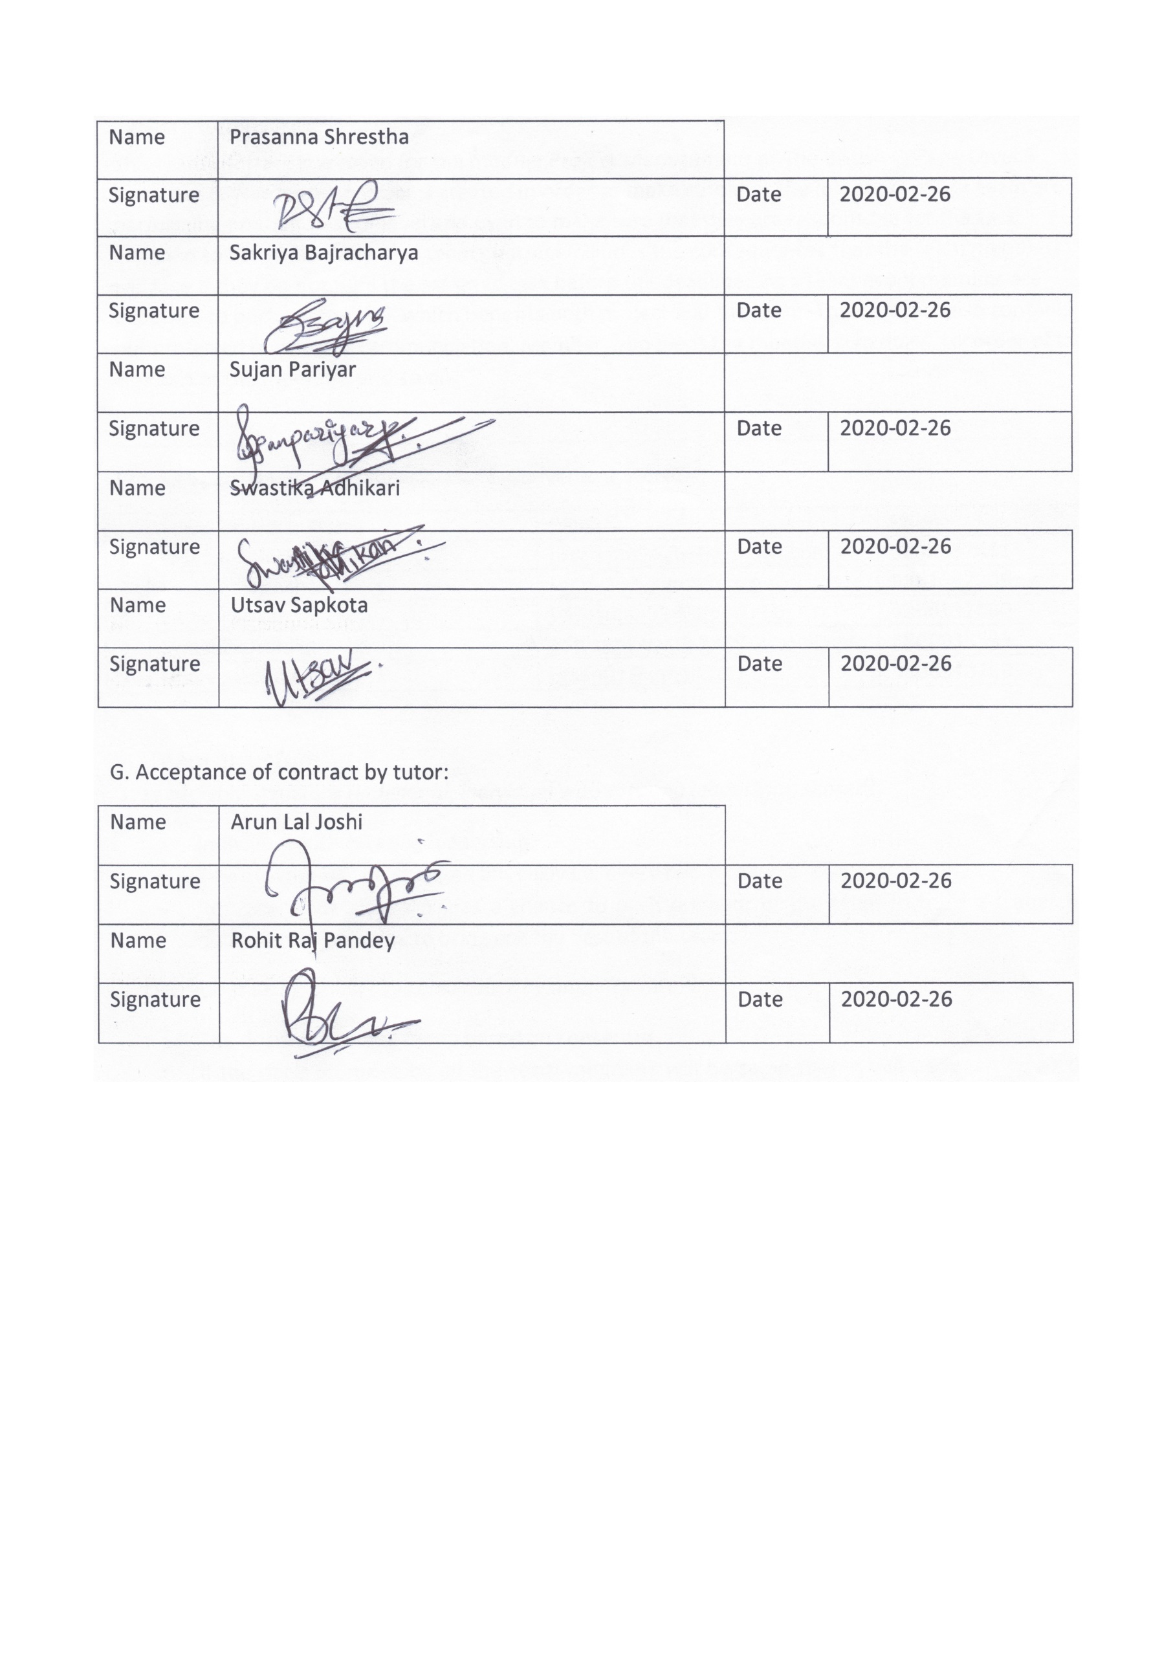

PLANNING PHASE

**Belbin’s Analysis**

**Team Belbin’s Analysis**

|  |  |  |
| --- | --- | --- |
| Version:1.0 **Belbin’s Analysis** Date reviewed:02/27/2020 | | |
| Primary role | Prasanna Shrestha | Resource Investigator |
| Sakriya Bajracharya | Complete Finisher |
| Sujan Pariyar | Monitor Evaluator |
| Swastika Adhikari | Implementer |
| Utsav Sapkota | Plant |
| Secondary role | Prasanna Shrestha | Team Worker |
| Sakriya Bajracharya | Specialist |
| Sujan Pariyar | Co-ordinator |
| Swastika Adhikari | Resource Investigator |
| Utsav Sapkota | Team Worker |
| Least likely role | Prasanna Shrestha | Shaper |
| Sakriya Bajracharya | Co-ordinator |
| Sujan Pariyar | Shaper |
| Swastika Adhikari | Specialist |
| Utsav Sapkota | Monitor Evaluator |
| Do you think the descriptions of these roles are an accurate description of your behaviour in teams? How do you see yourself differently? | Prasanna Shrestha | I have been working on the office environment for 2 years. I can motivate my team and can handle the pressure. Moreover, I’m a good listener and idealistic which will be plus point for my team. |
| Sakriya Bajracharya | Yes, I do think that the description of these roles is an accurate description of my behaviour in teams, as I have the keen eye to complete the things that I have started and I always want to become better in the task that I am assigned to. |
| Sujan Pariyar | Yes, I do think these roles are an accurate description of my behavior in team because in team we have to do the complex decision making for the success of the team project and I see myself confident and capable of making such decisions. |
| Swastika Adhikari | Yes, I am constantly anxious to investigate new thoughts. I generally work aiming to change the plans and thoughts formed in my mind into actions. I like the things to be done in a deliberate and composed manner. I work planning to be finished on schedule. Similarly, I am curious to investigate accessible options and ready to work as much possible to help the team accomplish its objective. I have a solid curious sense and an availability to see the conceivable outcomes in anything new. |
| Utsav Sapkota | Yes, I can reflect back on my actions on past projects and with fairly enough confidence, I can proclaim my roles as plant and team worker as primary and secondary roles respectively. I am quite creative in solving problems in unconventional ways and can put new ideas on desk, I am also a resourceful person and a free-thinker who also happens to think outside the box without letting mind wander away from project. |
| Are there roles identified by Belbin that you might like to develop in yourself more? Which ones and why? | Prasanna Shrestha | Yes, the role of co-ordinator is the one which I would like to develop on because by developing these skills I would be more confident of my talent and work for the goal conveniently. |
| Sakriya Bajracharya | Yes, I would like to develop more of co-ordinating things as I my mind is more spread out and I am not able to focus on a single task very persistently. |
| Sujan Pariyar | Everyone has something to learn and Yes, there are some role that I would like to develop in myself and among them complete finisher is that role because It becomes little mess at the end of the task. |
| Swastika Adhikari | Yes, I want to develop thought-oriented role i.e. Plant because I generally wish to become imaginative and solve the difficulties and issues faced by the group. I would like to be exceptionally innovative and great at taking care of issues in unpredictable manners. Likewise, I like to build up my ability for complex and strategic planning. I also intend to produce potentially remunerating ideas. |
| Utsav Sapkota | Yes, there are two roles I would like to groom myself to perform better in. It is Monitor Evaluator, my least likely role which I wish to develop so that I can have impartial judgement, deliver critical analysis and can provide a logical eye to the team. Along with it, I also wish to develop in me a Team Worker role so that I can surround myself with team members and communicate for conflict resolution, omit out misinterpretations to maintain effective communication within the team which helps the team to achieve a targeted goal easily without much hurdles in an allocated timeframe. |
| What possible situations in the coming months can you identify where you could work on developing these skills? | Prasanna Shrestha | Sometimes team member could feel hard to solve errors, gets demotivated then I would find a good way to solve the problems and motivate my team. |
| Sakriya Bajracharya | Possible situation when I might be able to work on developing these skills are when I have to become the team leader as the leader in our group is changed biweekly and I have to take on leadership role to further enhance my skills. |
| Sujan Pariyar | I think delay of the project and difficulties for error handling can be seen in coming months and for that we have decided for biweekly team meeting and timely informing the team member along with asking them for the assistance if needed. |
| Swastika Adhikari | The situations when any member of my team cannot solve the problems and challenges during the project I think I could motivate myself in order to solve the issues and build up my skill. |
| Utsav Sapkota | One of the possible situations could be on the presenting days of the final project. I shall be more confident on my part of the presentation. I would also put in extra effort on project planning and project monitoring phases in coming days. |
| Considering your team working, how do you think you could improve your effectiveness in group work and in contributing to the success of teams that you work in? | Prasanna Shrestha | According to my roles mentioned on the previous table, I am a good motivator, designer, can easily get involved with new people for research and exploration. I always do my best to solve the problems which would be effective to get success of my team. |
| Sakriya Bajracharya | I think that I can push my teammates harder so that they are able to complete the tasks that are assigned to them in said time. I want to help them by bringing in more creative ideas. I will also help them in tasks that they are stuck in if help is required. |
| Sujan Pariyar | By communicating with the team and instant informing about the problems raised will improve my effectiveness in group work. |
| Swastika Adhikari | I think I could improve the effectiveness in my group by transforming thoughts and ideas built in my team into plans and manageable projects and making sure all the things are done. I favour difficult work and handle issues in a deliberate manner. I will systematically set the tasks that need to be worked on. I focus on recognizing and working for the group. |
| Utsav Sapkota | I could use innovative ideas other than to just follow the bandwagon and help the team in any way possible. I could also improve my communication skills to confront opposition parties in team. As stated earlier, I could maintain effective communication within the team which would eventually help the team to achieve a targeted goal easily without much hurdles in an allocated timeframe. |
| Are the results of this inventory consistent with how you worked in the Foundation Project in your small groups for discussions and presentations? | Prasanna Shrestha | Yes it is consistent. It will be great knowledge for the real life project scenario. I think after working on this foundation project I will be more confident, handle pressure and good coordinator too. |
| Sakriya Bajracharya | Yes, so far, the results of this inventory is consistent with how I have worked in the foundation of the project but I feel that I can improve even more so that the group can benefit even more by removing any hiccups that are encountered during the project. |
| Sujan Pariyar | Yes, somehow the results of this inventory are consistent with our work in the project but there is some lag which we will sort as soon as possible and achieve are goal and make our project a success. |
| Swastika Adhikari | Yes, the results of this inventory are consistent. In the event that I feel inconsistent during the project I will be motivating myself and finishing my task in an appropriate manner to reach at the target of the project. |
| Utsav Sapkota | Yes, so far it has been consistent but there is always a place for improvement. We will eliminate our inconsistencies and by far, overcome our personality traits and preconceived notions to stick to our roles and goals in project. |
| How well did you contribute to group presentations? | Prasanna Shrestha | I will contribute my 100 percent for the group presentation according to requirement. |
| Sakriya Bajracharya | I want to contribute fully by being dedicated in the project, making sure that all resources are utilized and the full potential of my team members are utilized. |
| Sujan Pariyar | I want to give the best out of me in the group presentation. I will provide the requisites and will be confident, punctual, well-dressed during the group presentations. |
| Swastika Adhikari | I want to contribute my best with as much efforts as possible. I want to develop team mentality and play a positive role. I will be active in communicating, creating thoughts and settling on the choices and plan for the group presentations. |
| Utsav Sapkota | I am fully dedicated to present our team project with variety of resources, proper attire, proper response to questionnaires and confidence. |

**Individual Belbin’s Analysis**

|  |  |  |
| --- | --- | --- |
| Version:1.0 **Belbin’s Analysis** Date reviewed: 2020-02-27 | | |
| Primary role | Swastika Adhikari | Implementer |
| Secondary role | Swastika Adhikari | Resource Investigator |
| Least likely role | Swastika Adhikari | Specialist |

**Name: Swastika Adhikari**

|  |  |  |
| --- | --- | --- |
| Do you think the descriptions of these roles are an accurate description of your behaviour in teams? How do you see yourself differently? |  | Yes, I am constantly anxious to investigate new thoughts. I generally work aiming to change the plans and thoughts formed in my mind into actions. I like the things to be done in a deliberate and composed manner. I work planning to be finished on schedule. Similarly, I am curious to investigate accessible options and ready to work as much possible to help the team accomplish its objective. I have a solid curious sense and an availability to see the conceivable outcomes in anything new. |
| Are there roles identified by Belbin that you might like to develop in yourself more? Which ones and why? |  | Yes, I want to develop thought-oriented role i.e. Plant because I generally wish to become imaginative and solve the difficulties and issues faced by the group. I would like to be exceptionally innovative and great at taking care of issues in unpredictable manners. Likewise, I like to build up my ability for complex and strategic planning. I also intend to produce potentially remunerating ideas. |
| What possible situations in the coming months can you identify where you could work on developing these skills? |  | The situations when any member of my team cannot solve the problems and challenges during the project, I think I could motivate myself in order to solve the issues and build up my skill. |
| Considering your team working, how do you think you could improve your effectiveness in group work and in contributing to the success of teams that you work in? |  | I think I could improve the effectiveness in my group by transforming thoughts and ideas built in my team into plans and manageable projects and making sure all the things are done. I favour difficult work and handle issues in a deliberate manner. I will systematically set the tasks that need to be worked on. I focus on recognizing and working for the group. |
| Are the results of this inventory consistent with how you worked in the Foundation Project in your small groups for discussions and presentations? |  | Yes, the results of this inventory are consistent. In the event that I feel inconsistent during the project I will be motivating myself and finishing my task in an appropriate manner to reach at the target of the project. |
| How well do you want to contribute to group presentations? |  | I want to contribute my best with as much efforts as possible. I want to develop team mentality and play a positive role. I will be active in communicating, creating thoughts and settling on the choices and plan for the group presentations. |

**Ms Project**

**Gantt chart**

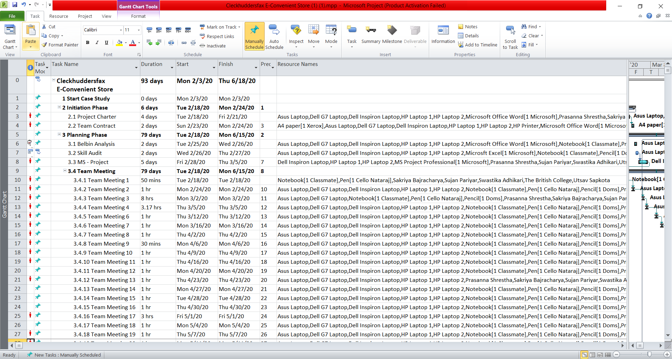

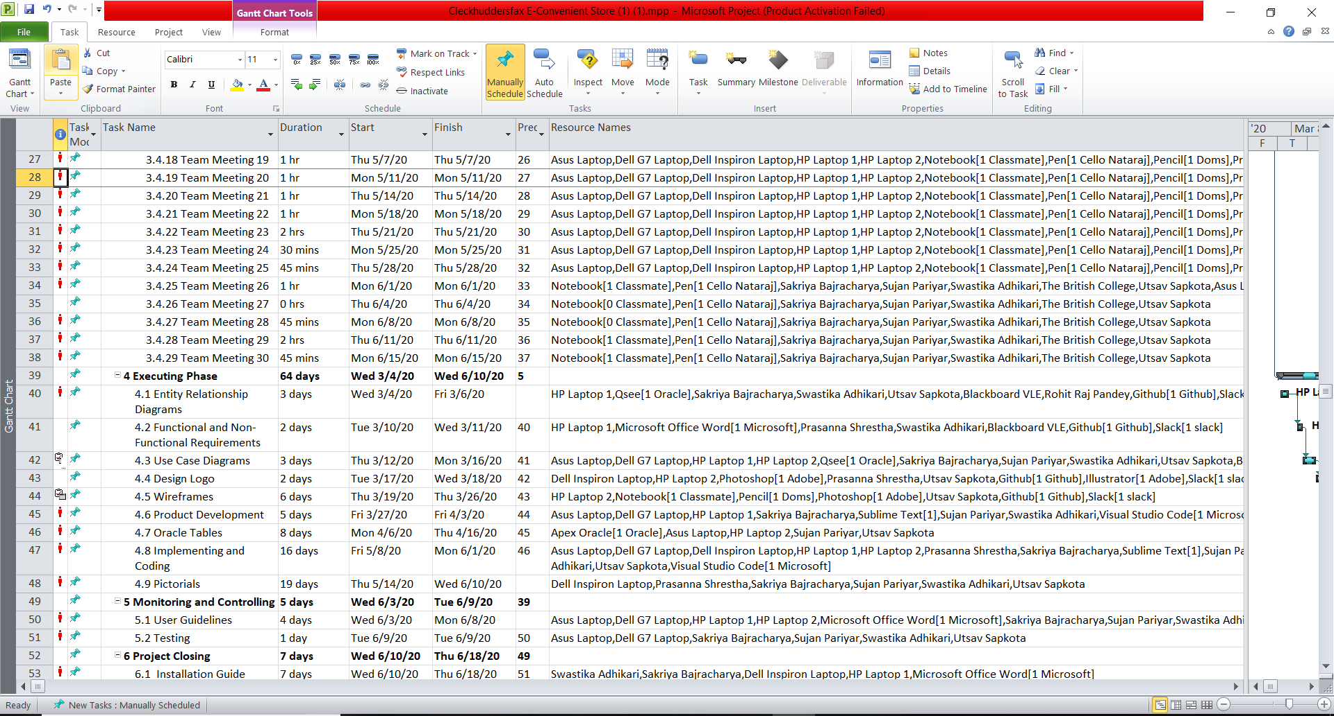

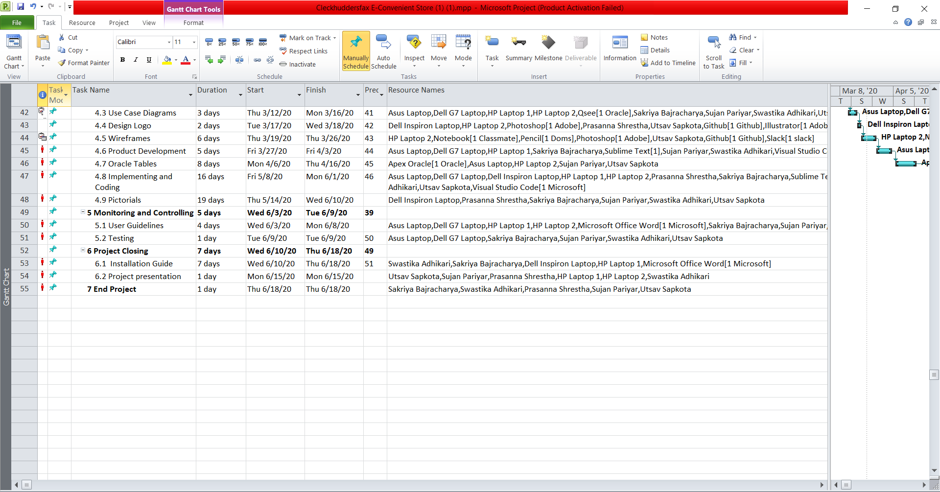

This is a Gantt chart which consists of task mode, task name, duration of the task, starting date of the task, finish date of the task, predecessors and resource names.

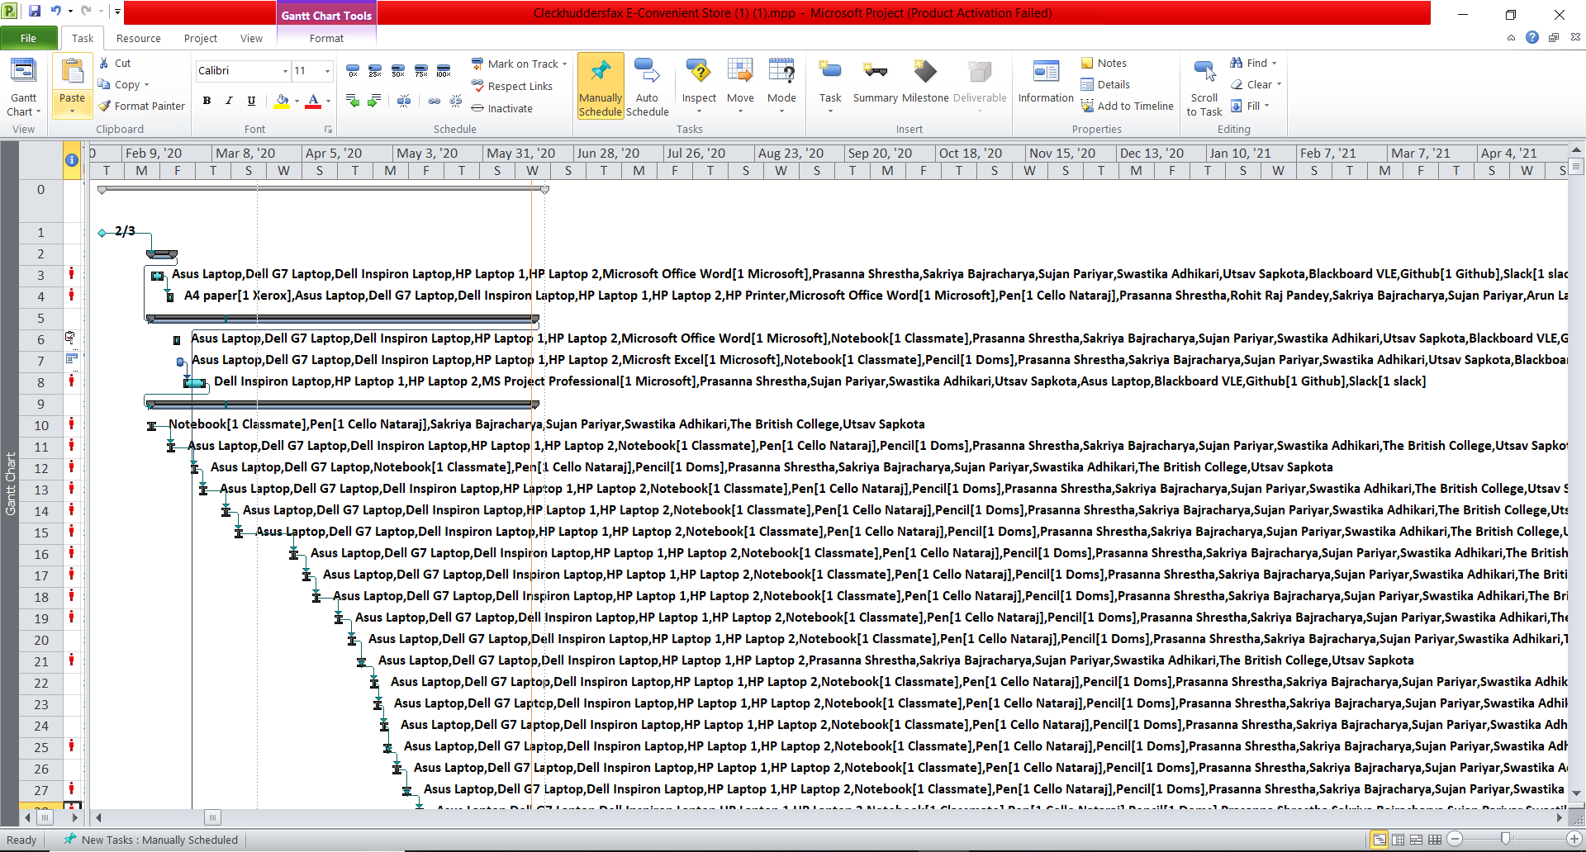

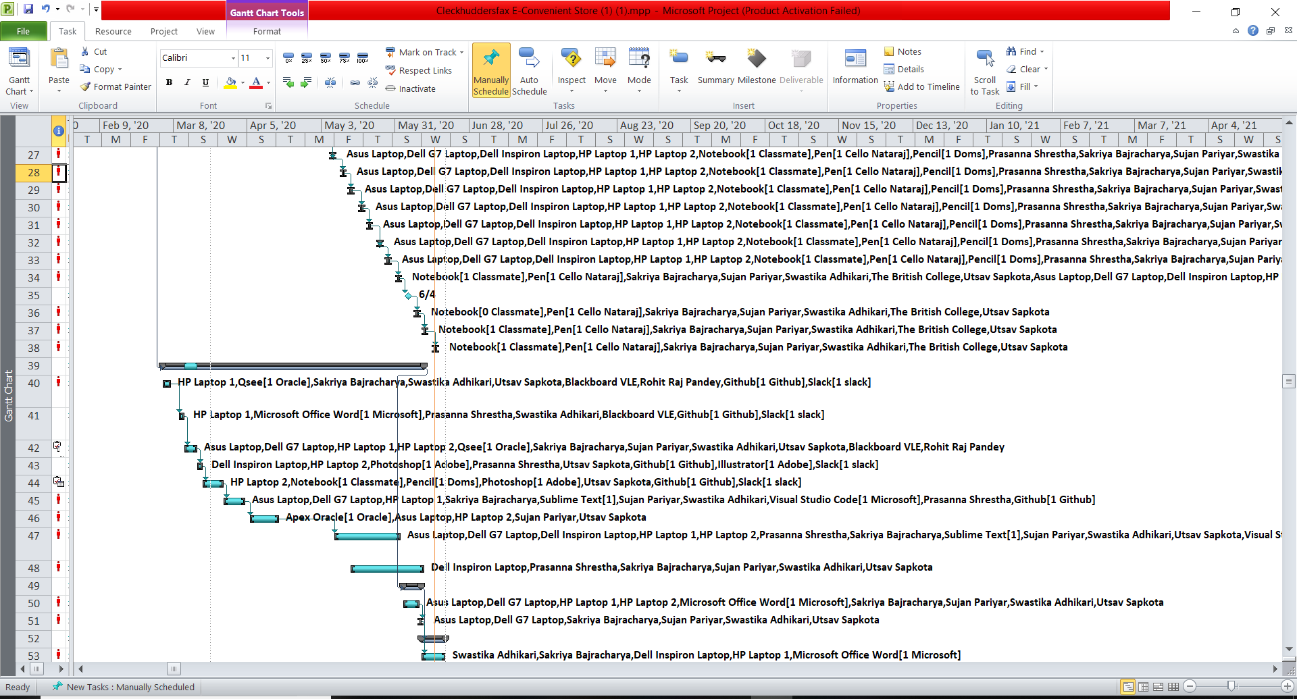

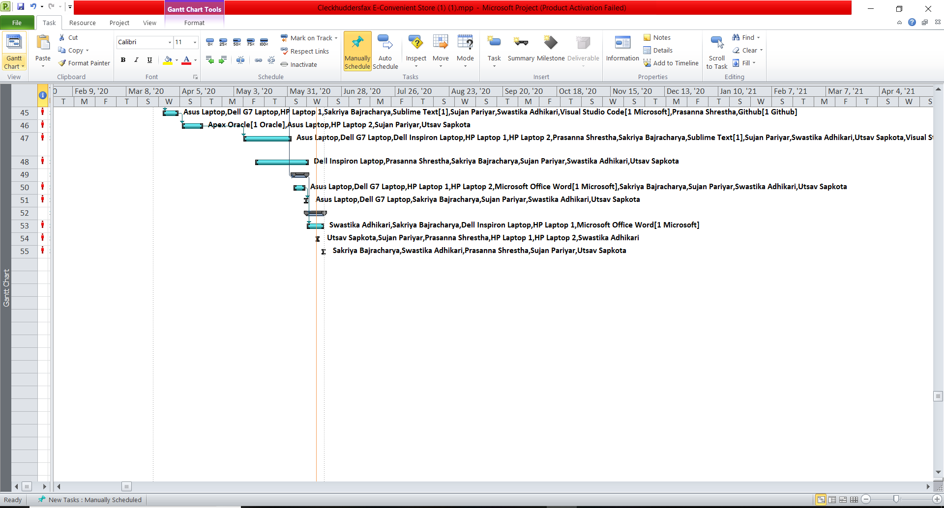

This is a Gantt chart which consists of task mode, task name, duration of the task, starting date of the task, finish date of the task, predecessors and resource names.

**Network Diagram**

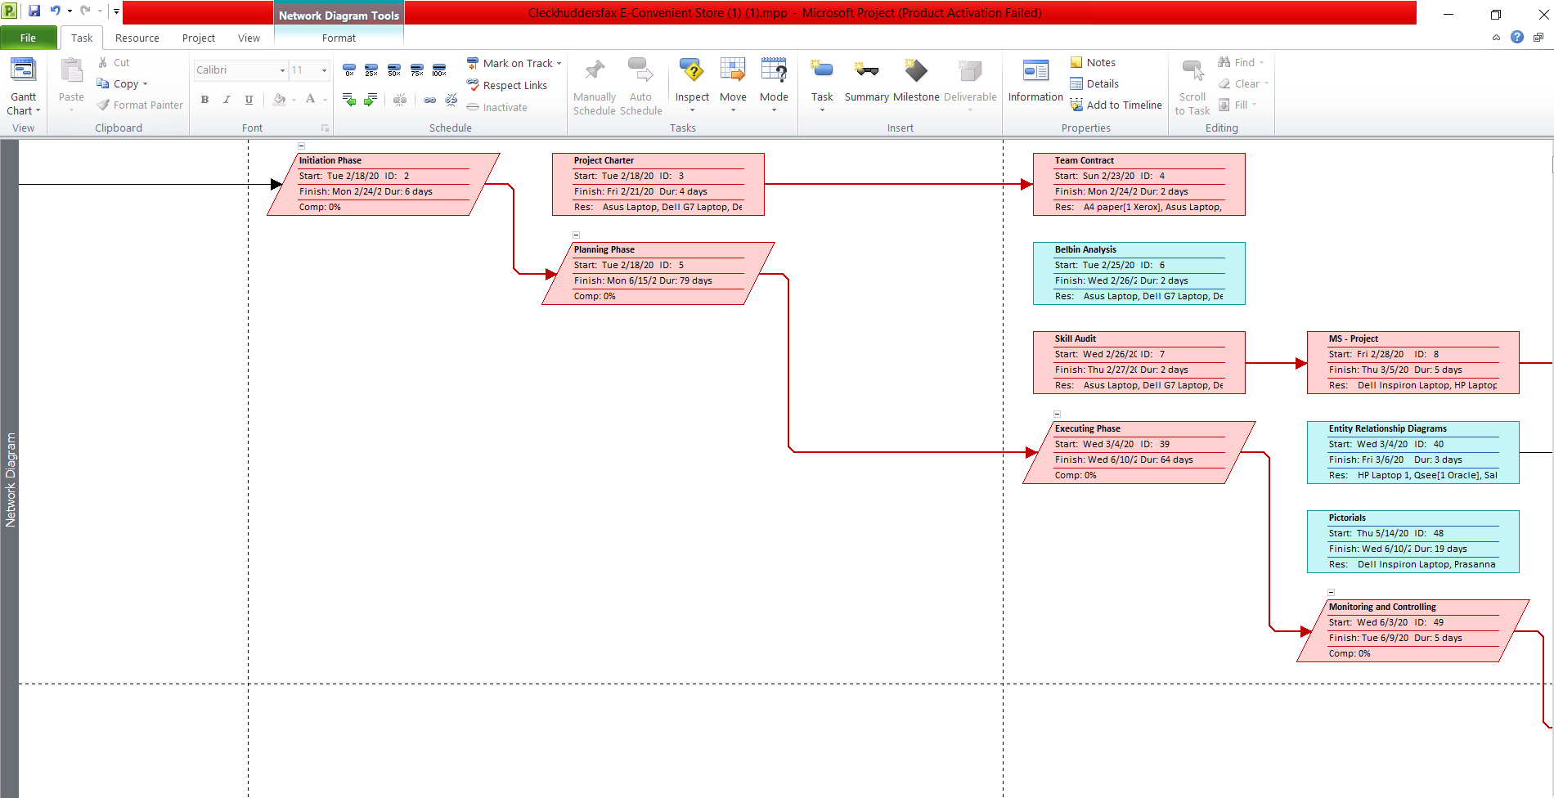

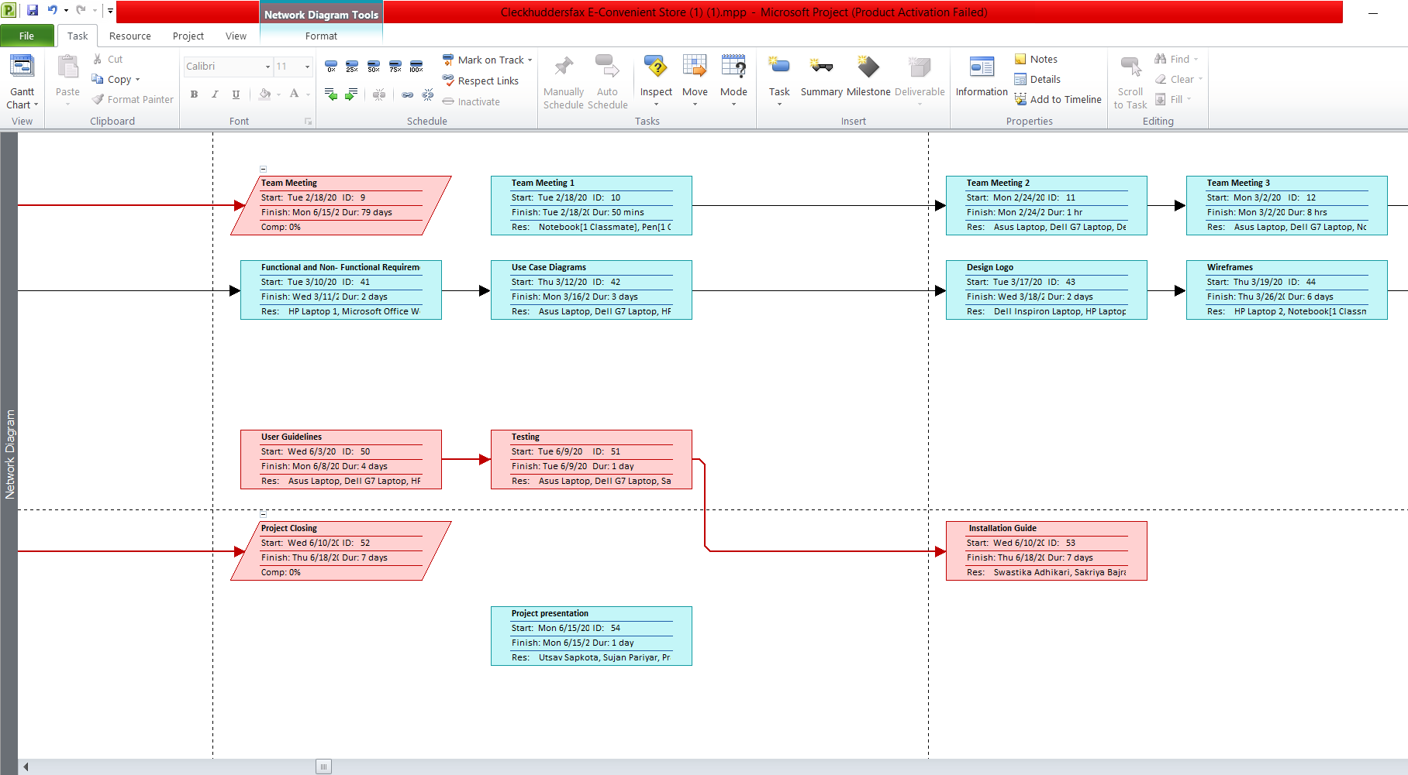

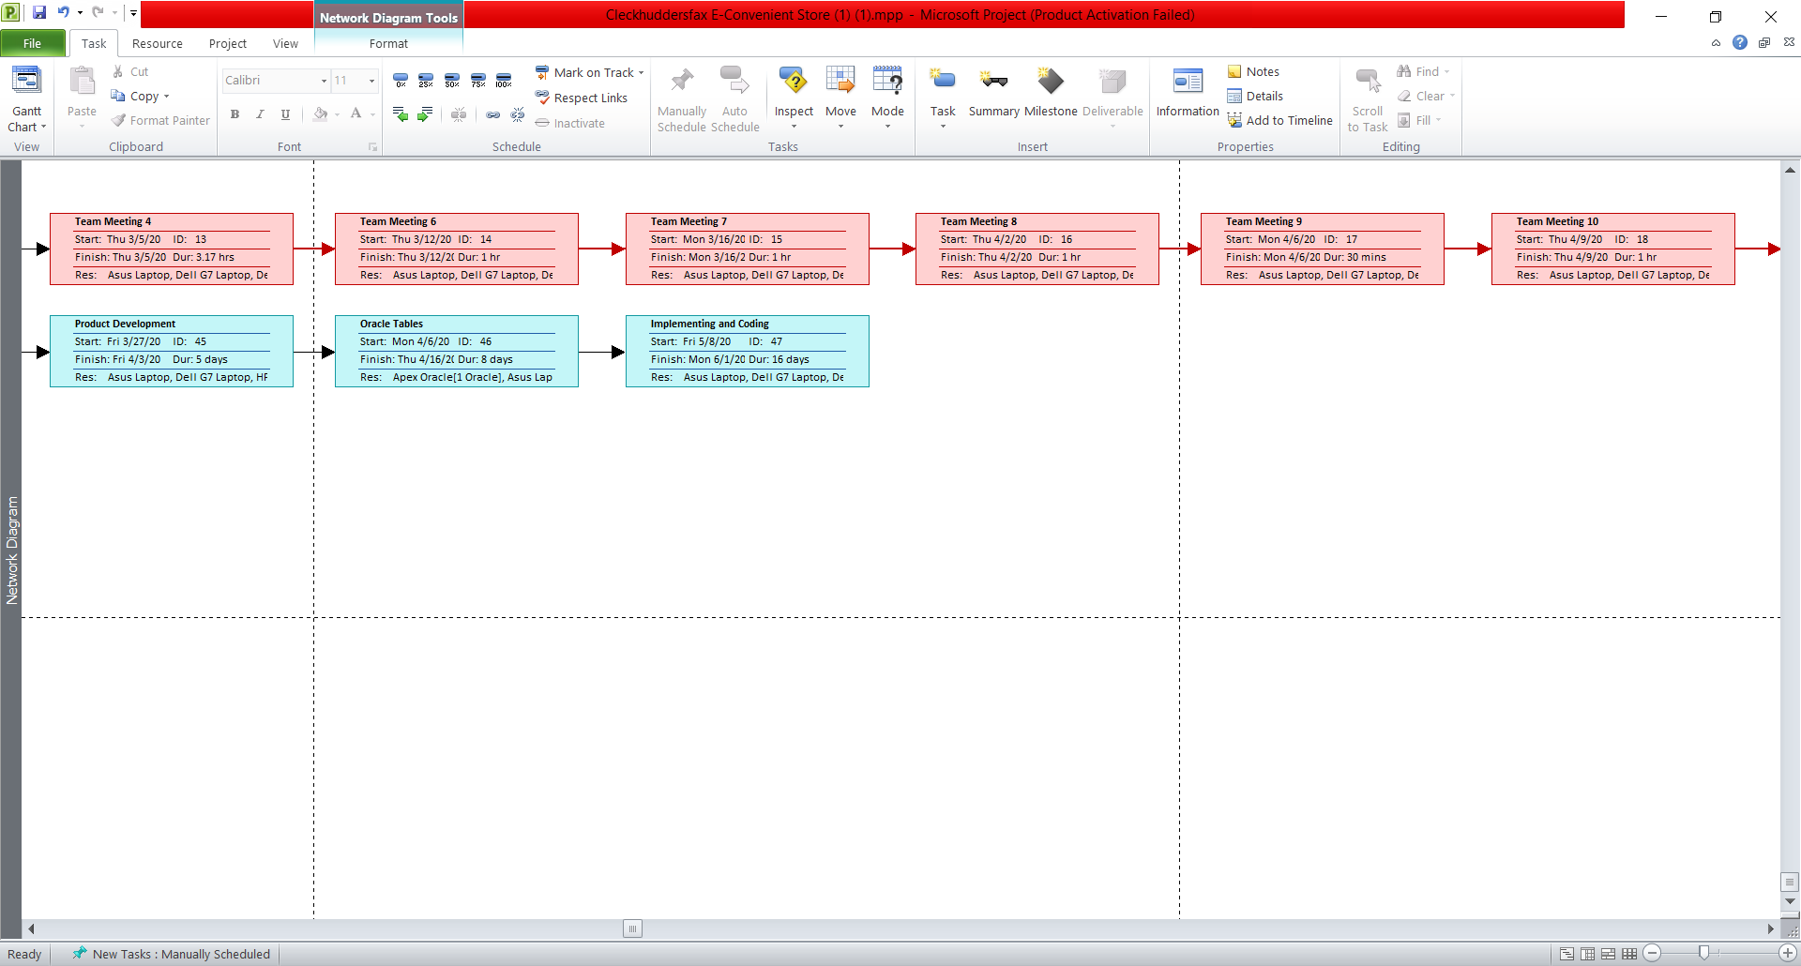

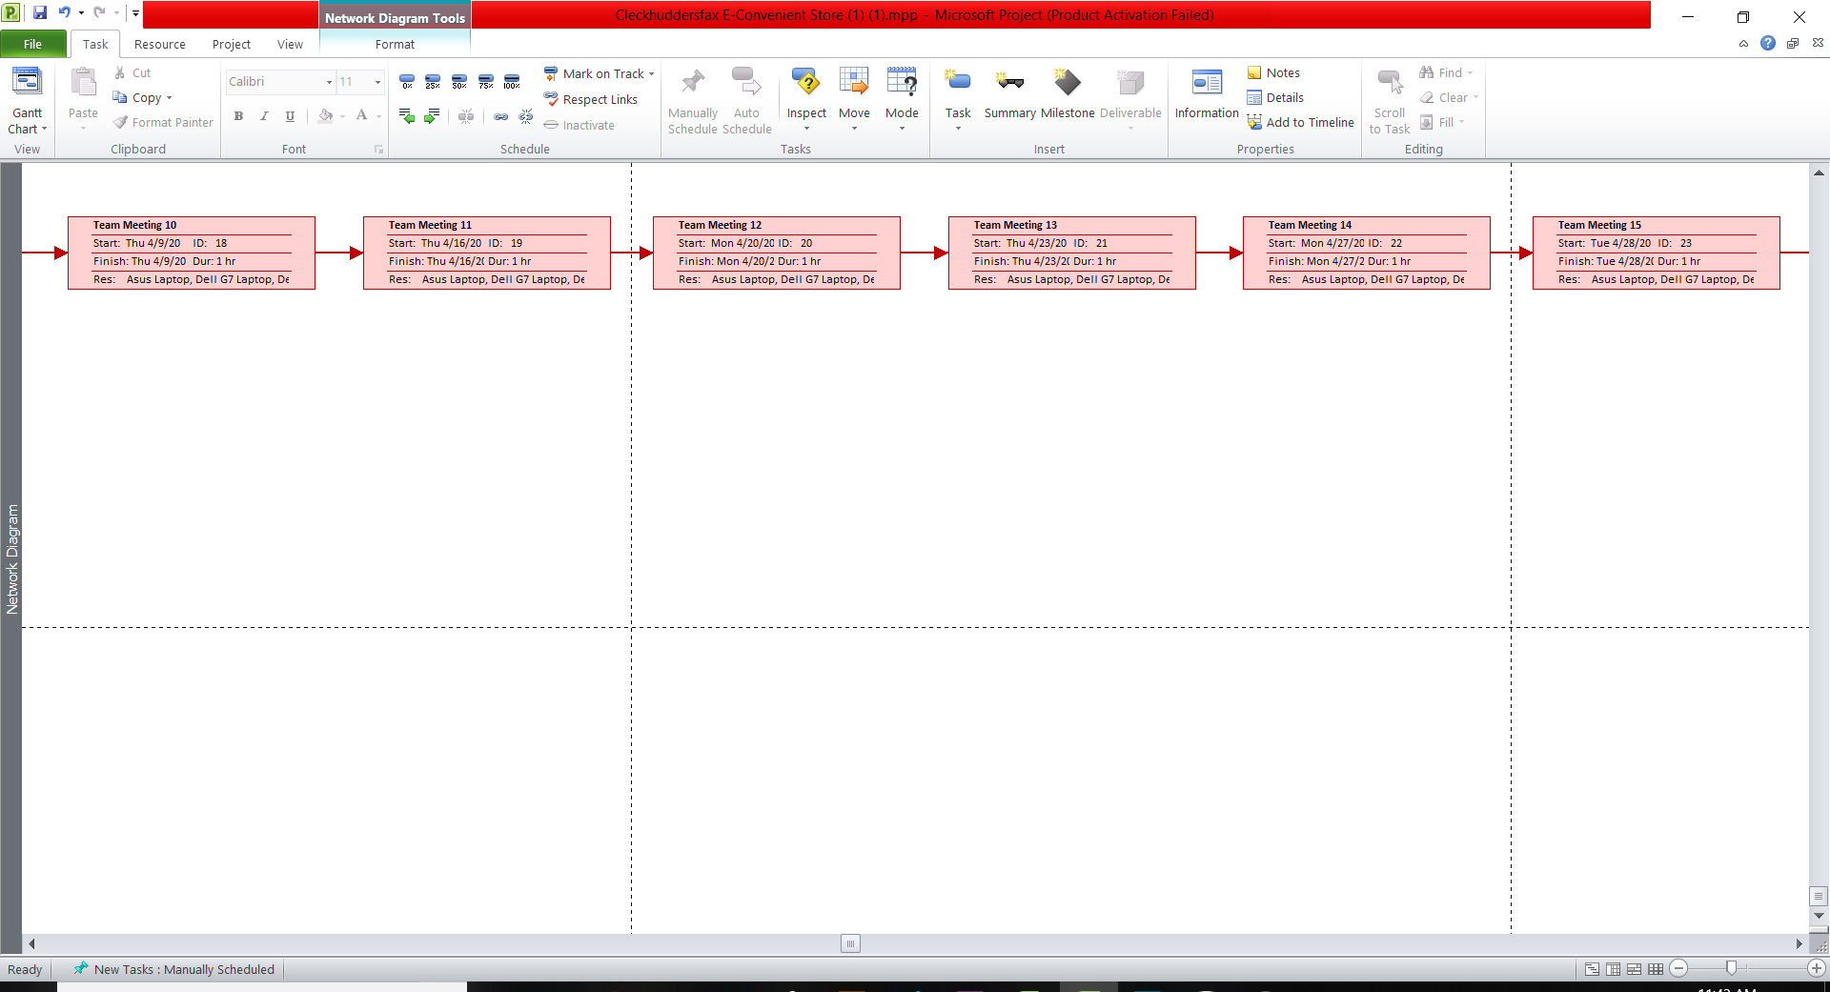

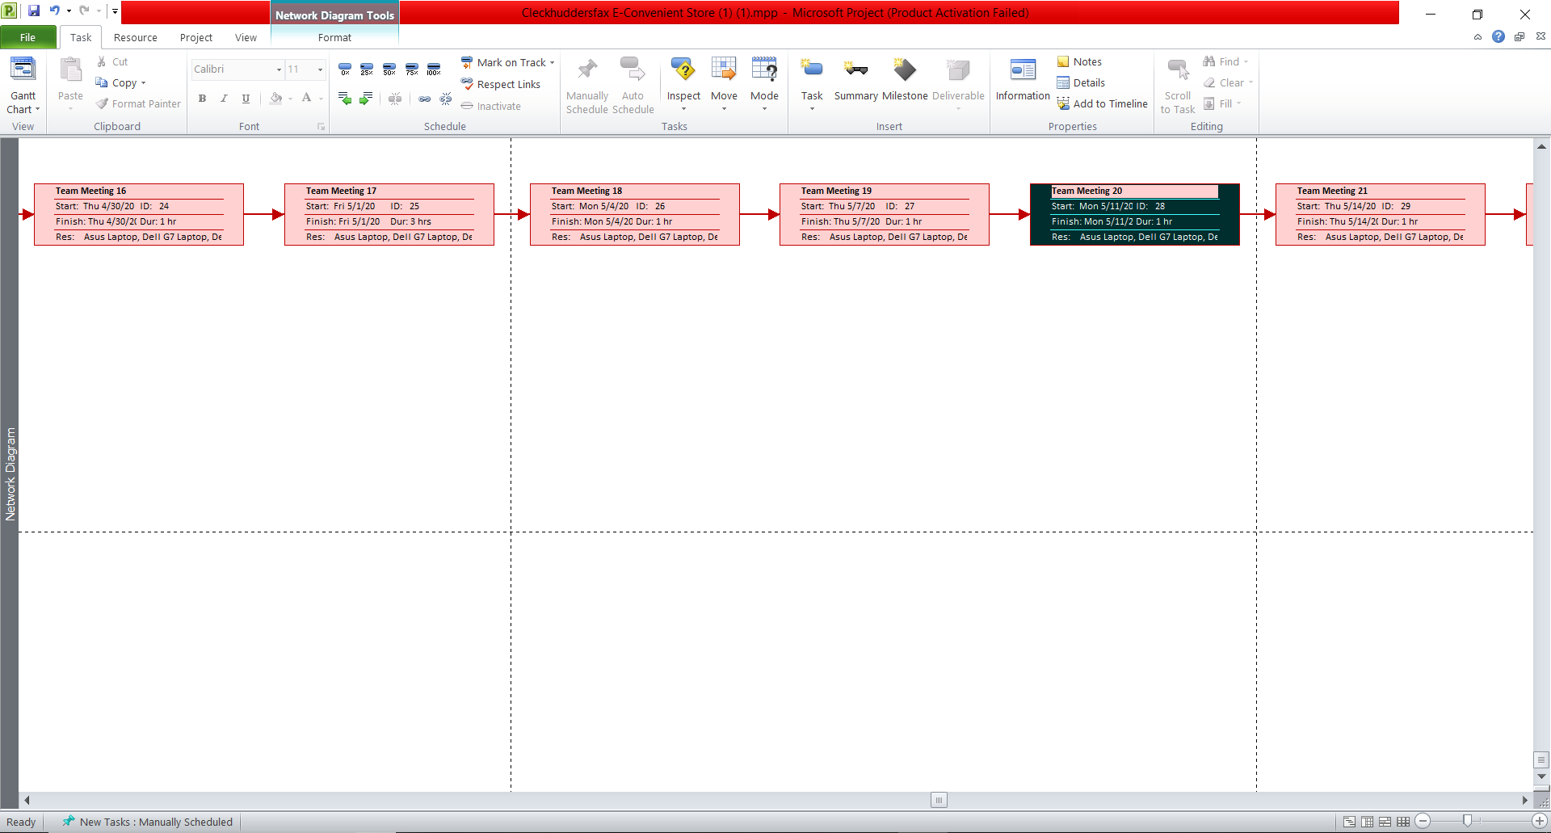

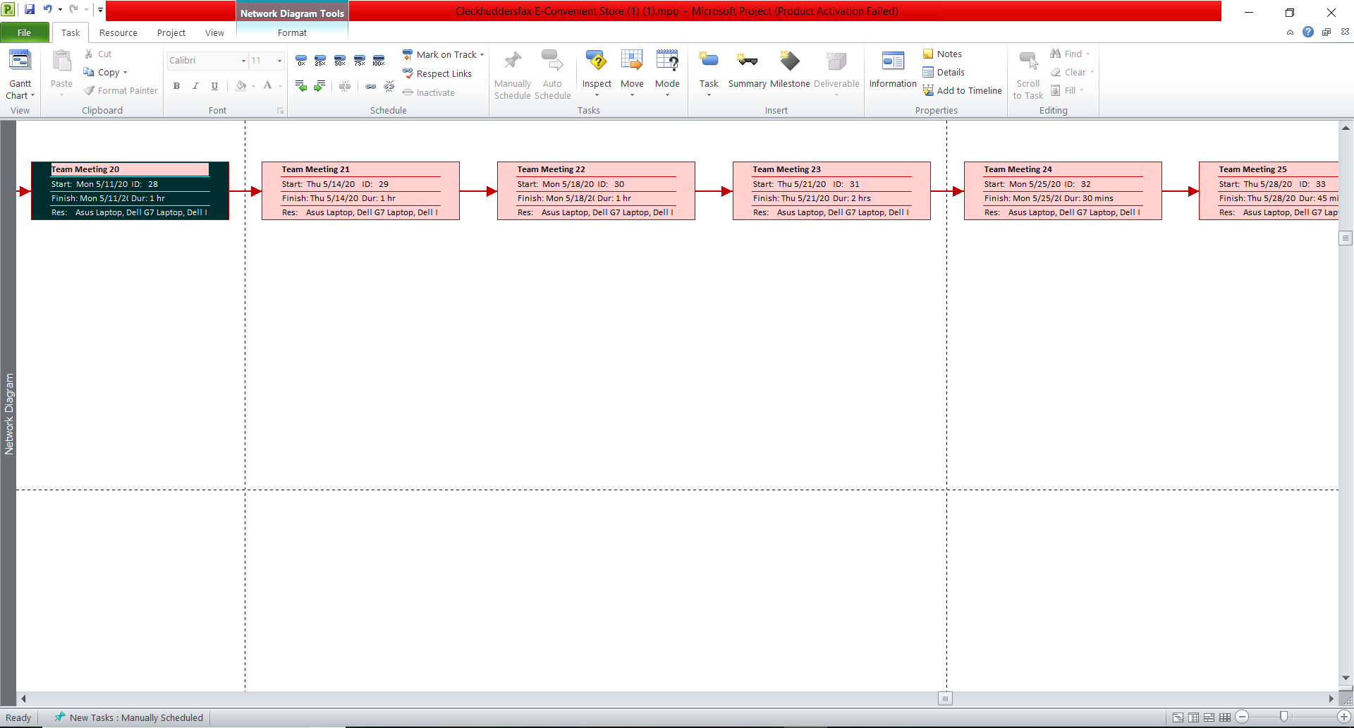

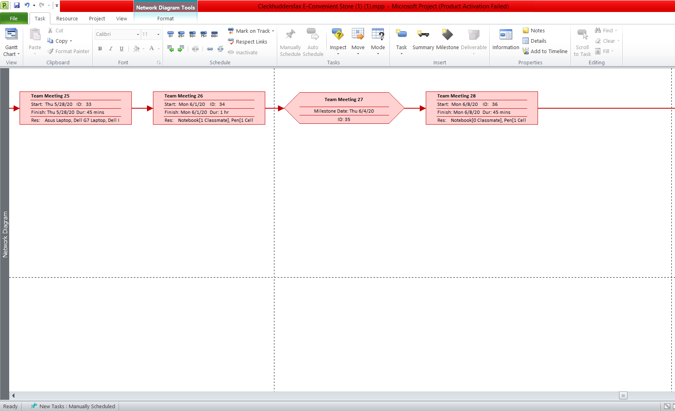

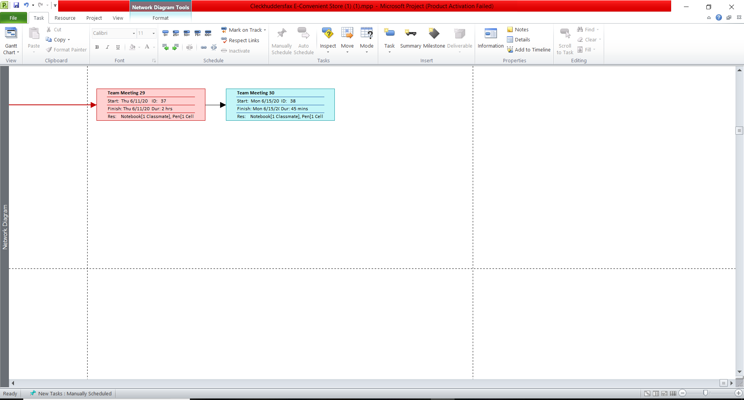

This is a network diagram which shows the flow of task.

**Change Working Time**

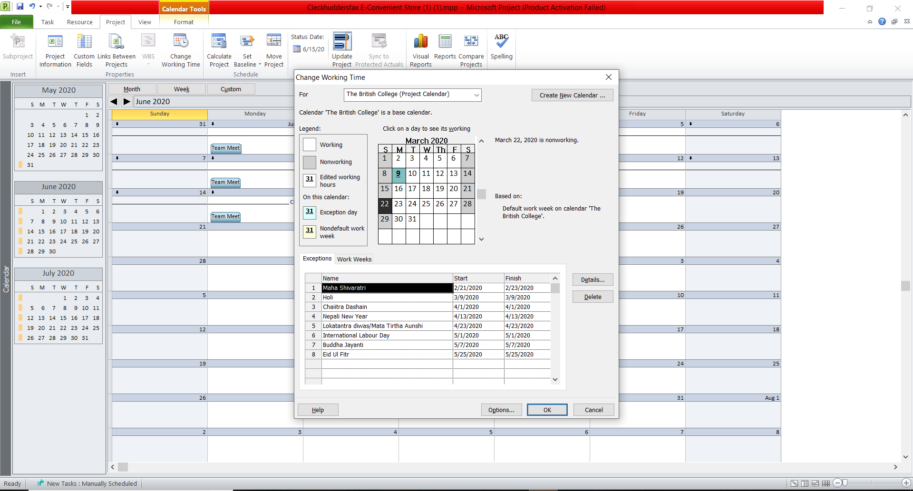

This is a diagram which shows the changes on working time. It shows the day in which task is not performed.

**Calendar**

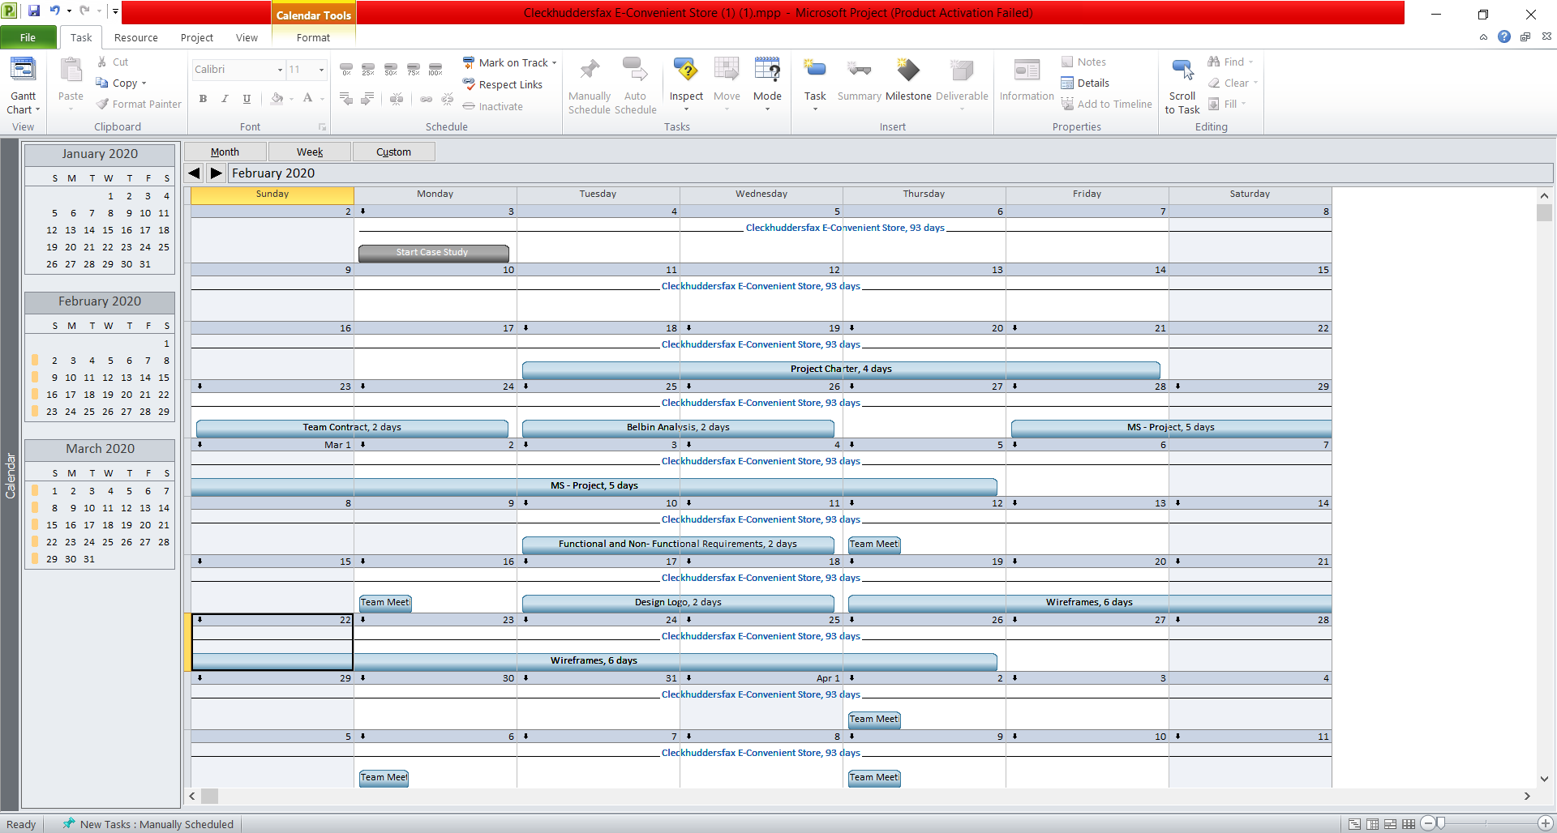

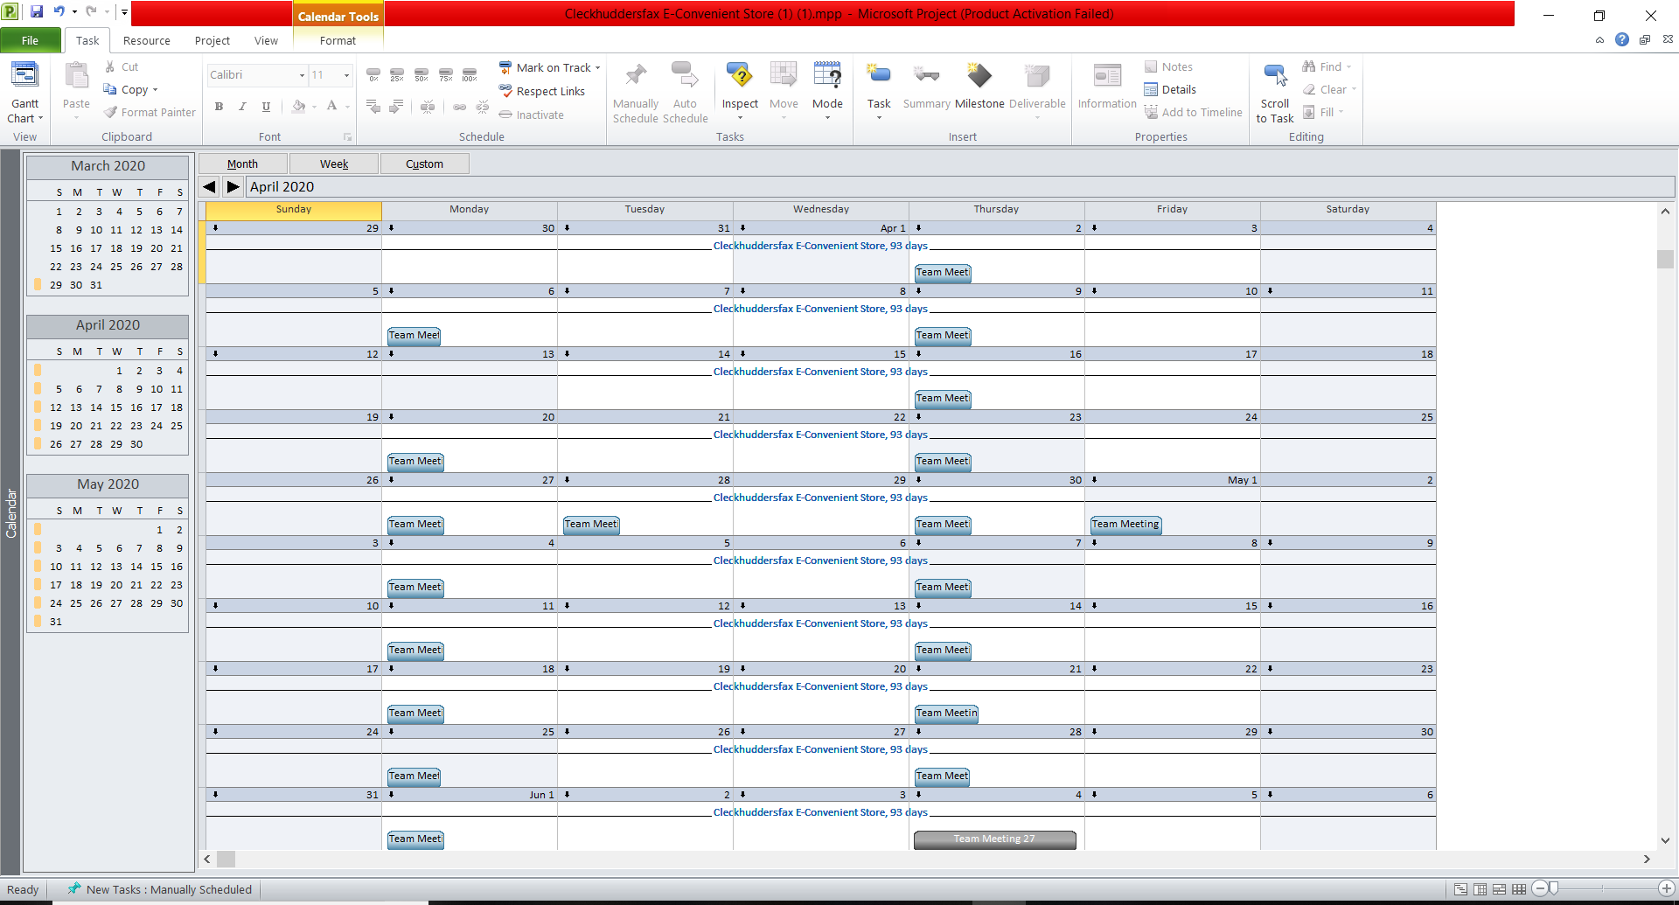

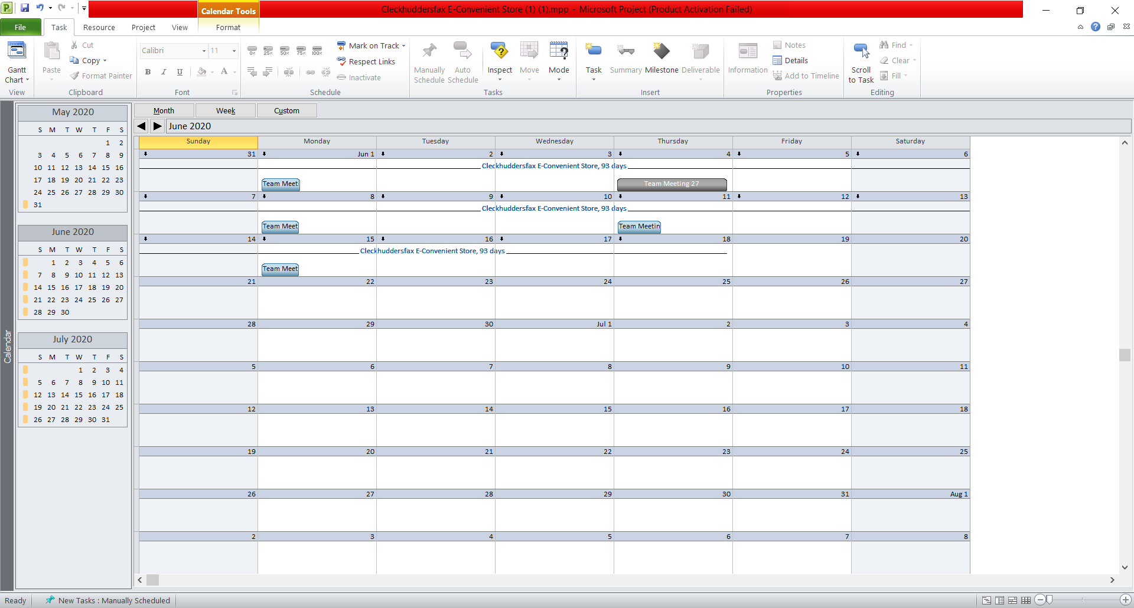

This is a calendar which shows on which days the tasks are performed.

**Timeline**

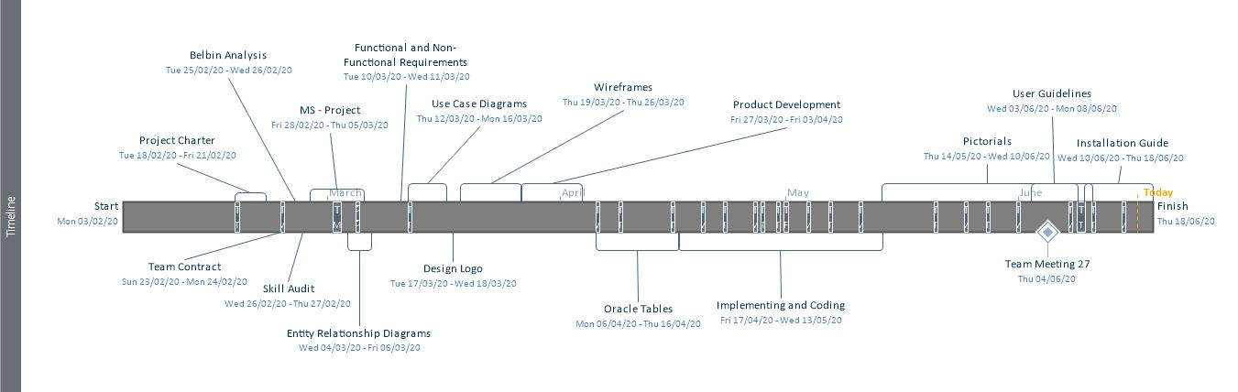

This is a timeline which shows the time and the tasks performed from the start of the project to the end of the project.

**Resource Sheet**

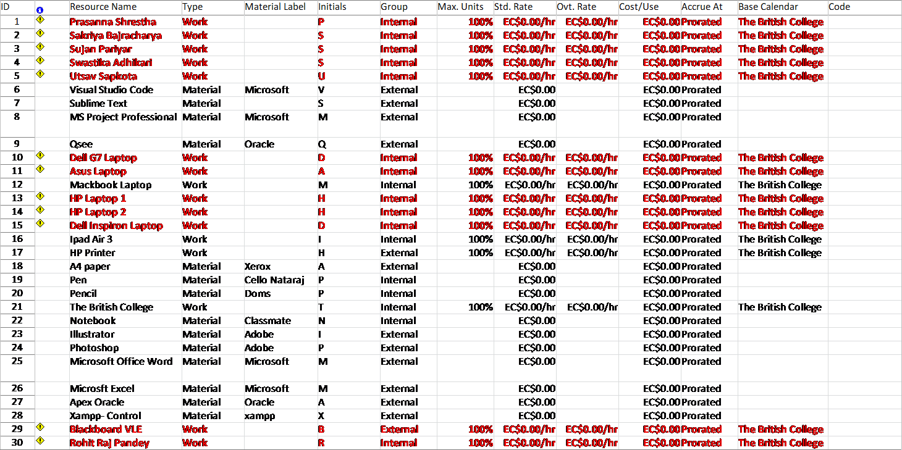



This is a resource sheet which shows the resource name, type, material used, initials, group, Maximum Units, Cost/Use, Accrue At, Base Calendar used for the project.

**Task Sheet**

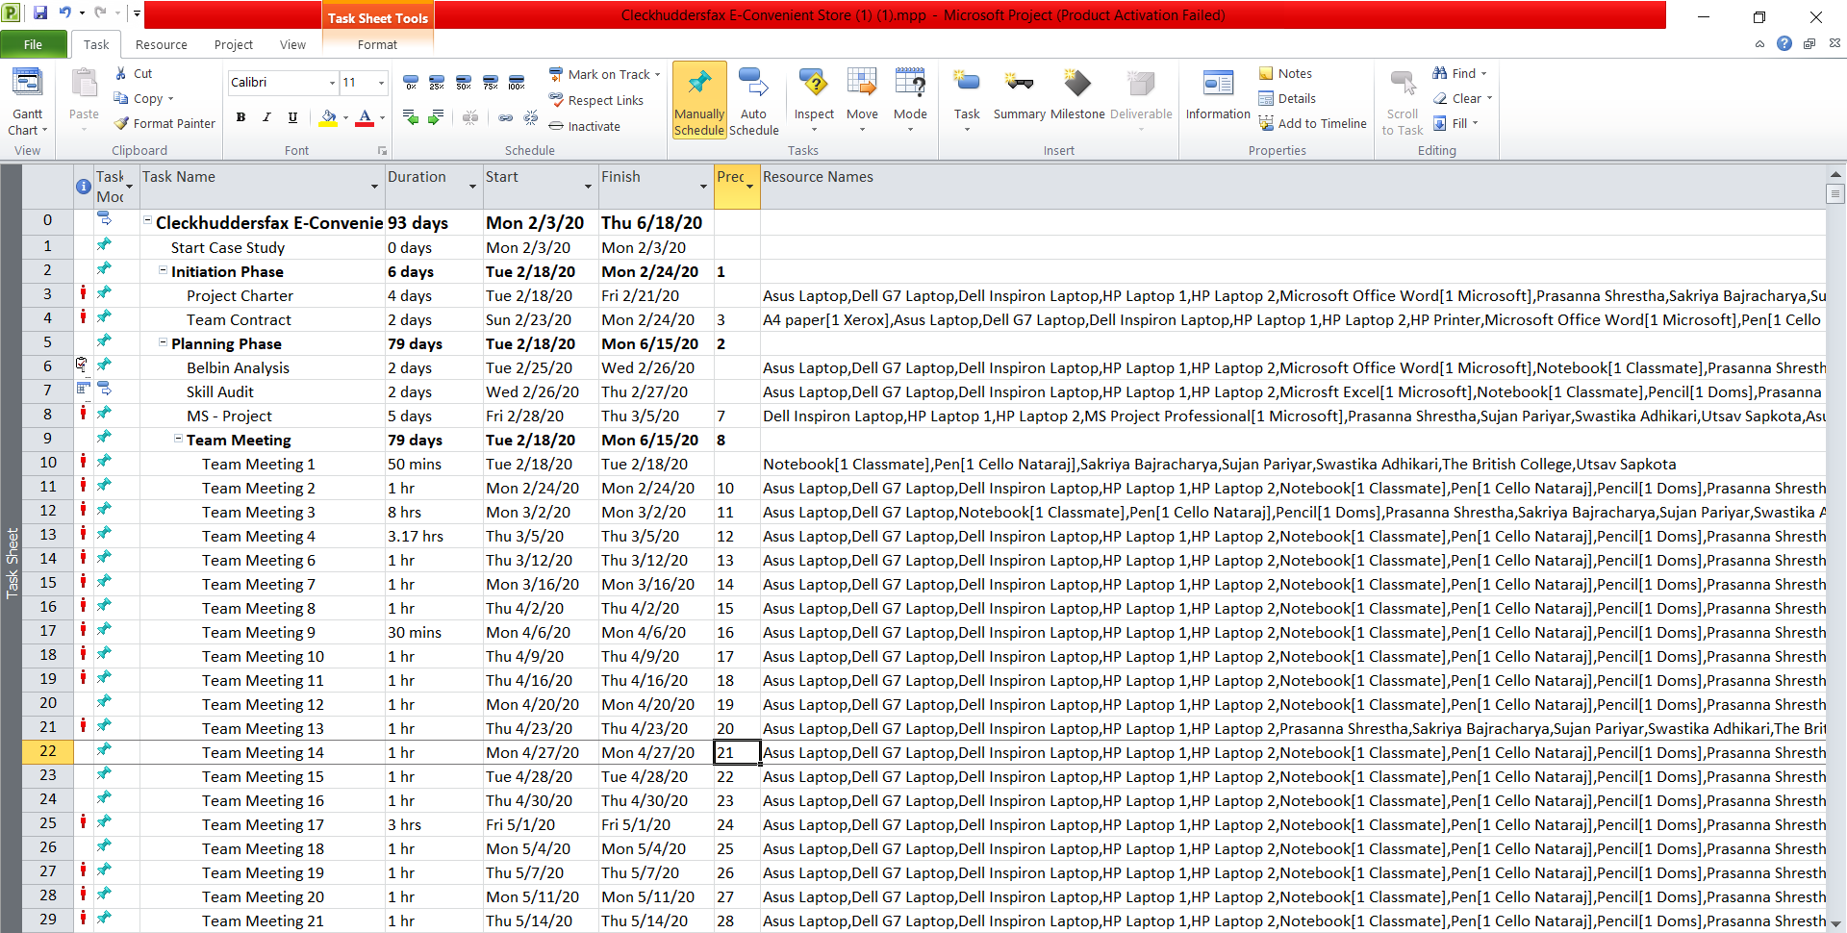

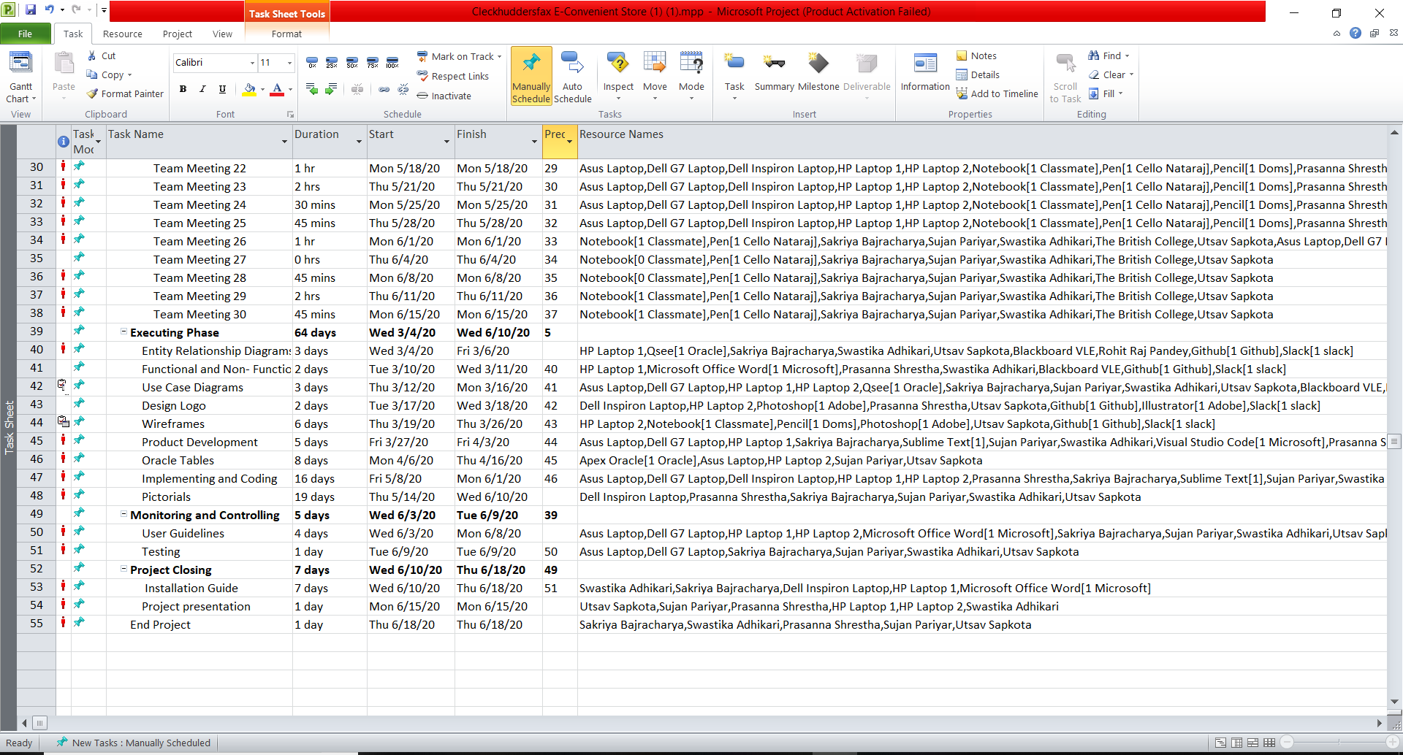

This is a task sheet which shows task mode, task name, duration, start and end time of the task.

**Skill Audit**

**Team Skills Audit**

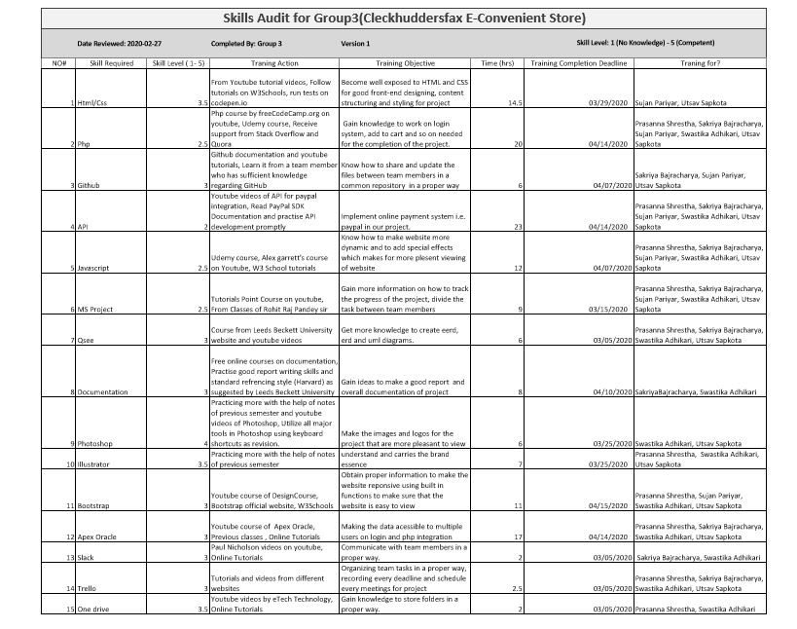

This is a skill audit of team.

**Individual Skills Audit**

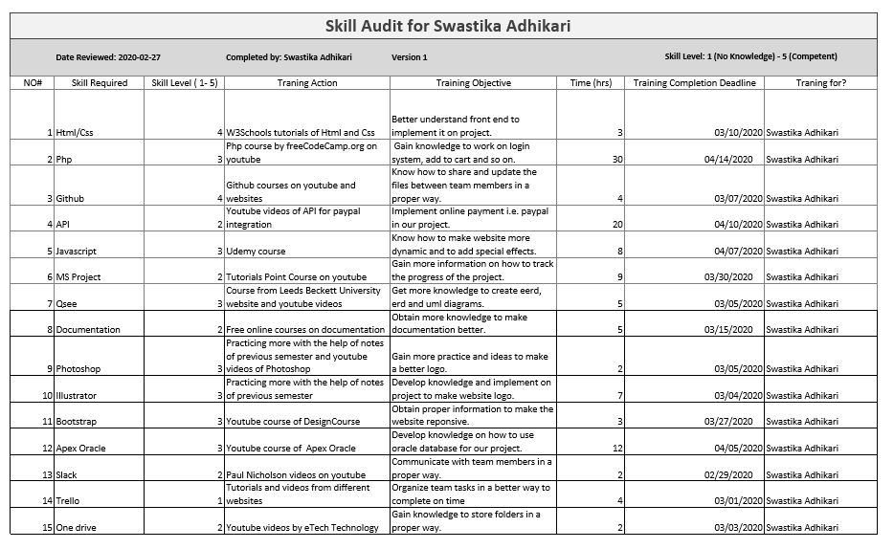

This is an individual skill audit.

**Team Meetings**

# Meeting Minutes



**Location:**

The British College, Kathmandu

# AGENDA AND NOTES, DECISIONS, ISSUES

|  |  |  |  |  |  |  |
| --- | --- | --- | --- | --- | --- | --- |
| Duration | Topic / Discussion | Date | Facilitator | Status | Time | Meeting Type |
| 50 Min | Review of needed Items and Resources, Project Charter Discussion | 18/02/2020 | The British College | Complete | 11:30 AM – 12:20 PM | Information Sharing |

# ATTENDEES

# Prashanna Shrestha, Sakriya Bajracharya, Sujan Pariyar, Swastika Adhikari, Utsav Sapkota

1. Introductions were made at the first meeting, required materials and software provided by our project manager Sir Rohit Raj Pandey was noted and shared in the meeting, followed by a discussion of project charter, in which the scope of project, project brief and means of communication were discussed. As means of communication, Slack and Trello were approved unanimously.

|  |  |  |  |  |  |  |
| --- | --- | --- | --- | --- | --- | --- |
| Duration | Topic / Discussion | Date | Facilitator | Status | Time | Meeting Type |
| 1 Hr | Belbin‘s Analysis, Next Meeting Purpose and Agendas | 24/02/2020 | The British College | Complete | 11:30 AM – 12:30 PM | Information Sharing  Decision Making |

# ATTENDEES

# Prashanna Shrestha, Sakriya Bajracharya, Sujan Pariyar, Swastika Adhikari, Utsav Sapkota

1. After the first effective meeting, the team scheduled next meeting on Trello in a week for Belbin Analysis. The team sat together in the conference hall facilitated by The British College and started discussion.Out of the discussion, individuals from the team noted their primary, secondary and least likely roles accordingly.Though some changes were made, the primary roles stayed unchanged as per the meeting. After Belbin analysis was complete, team sat for a cup of tea and decided on next meeting purpose and agenda.

|  |  |  |  |  |  |  |
| --- | --- | --- | --- | --- | --- | --- |
| Duration | Topic / Discussion | Date | Facilitator | Status | Time | Meeting Type |
| 4 Hr | Discussion on Skills Audit, ERD and Use Case Diagrams | 25/02/2020 | The British College | Complete | 11:30 AM – 3:00 PM | Status Update  Problem Solving |

# ATTENDEES

# Prashanna Shrestha, Sakriya Bajracharya, Sujan Pariyar, Swastika Adhikari, Utsav Sapkota

1. The agenda of this meeting was slightly different than the rest. Our project manager sir had issued an execution phase in design where Use Case diagrams and Entity Relationship Diagrams were to be made. After quickly finishing up with individual Skills Audit, out team figuratively graded themselves which was reviewed by each other in the team. A final cumulative grade of the team was then listed, and Team Skills Audit was complete. Our team rushed to study room at college premise to start and help each other in designing Use Case model of the project. After finishing a trial design of Use Case and ERD, we visited our supervisor Sir Rohit Raj Pandey who eventually was free and in spite of his busy schedule, he dedicated his precious time to help and provide us with wonderful new ideas and variations that could come up. We got new insights as to what could be added and removed from our initial design. The final design was once again reviewed by the team before final submitting was done.

|  |  |  |  |  |  |  |
| --- | --- | --- | --- | --- | --- | --- |
| Duration | Topic / Discussion | Date | Facilitator | Status | Time | Meeting Type |
| 2 Hr | Discussion on Wireframes, Templates and MS Project | 10/03/2020 | The British College | Complete | 11:30 AM – 1:00 PM | Information Sharing |

# ATTENDEES

# Prashanna Shrestha, Sakriya Bajracharya, Sujan Pariyar, Swastika Adhikari, Utsav Sapkota

After a tedious yet fruitful meeting, our team has sat down together for template sampling and wire framing. The team locked down to a common template and started on building wireframe. As brilliant might it sound, template sampling wasn’t the only challenge. We had to study its compatibility, responsive designs, license and many more factors that could impact our entire project. Our team has discussed and decided to include an added wireframe for invoice, cart, login and signup functionalities along with CRUD for customer and trader interface and search features in template. Meanwhile in the meeting, the team has decided to push its efforts in wireframing and MS Project.

|  |  |  |  |  |  |  |
| --- | --- | --- | --- | --- | --- | --- |
| Duration | Topic / Discussion | Date | Facilitator | Status | Time | Meeting Type |
| 3 Hr | Oracle table, Implementing and coding | 01/05/2020 | Google Meet | Complete | 12 PM – 3PM | Information Sharing |

# ATTENDEES

# Prashanna Shrestha, Sakriya Bajracharya, Sujan Pariyar, Swastika Adhikari, Utsav Sapkota

# In the hard time of Covid-19, we managed to do meeting online through Google meet . And we discussed about the oracle table and the project flow. Implementing and coding part was discussed about the homepage, customer interface, trader interface, admin and dashboard as per the leader assigned the task to every individual in the team though it was really tough to communicate due to internet breakdown and load shedding.

|  |  |  |  |  |  |  |
| --- | --- | --- | --- | --- | --- | --- |
| Duration | Topic / Discussion | Date | Facilitator | Status | Time | Meeting Type |
| 2 Hr | Installation Guide , apex oracle application | 11/06/2020 | Google Meet | Complete | 2 PM – 4PM | Information Sharing |

# ATTENDEES

# Prashanna Shrestha, Sakriya Bajracharya, Sujan Pariyar, Swastika Adhikari, Utsav Sapkota

# The agenda of this meeting was to install, update the apex oracle and build an application and discuss about the testing of project to be done in the coming days and finalise the project with all the requirements.

**Communication Tool Used**

**Slack**

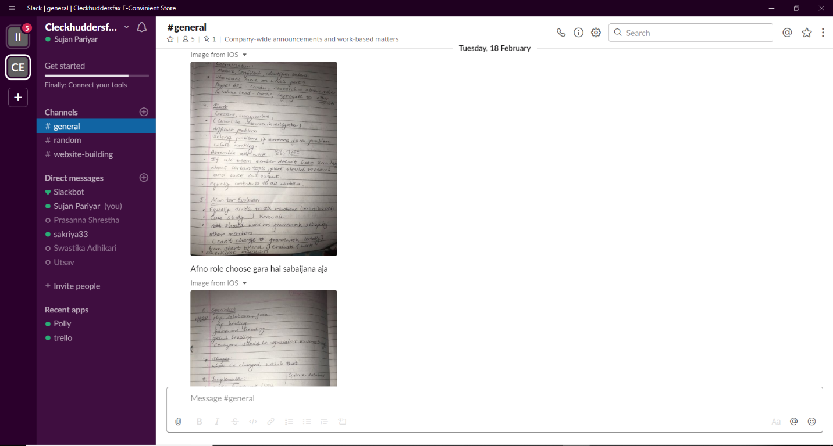

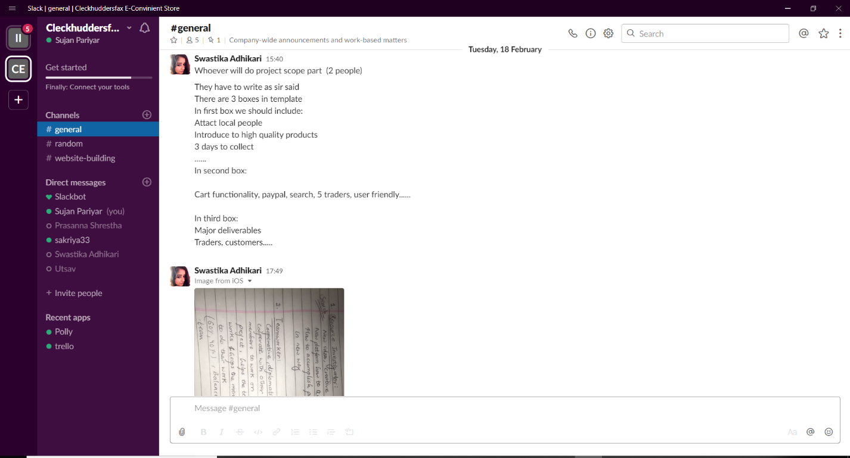

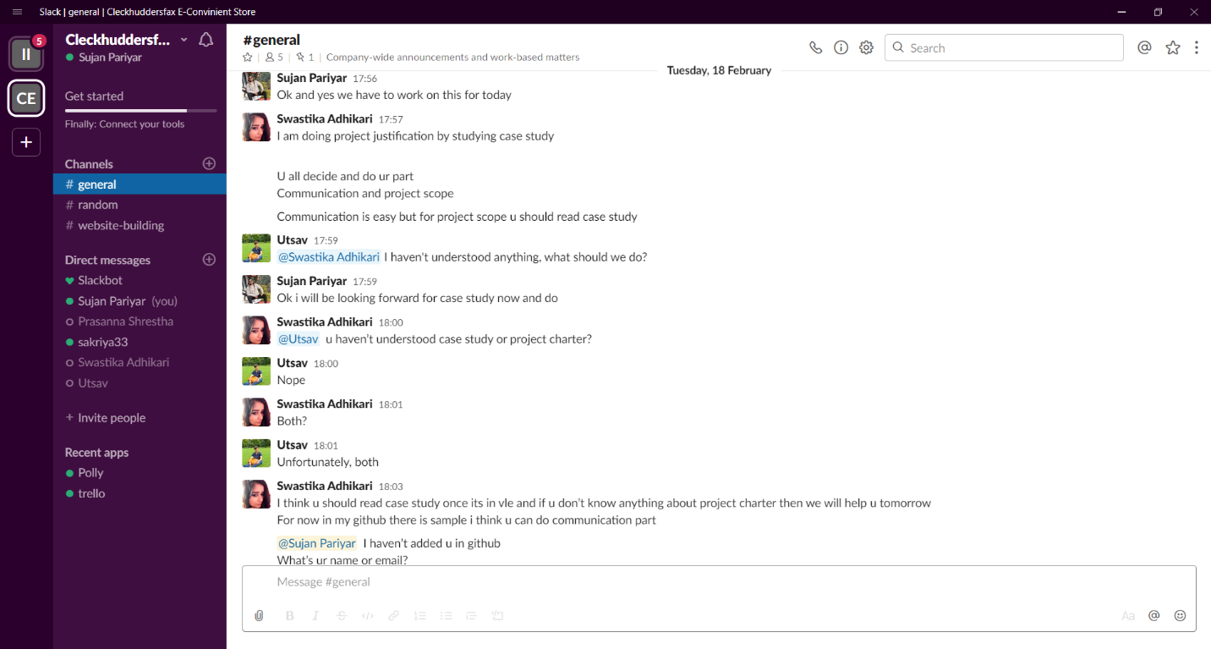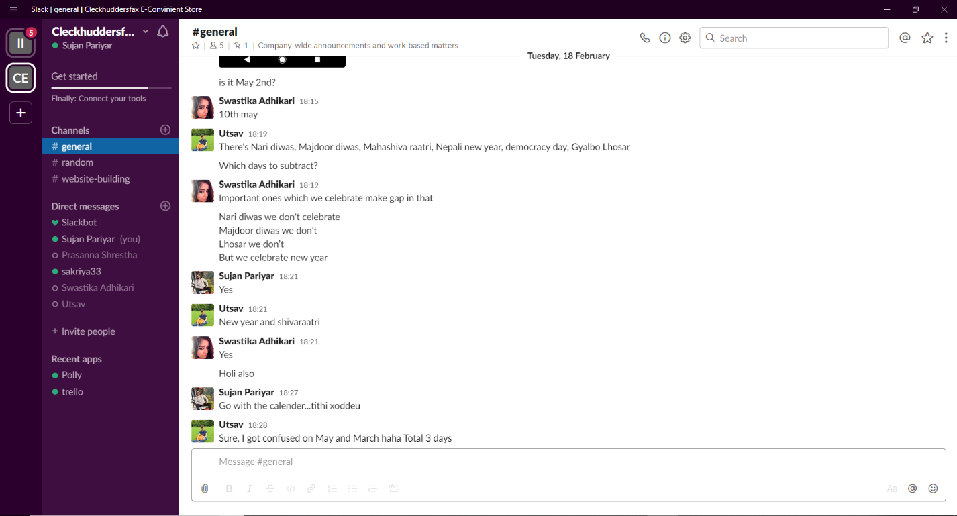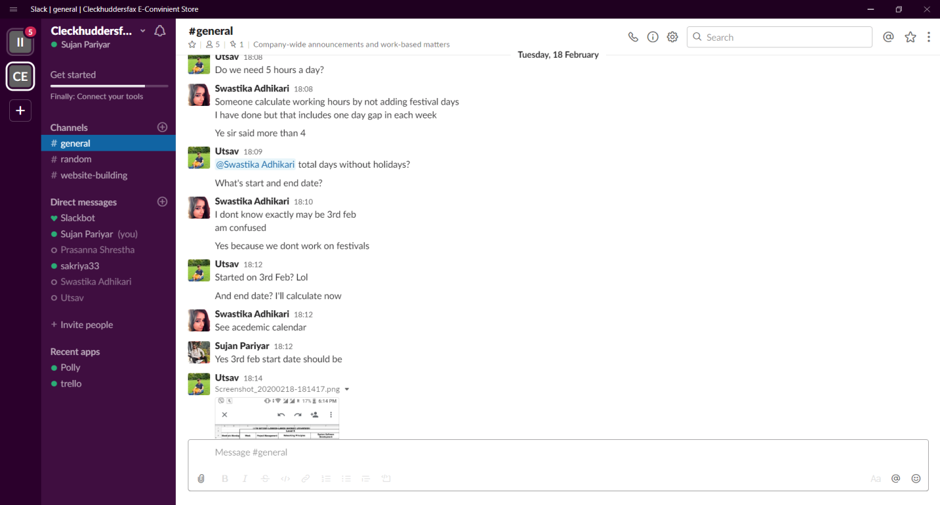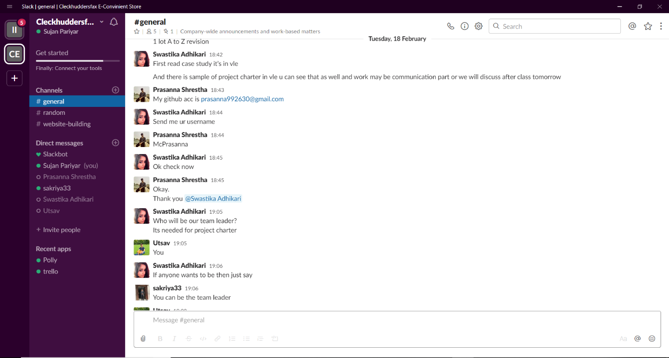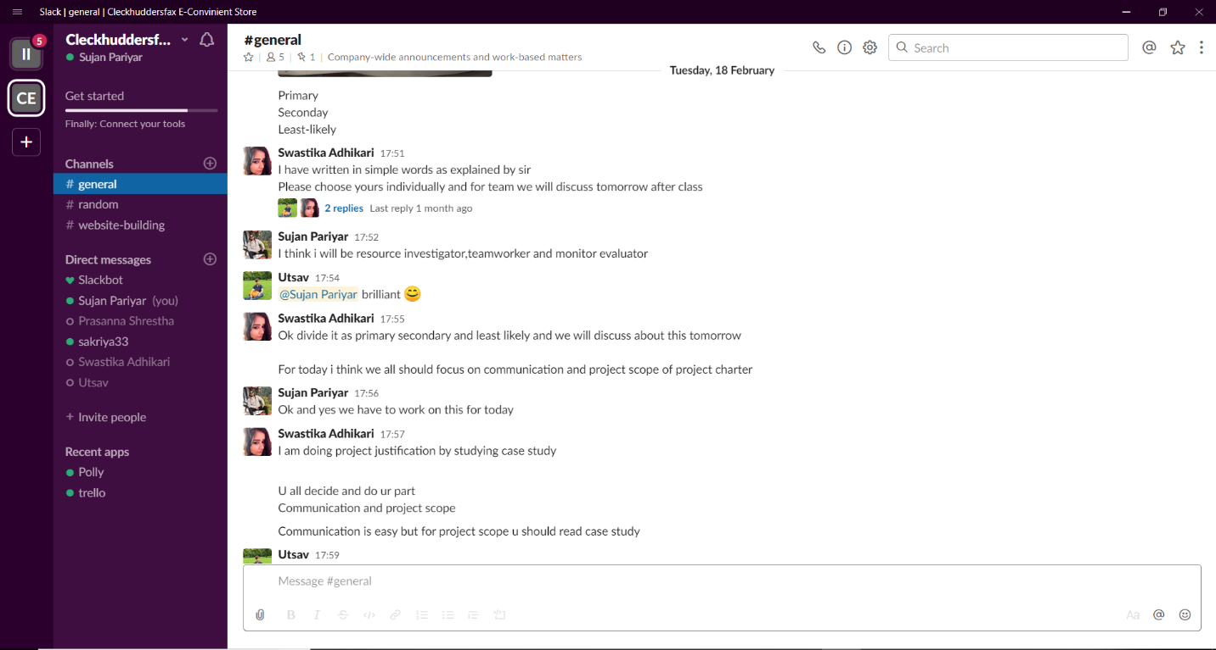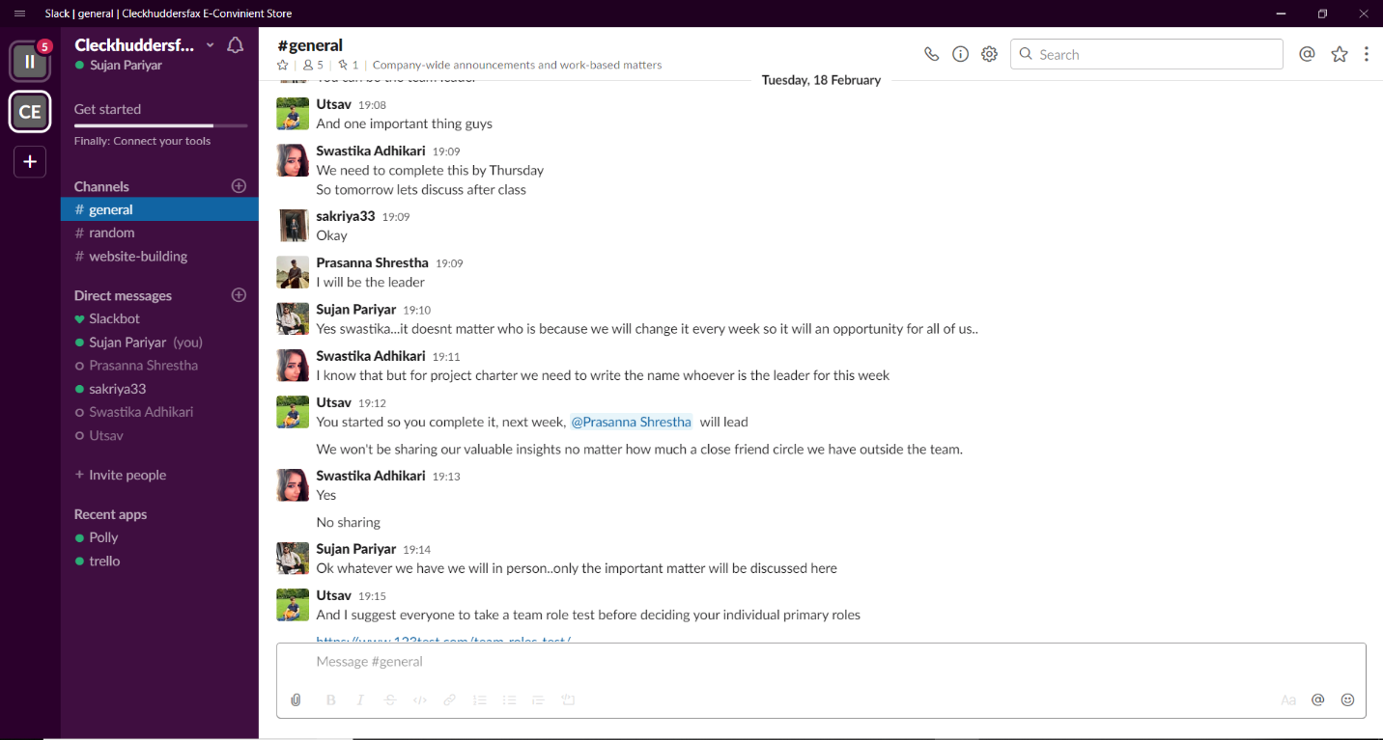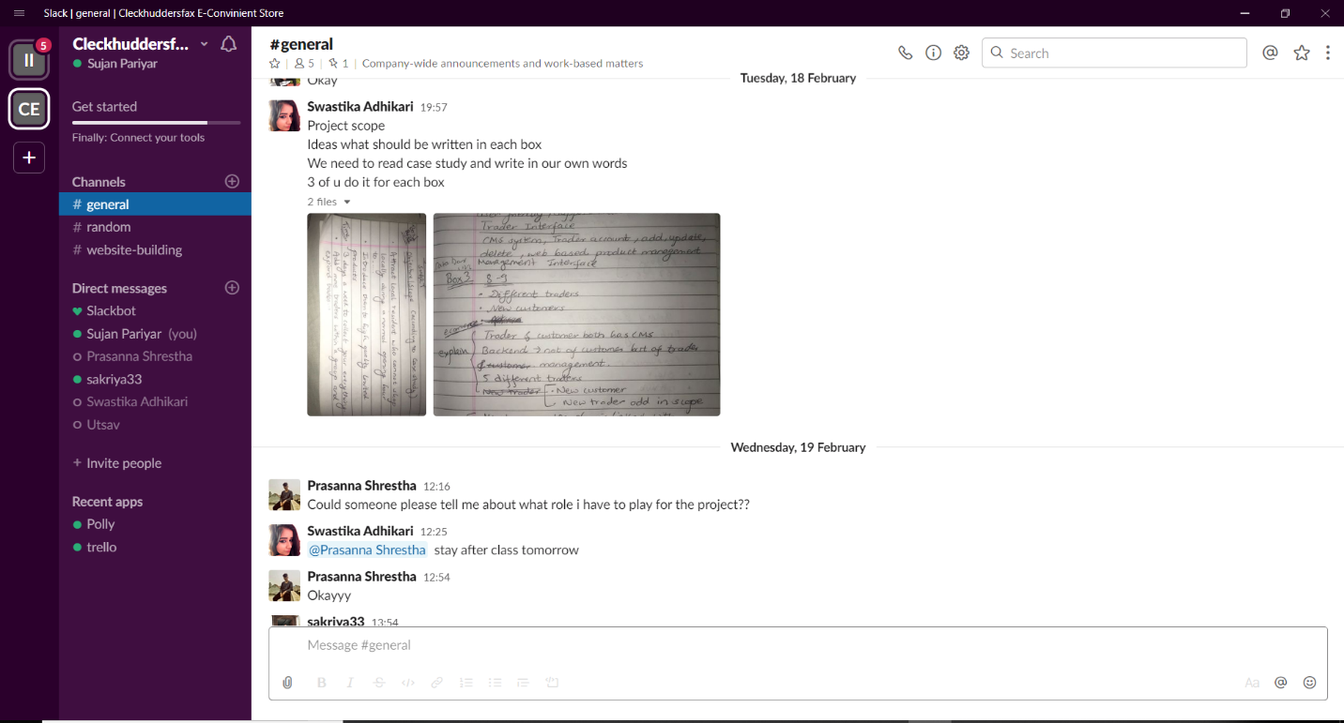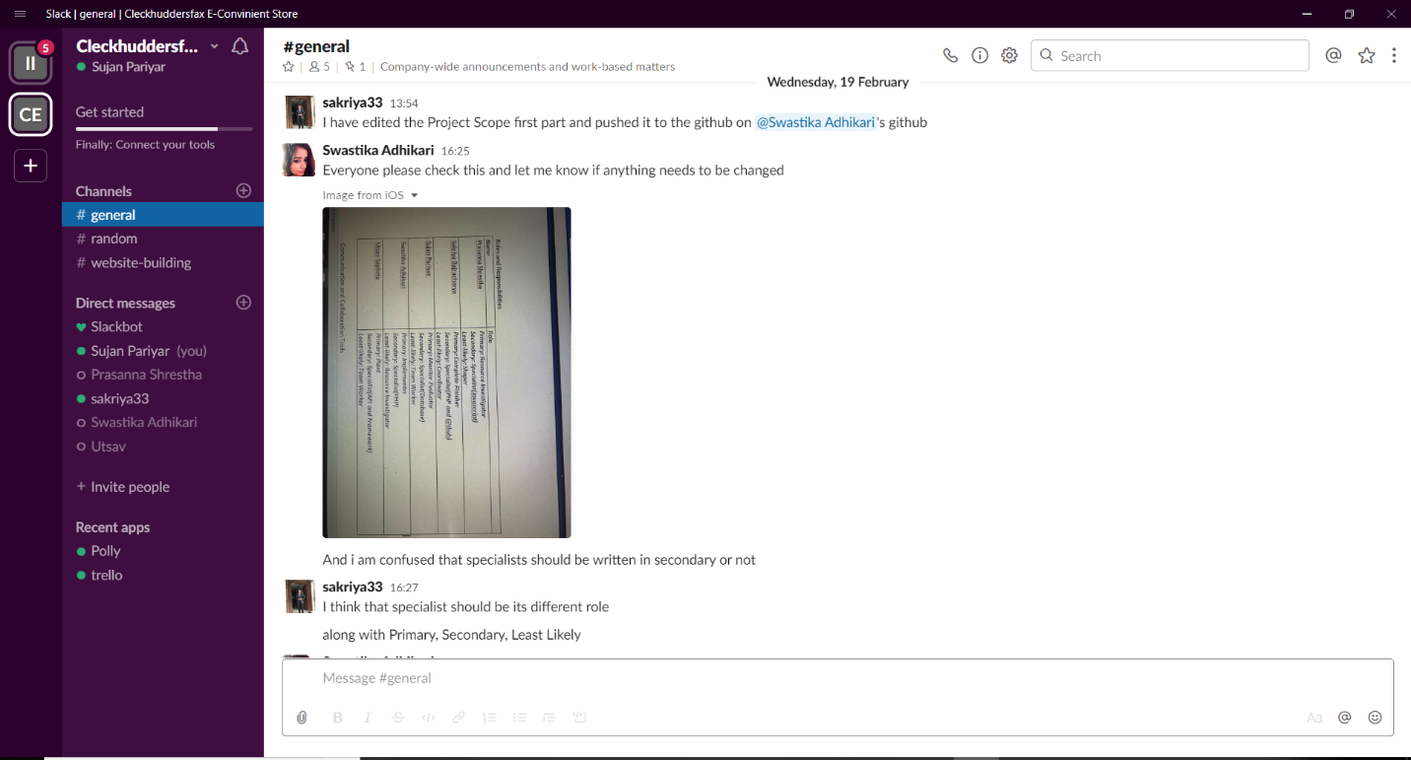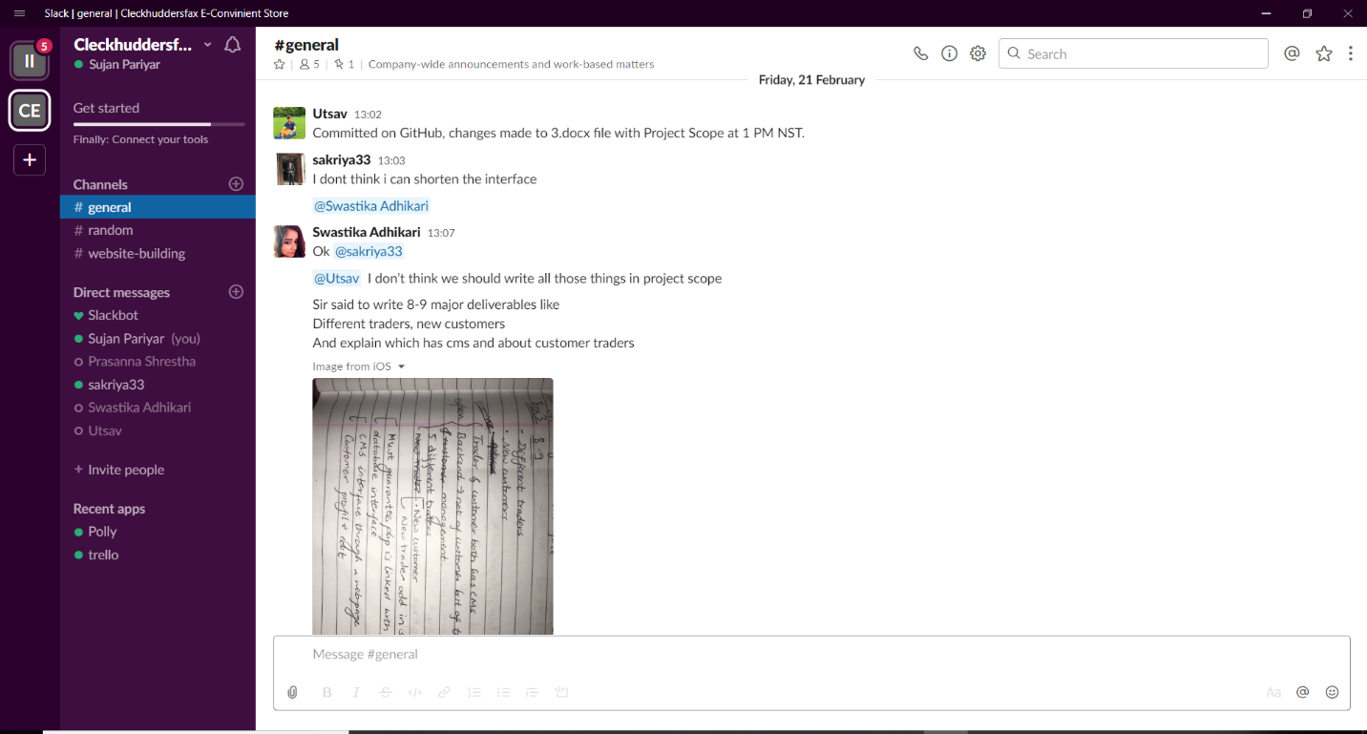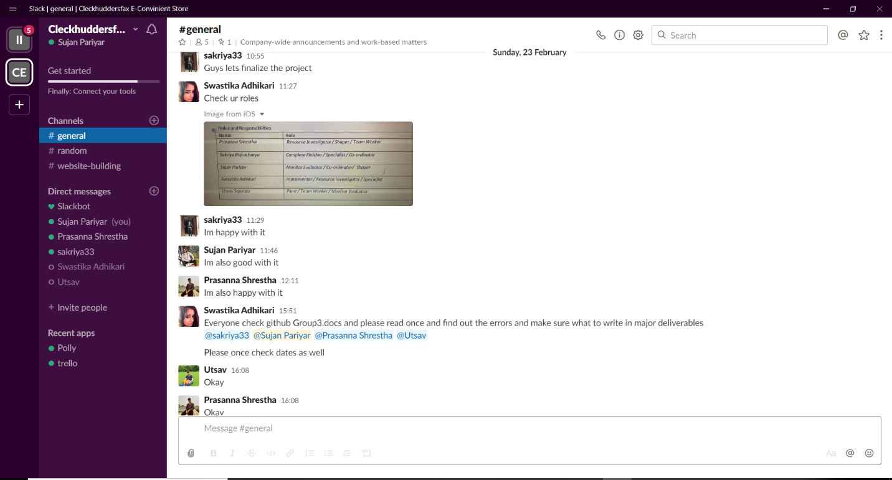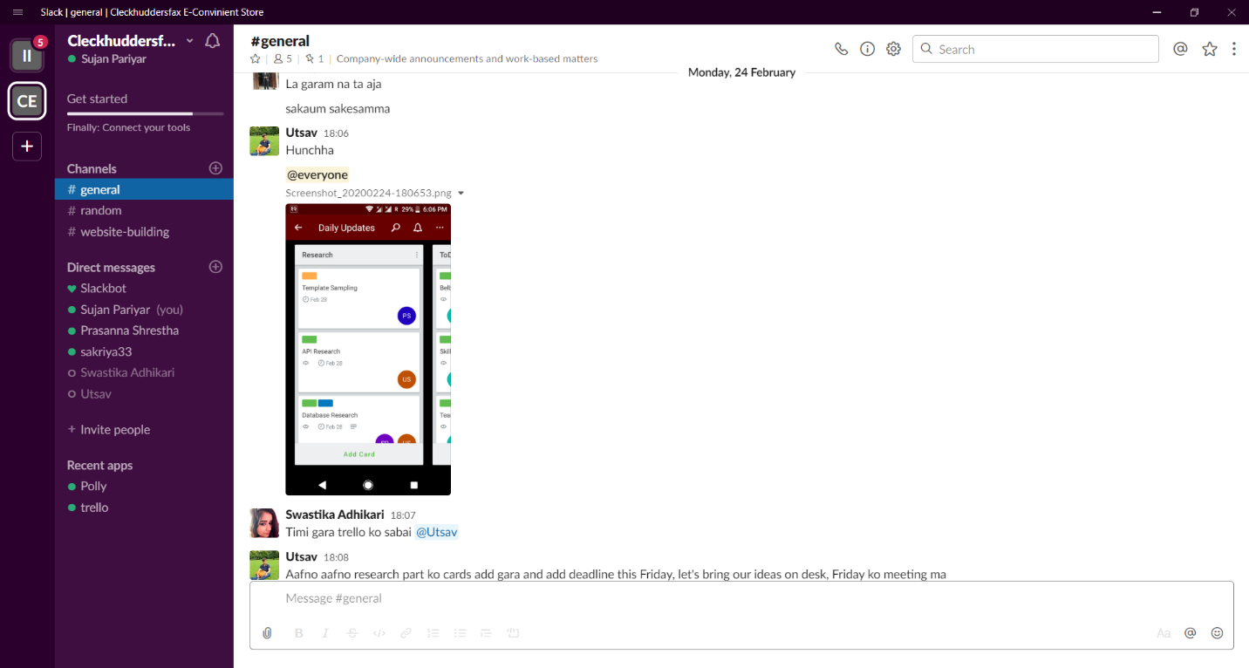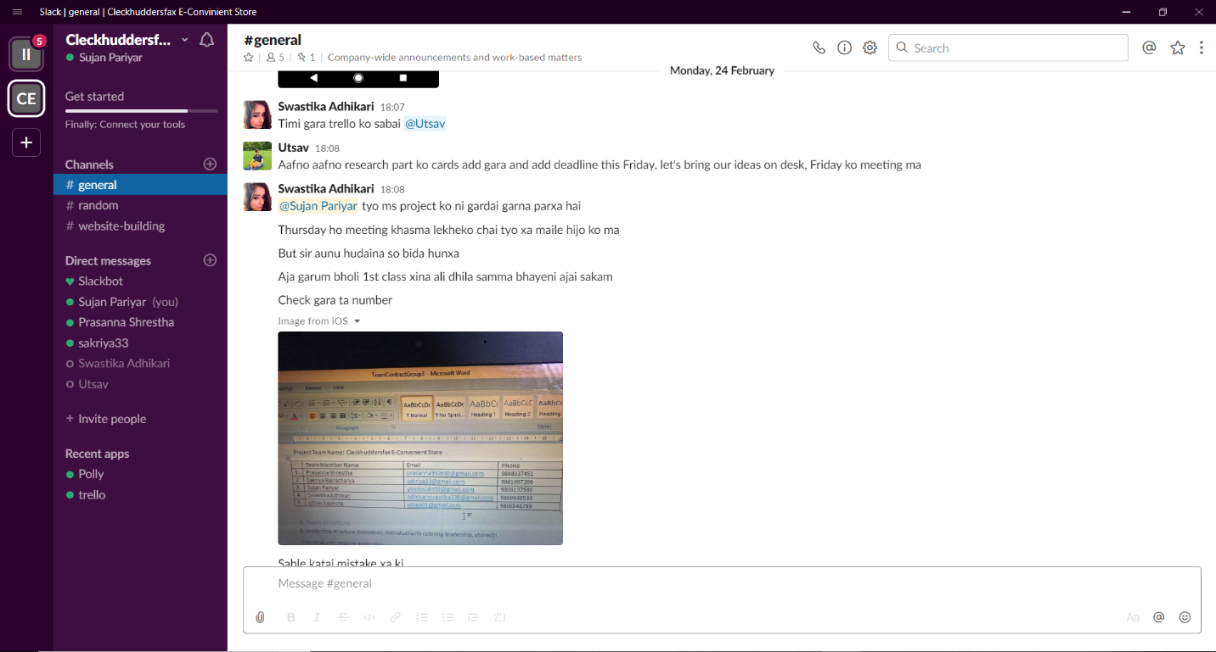

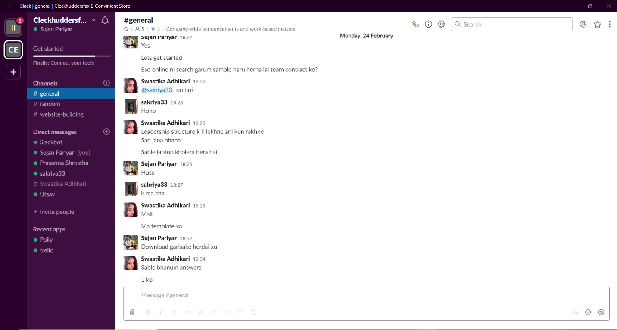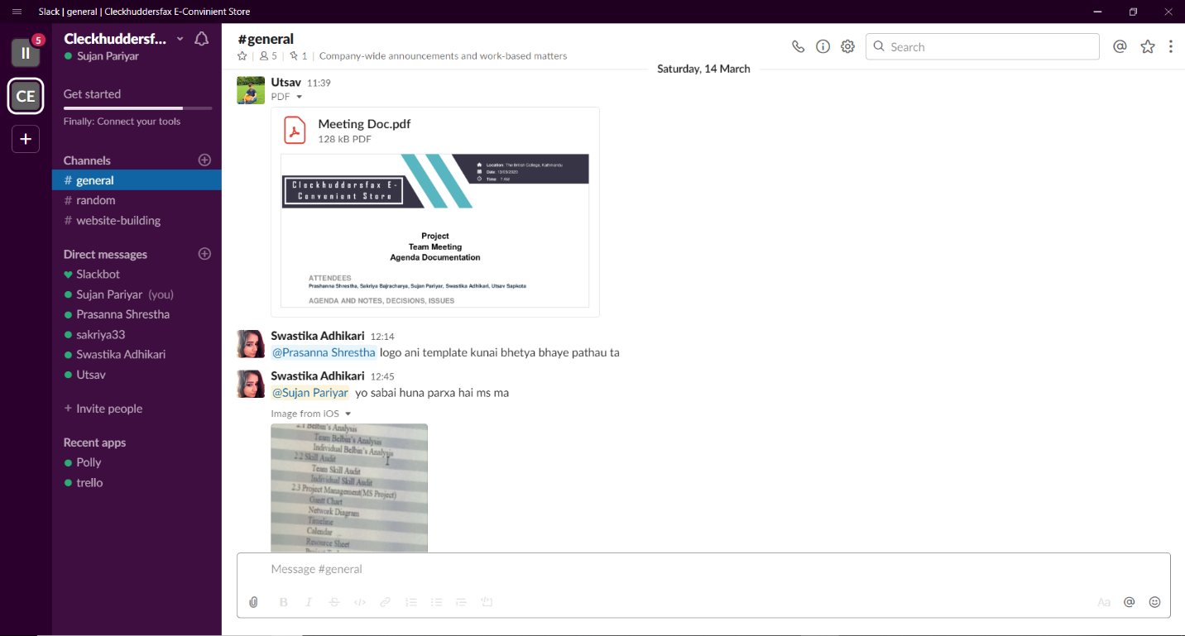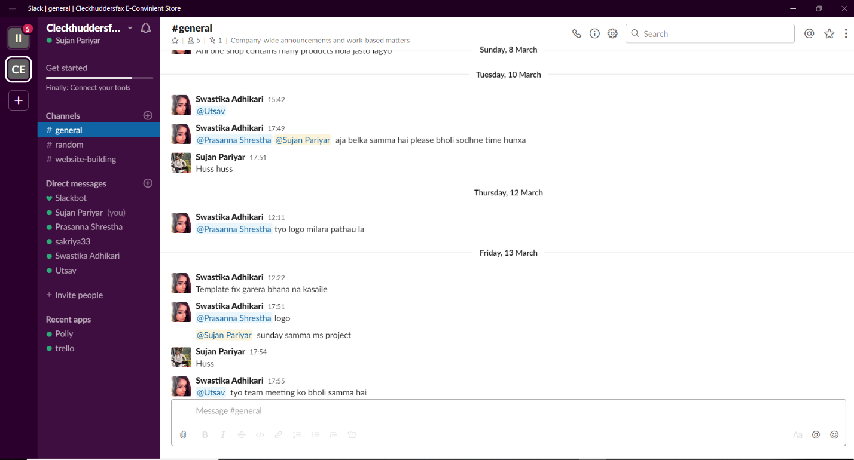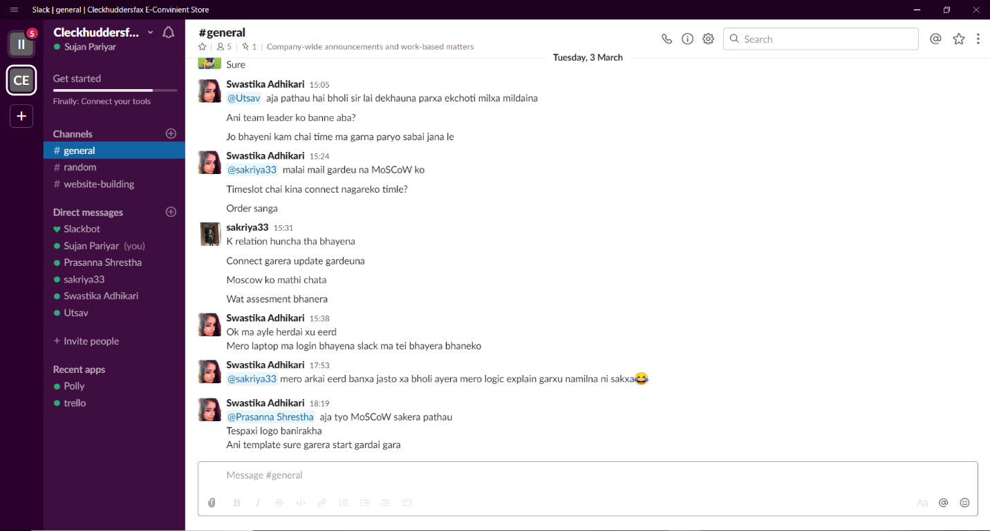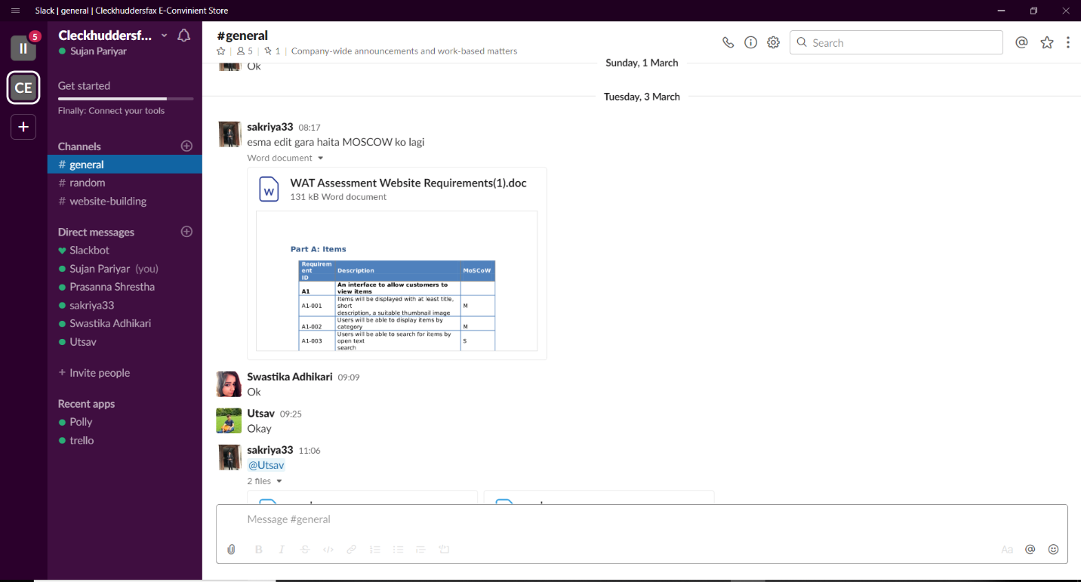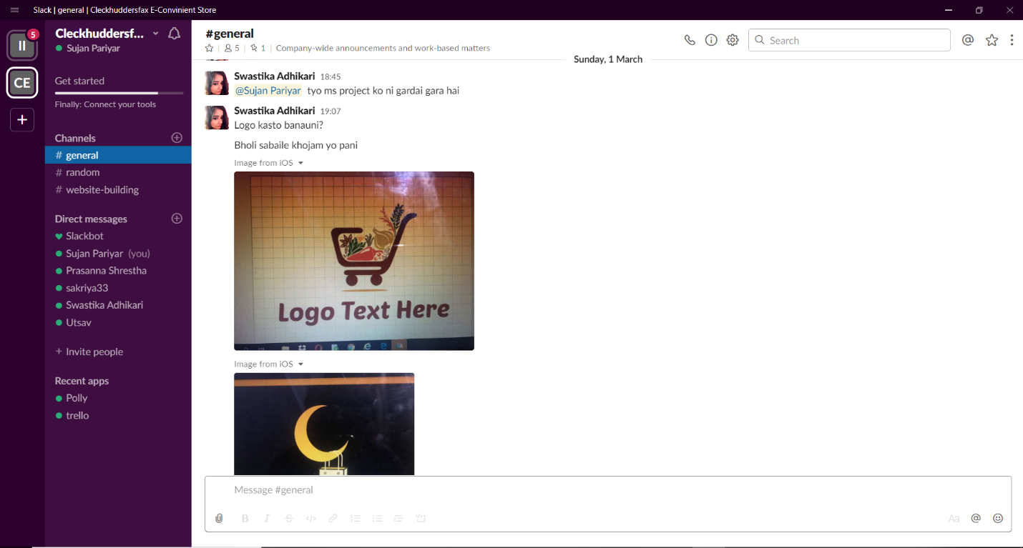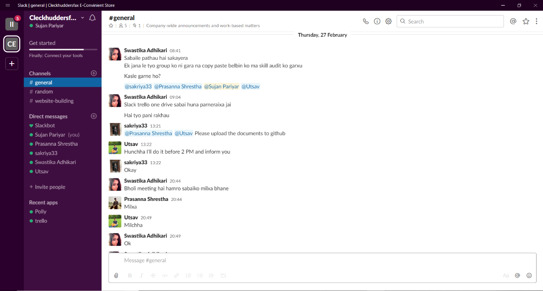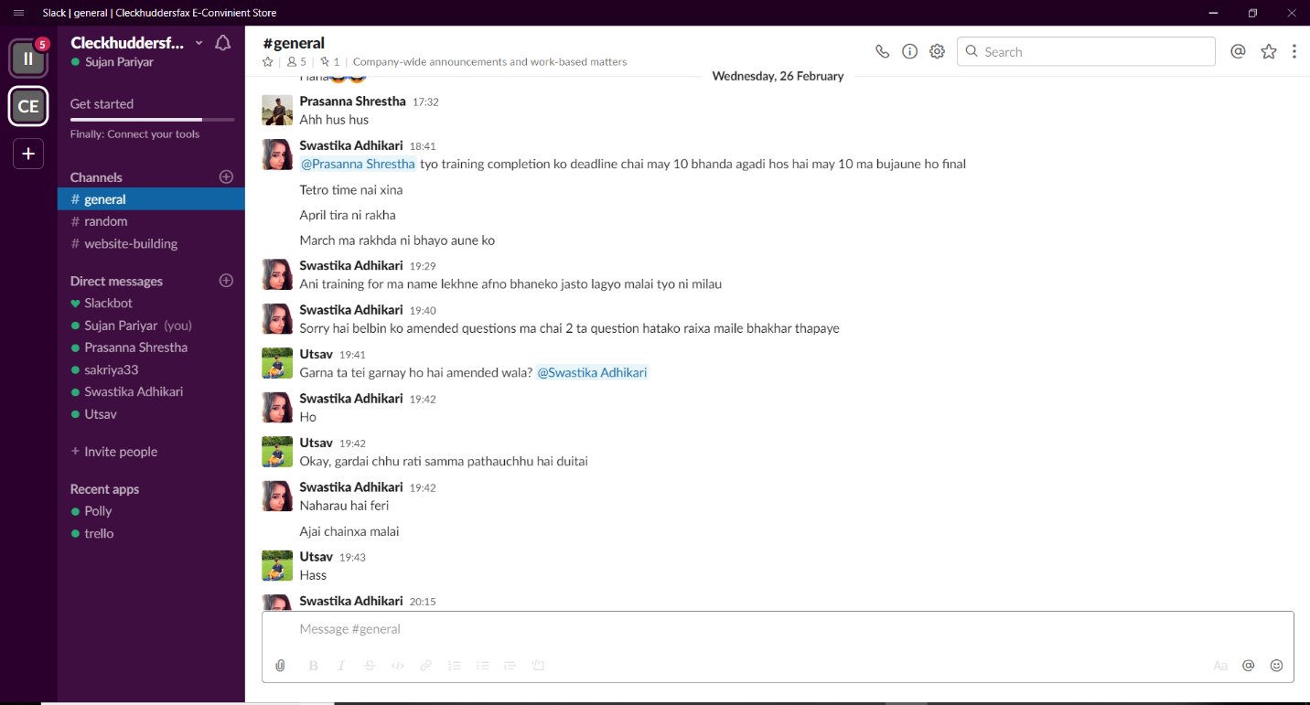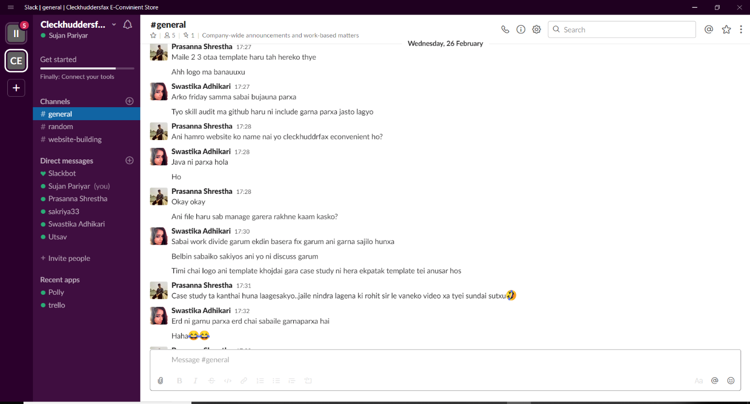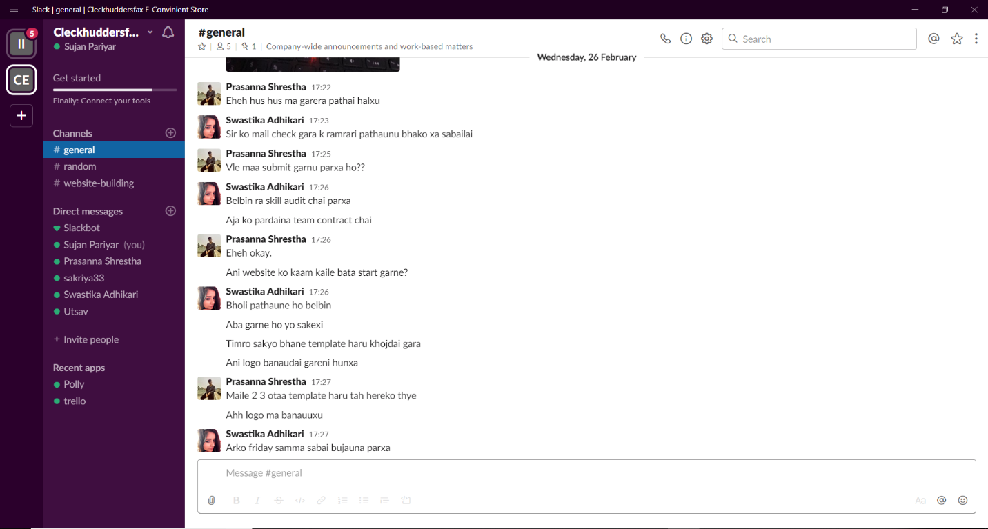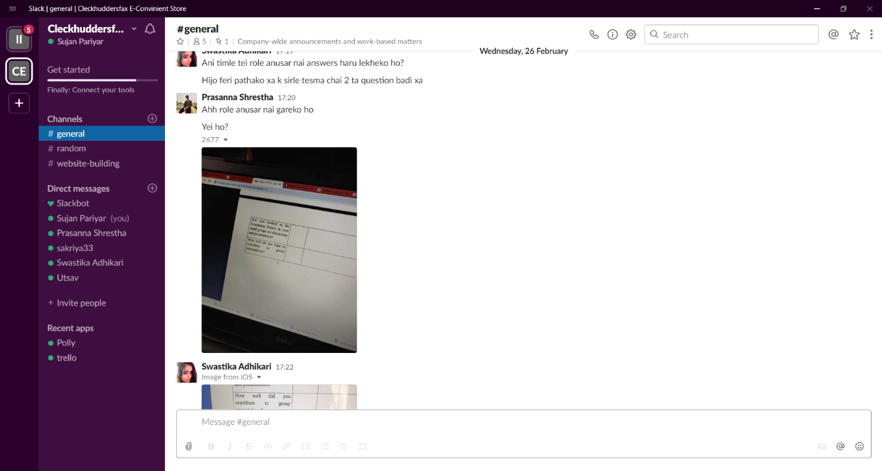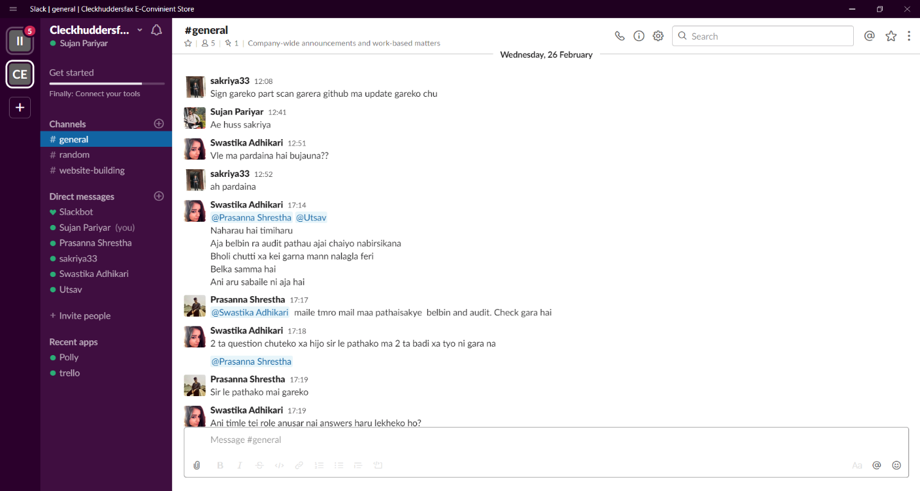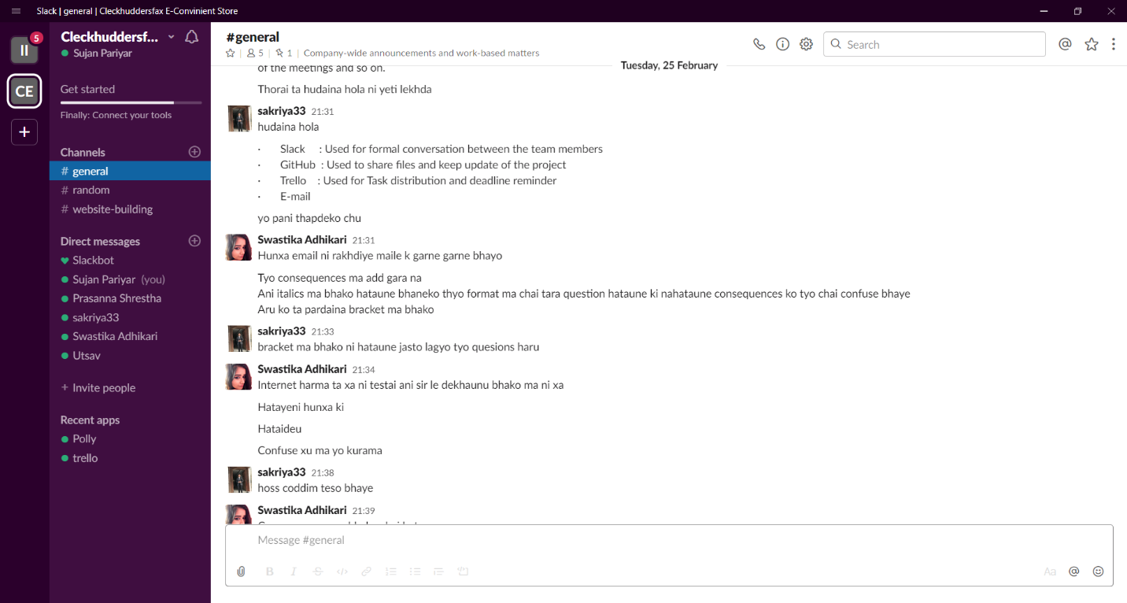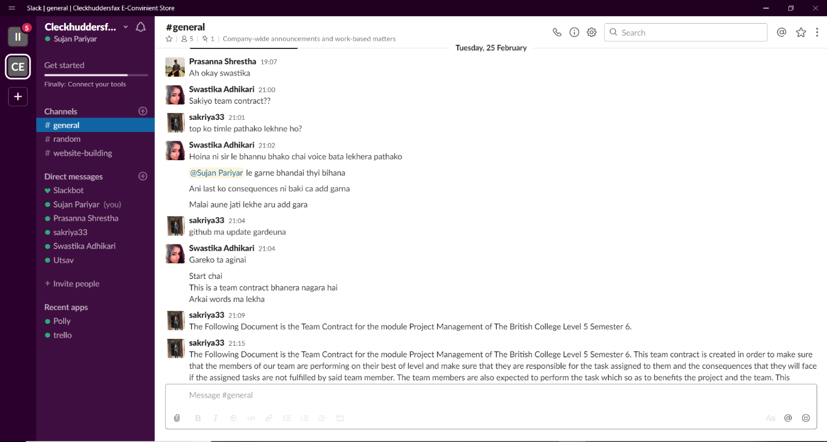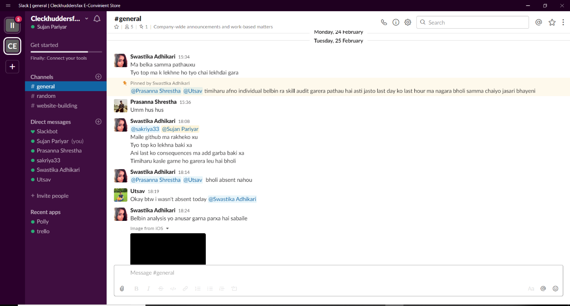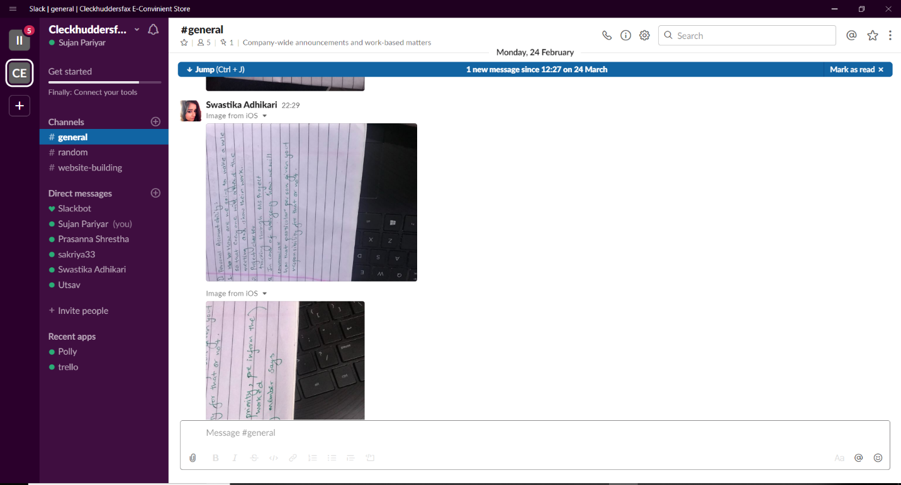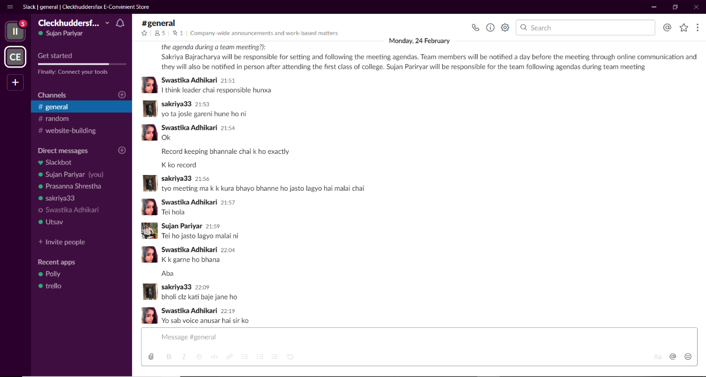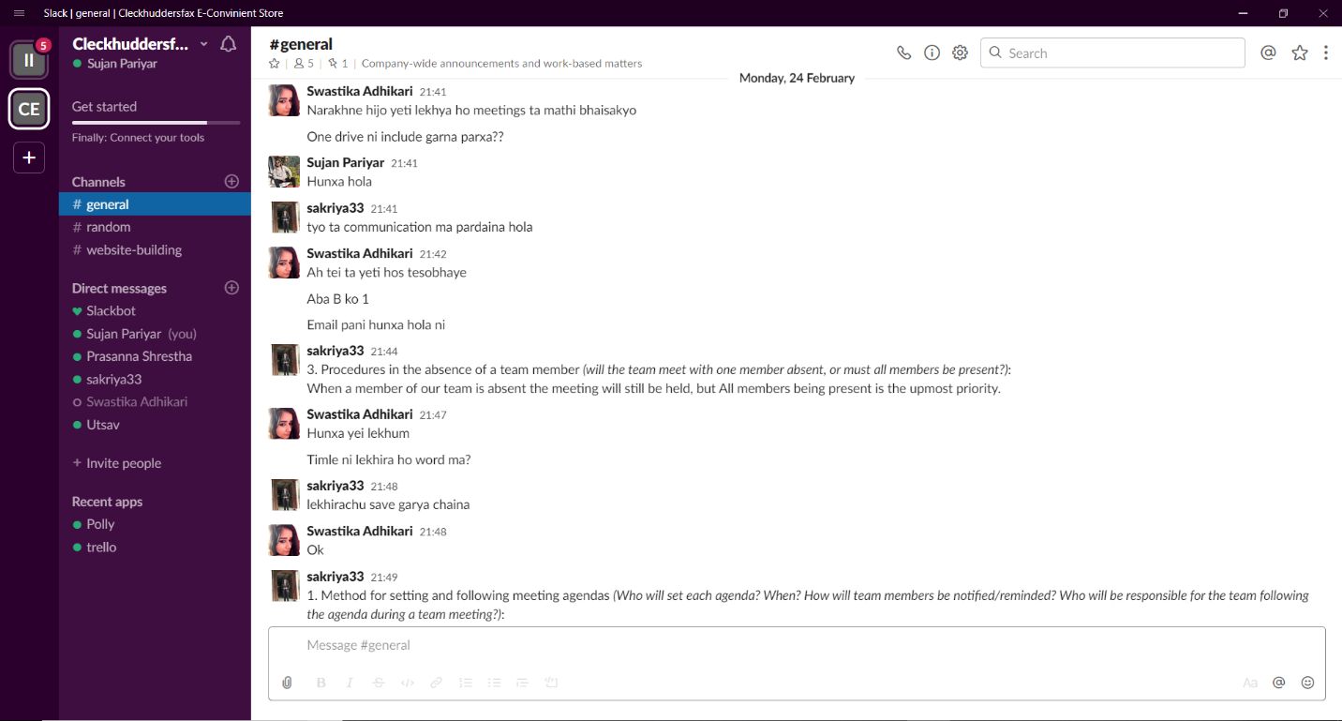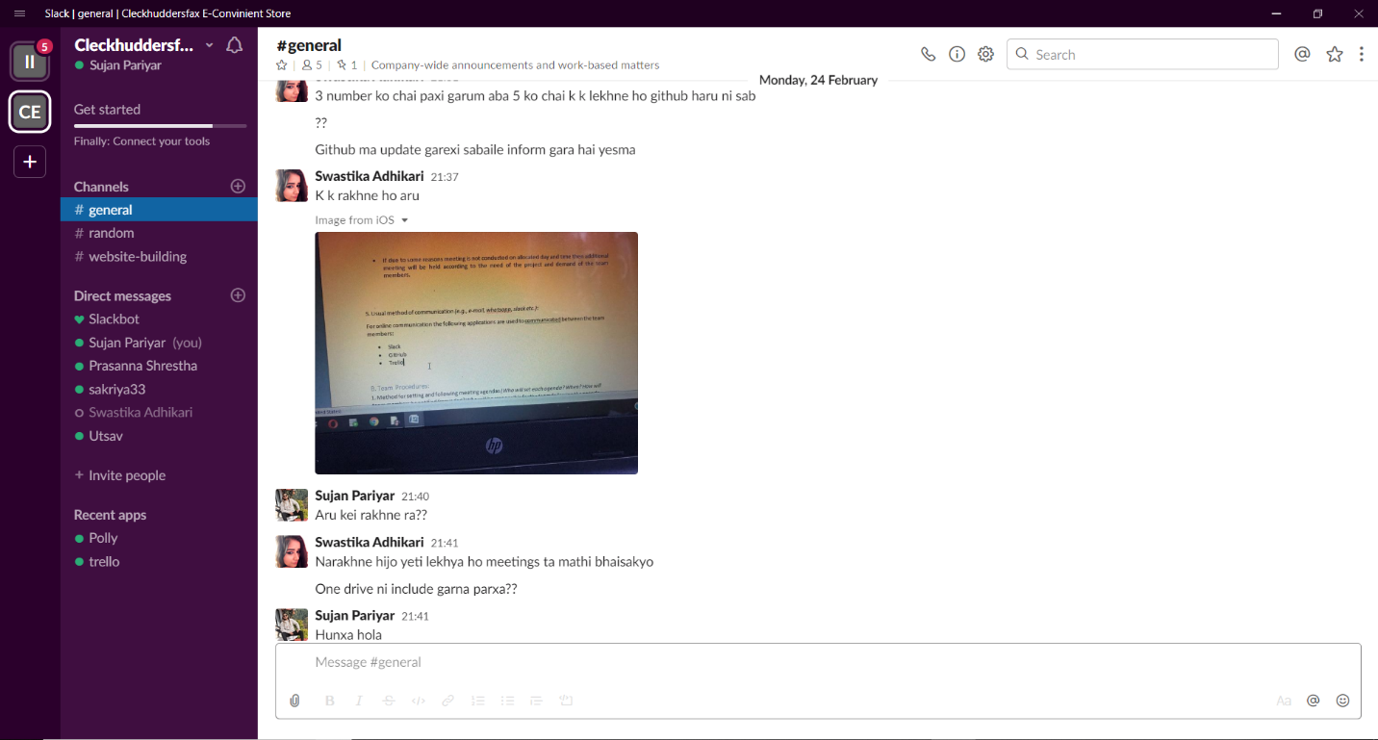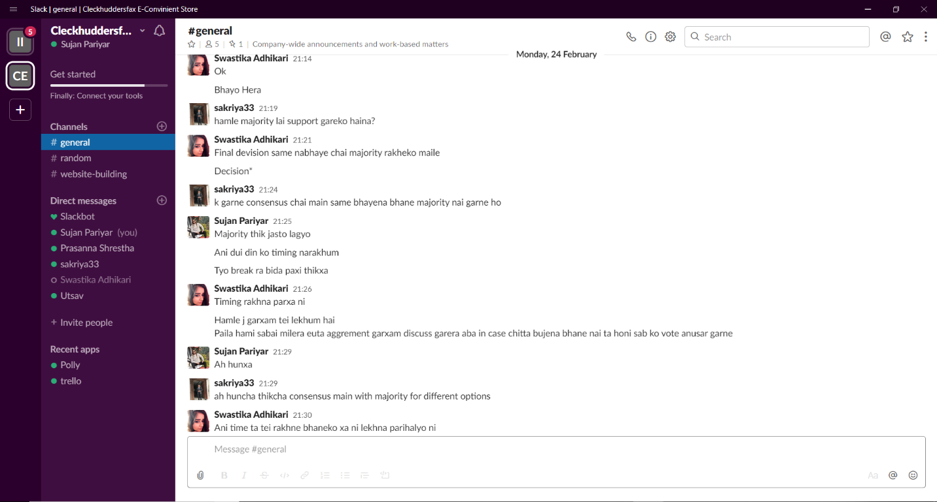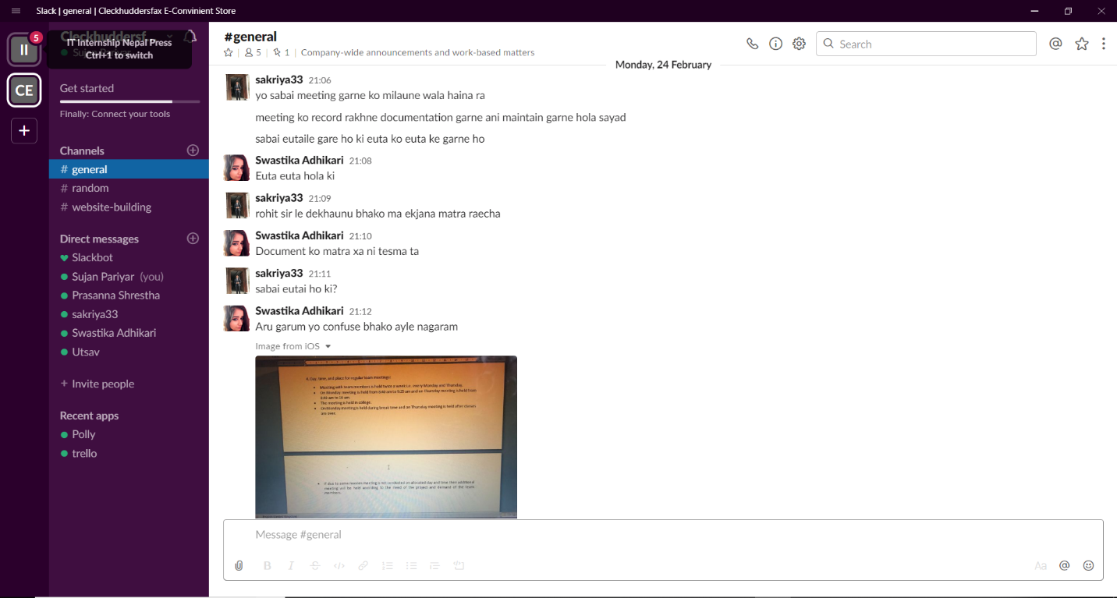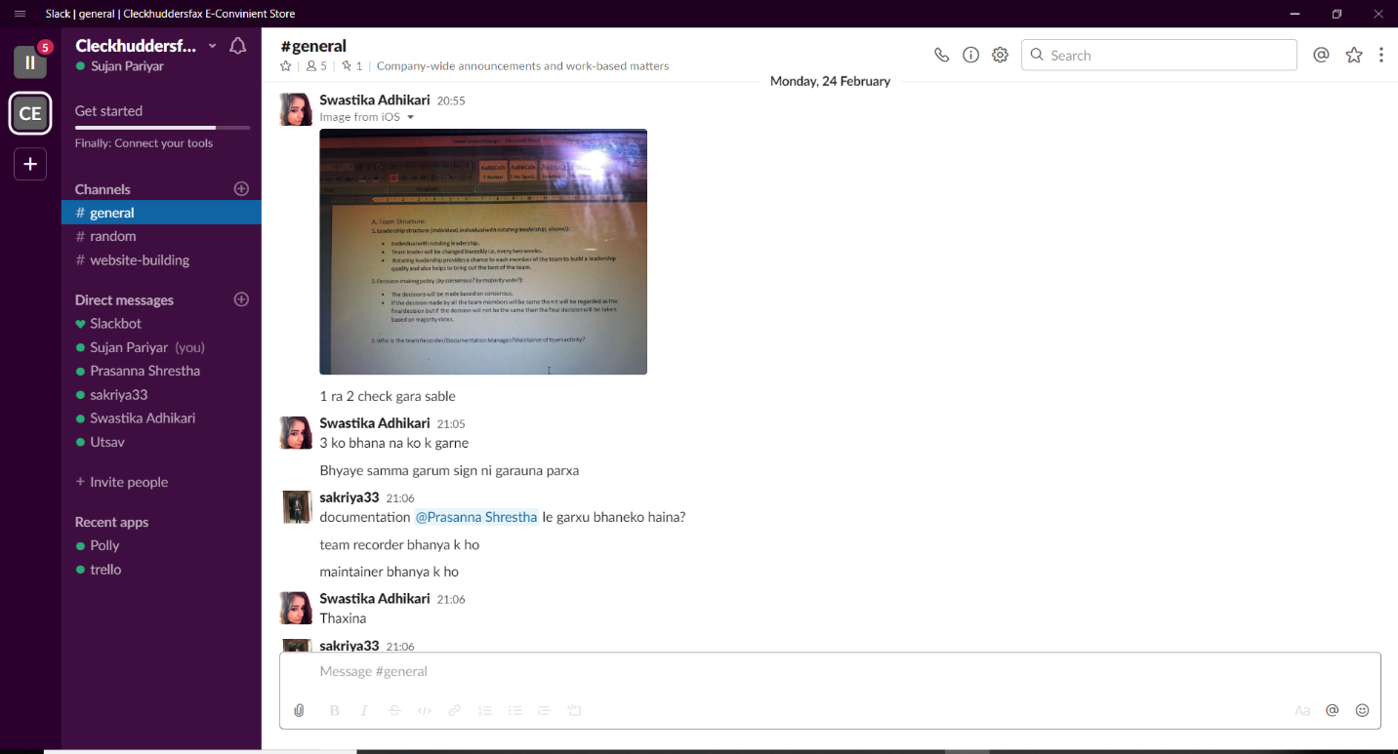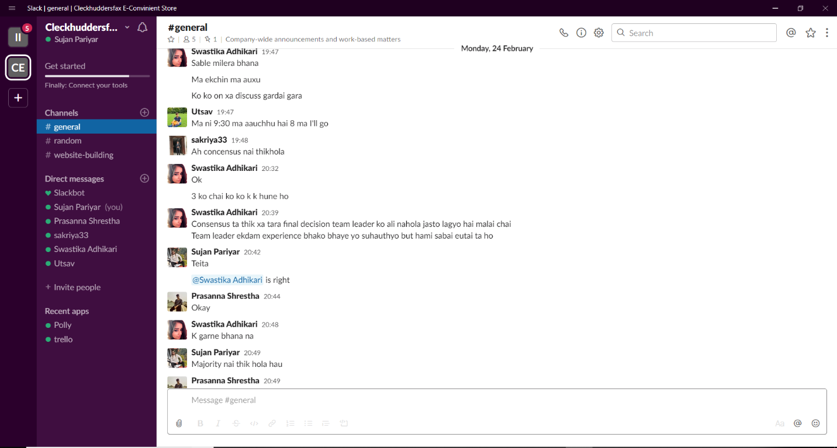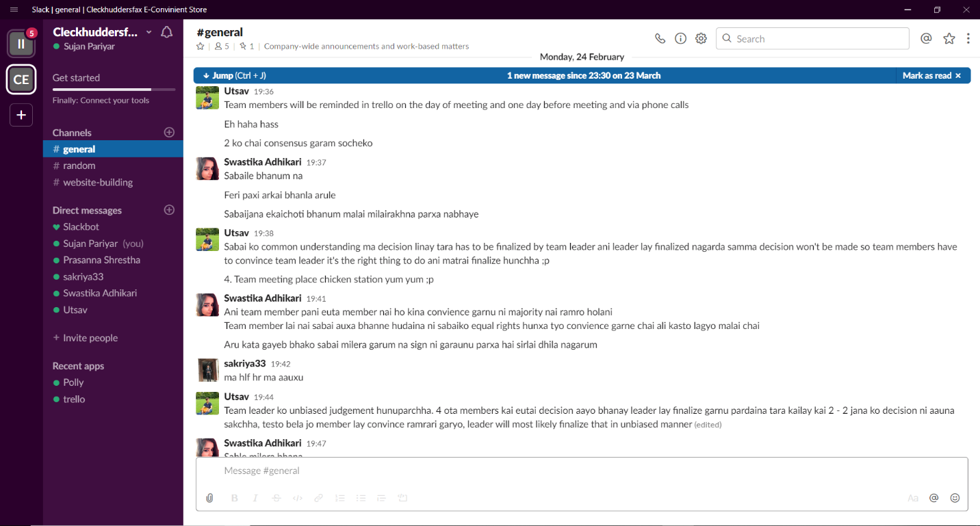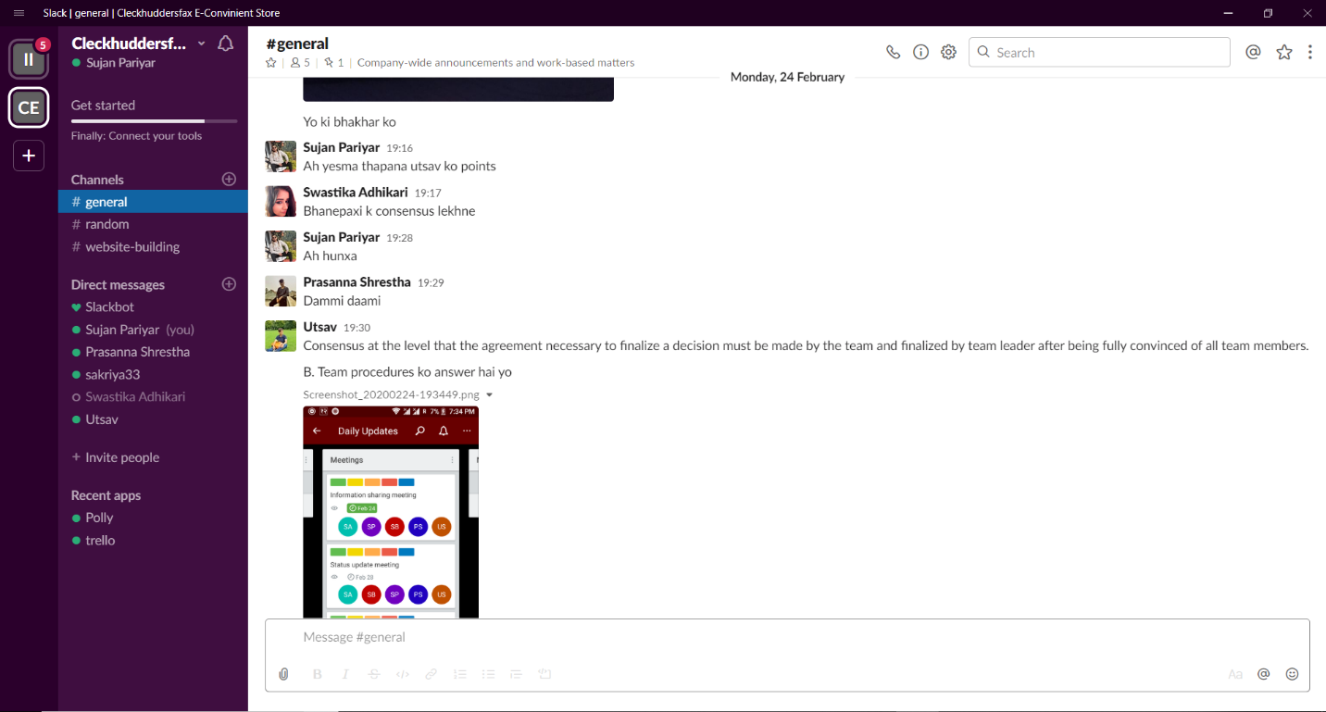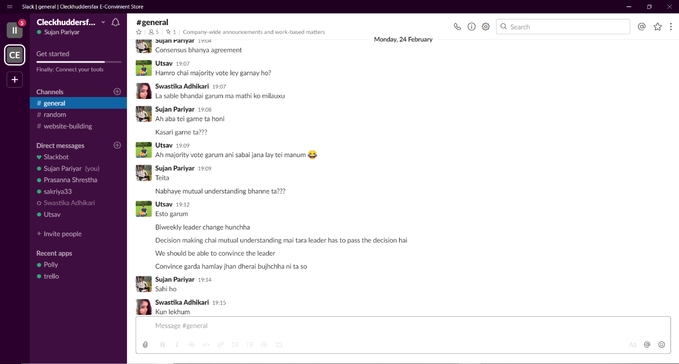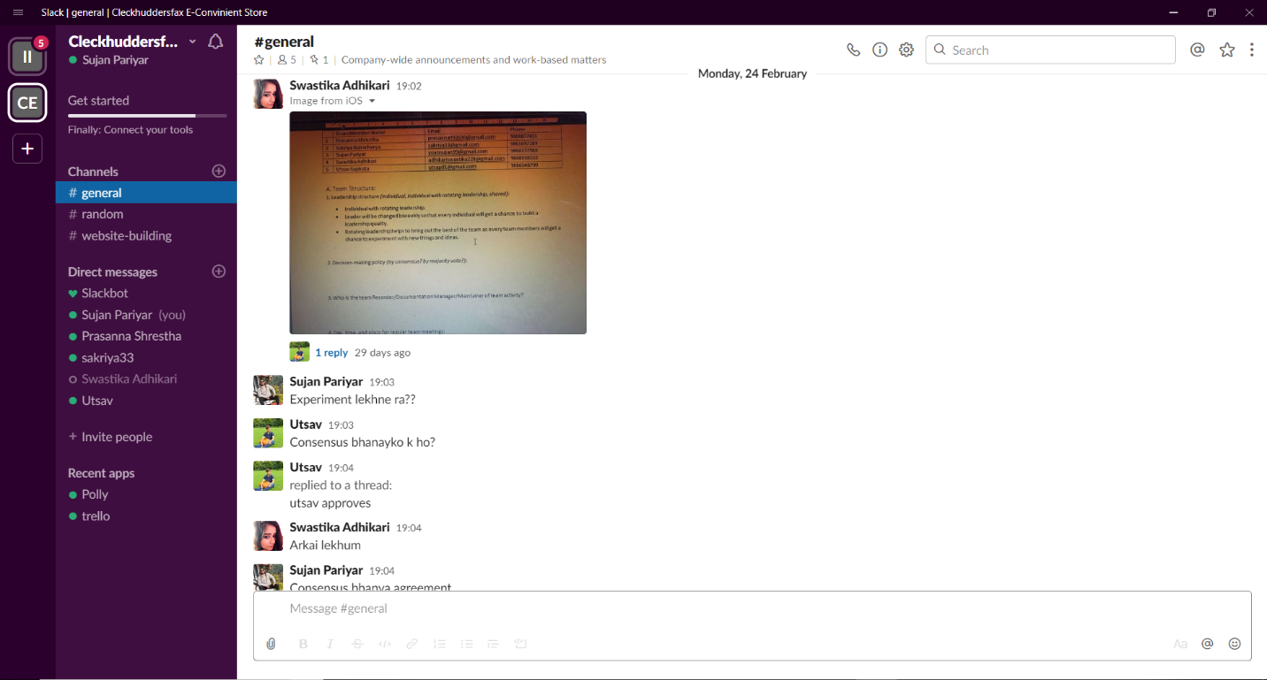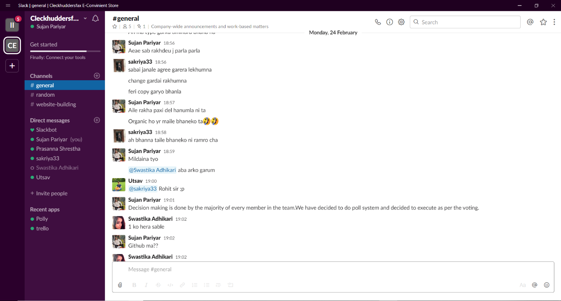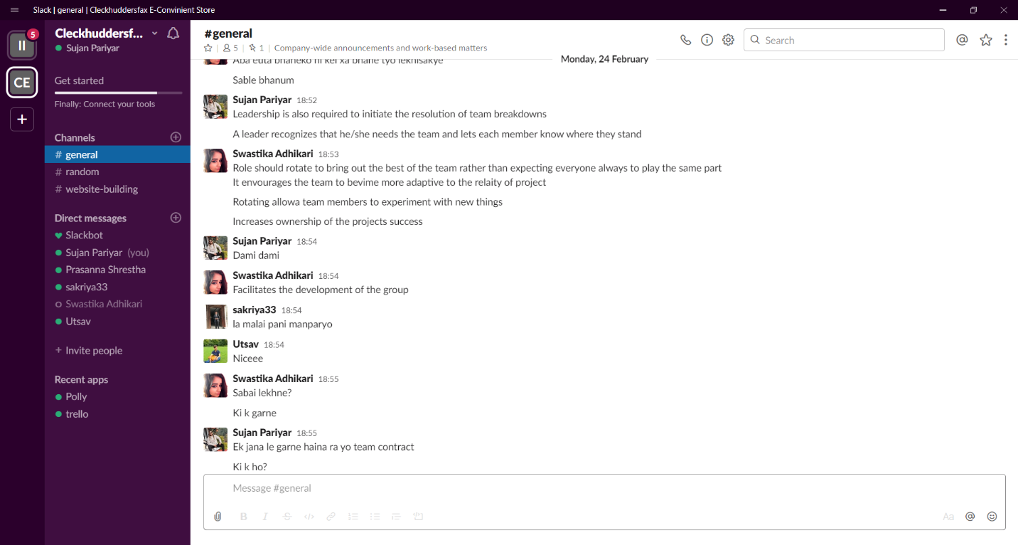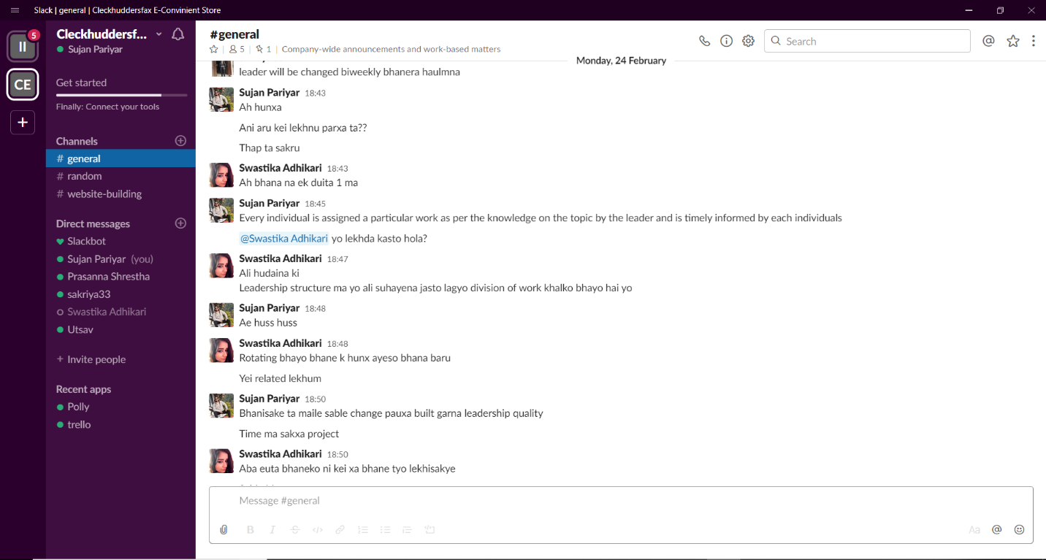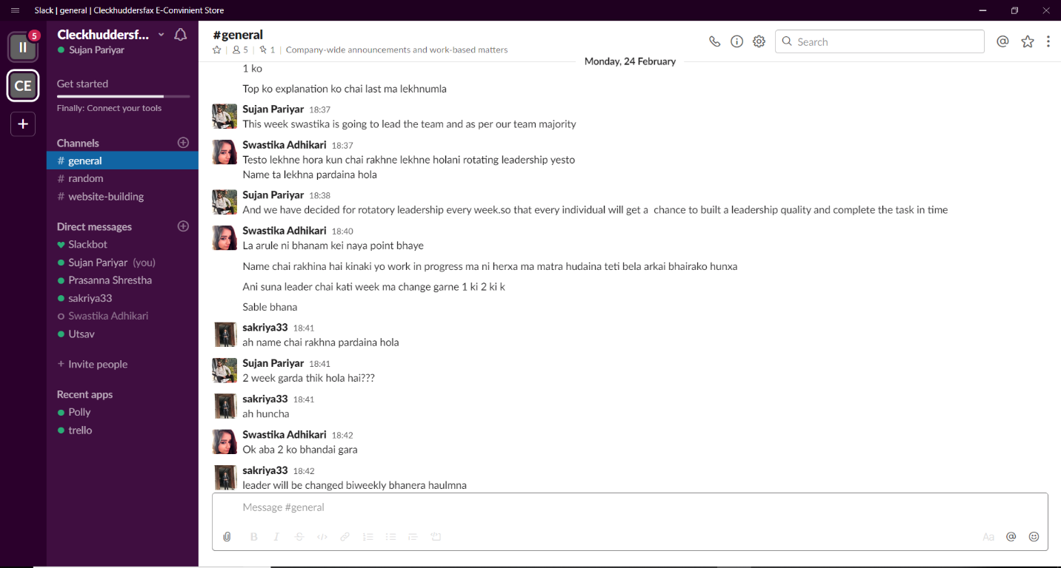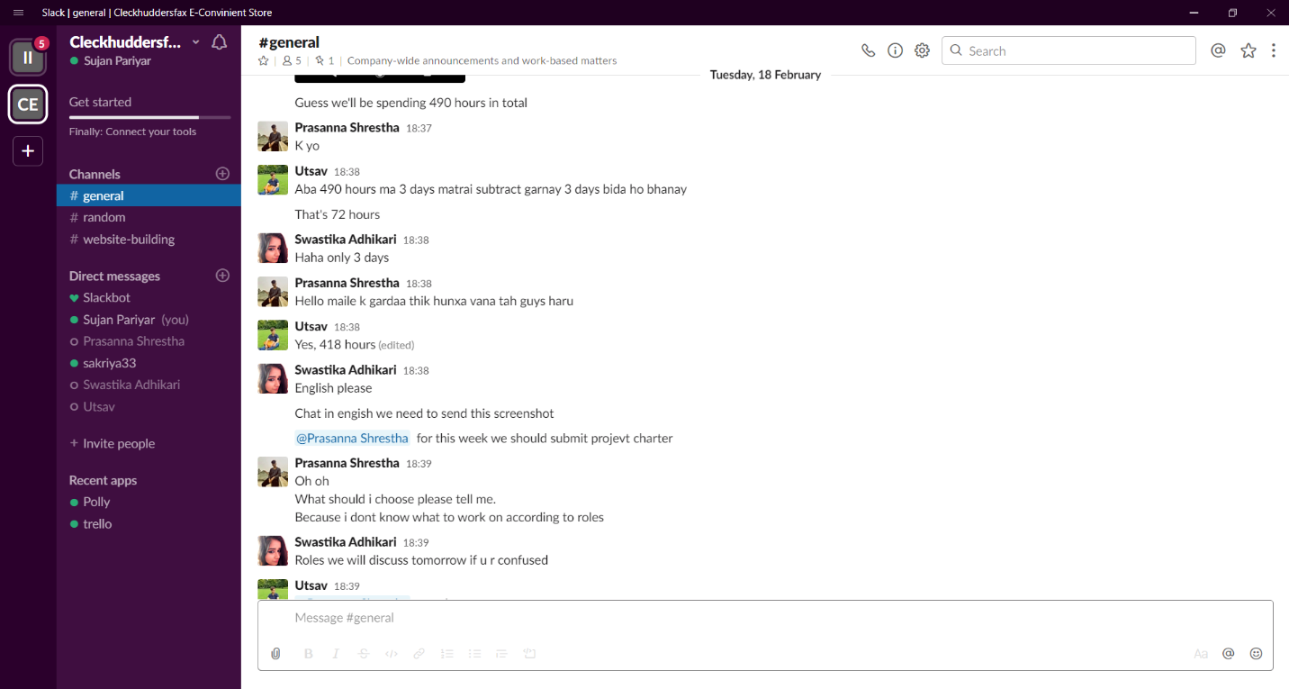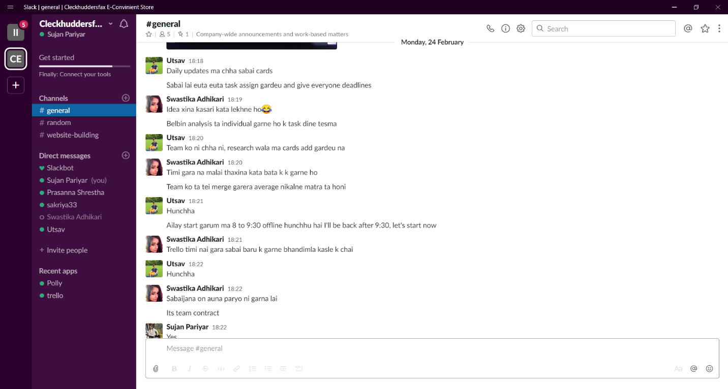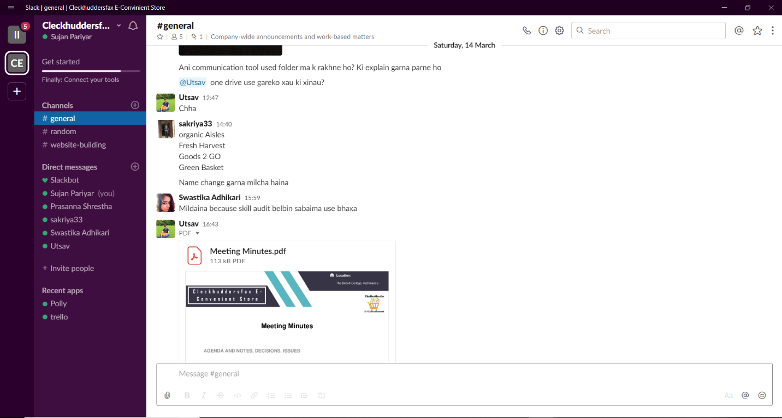

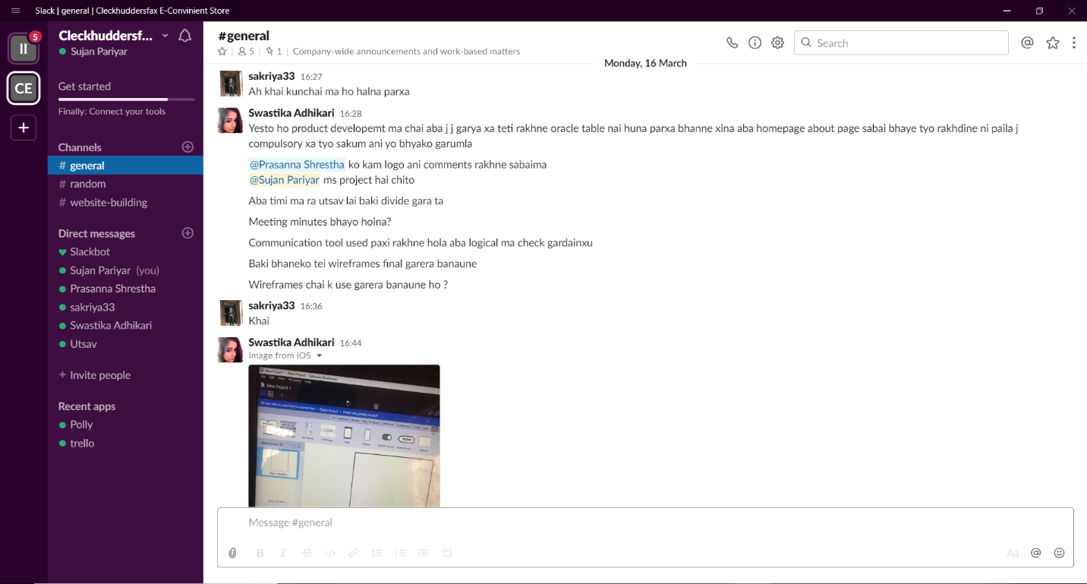

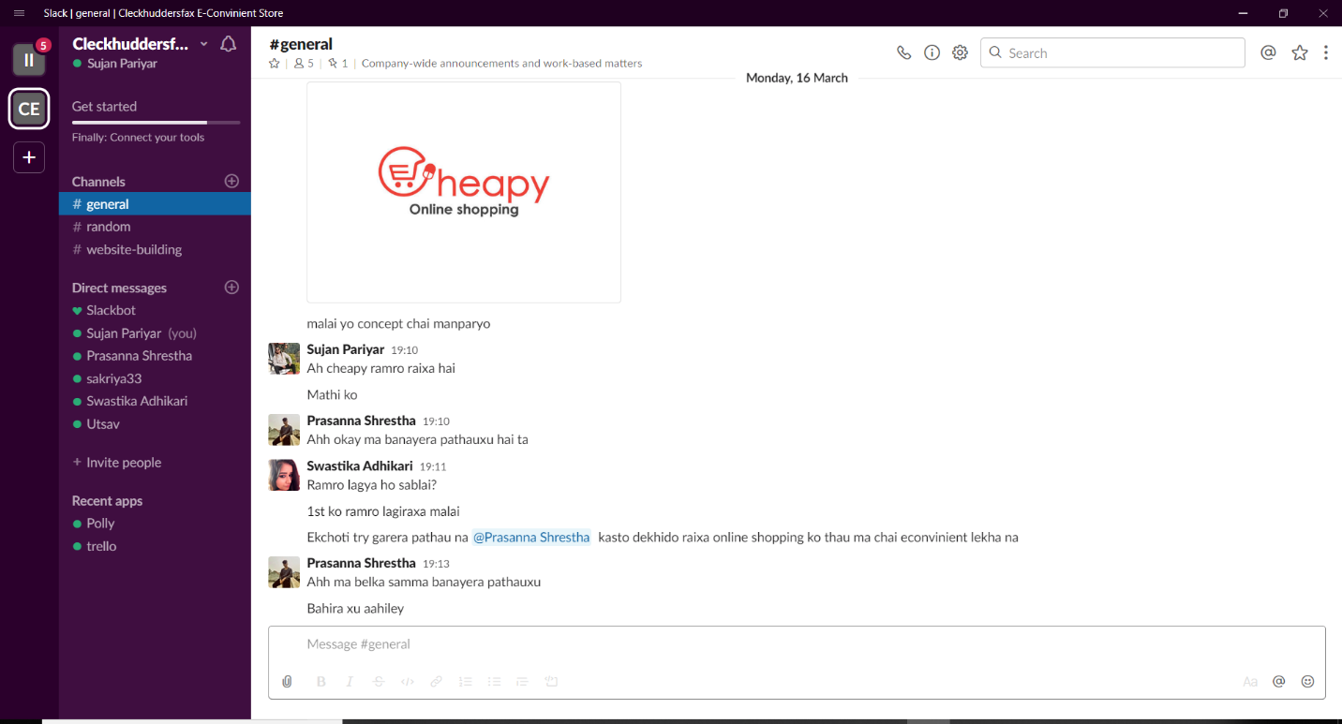

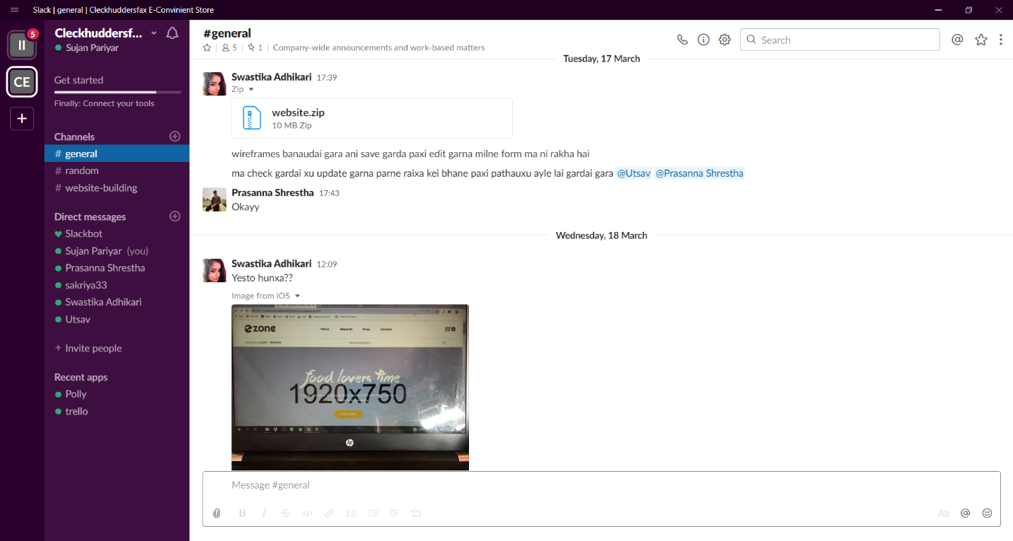

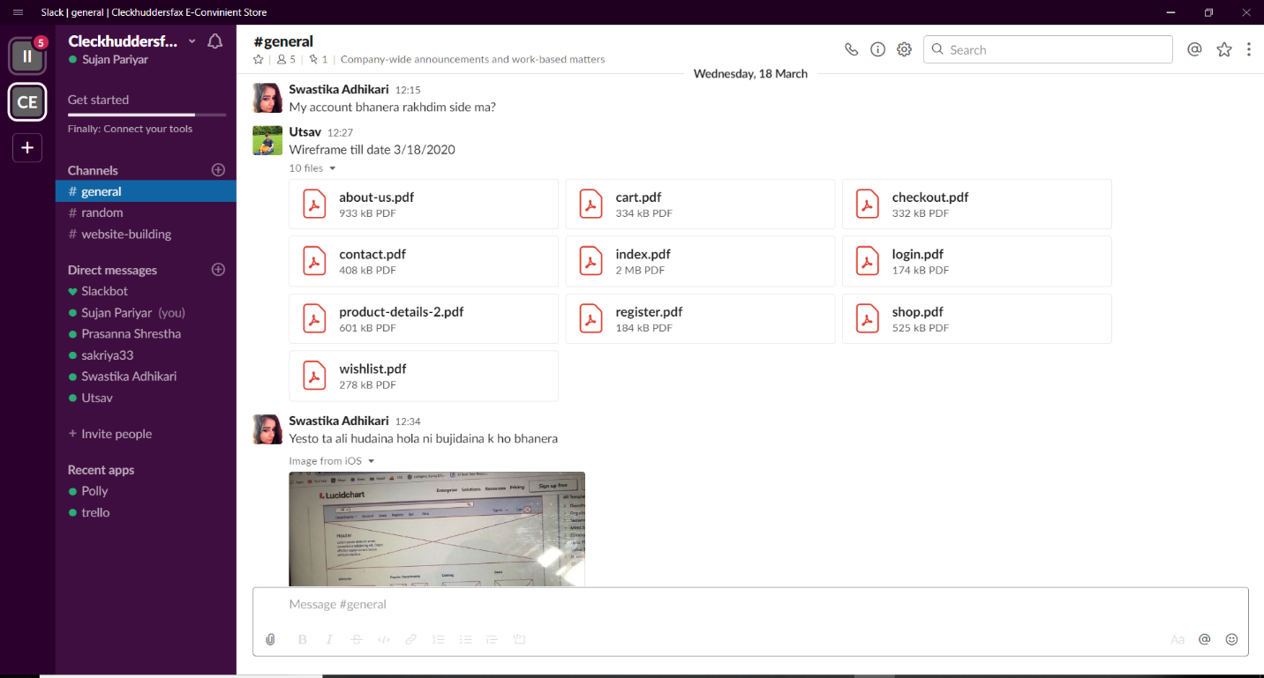

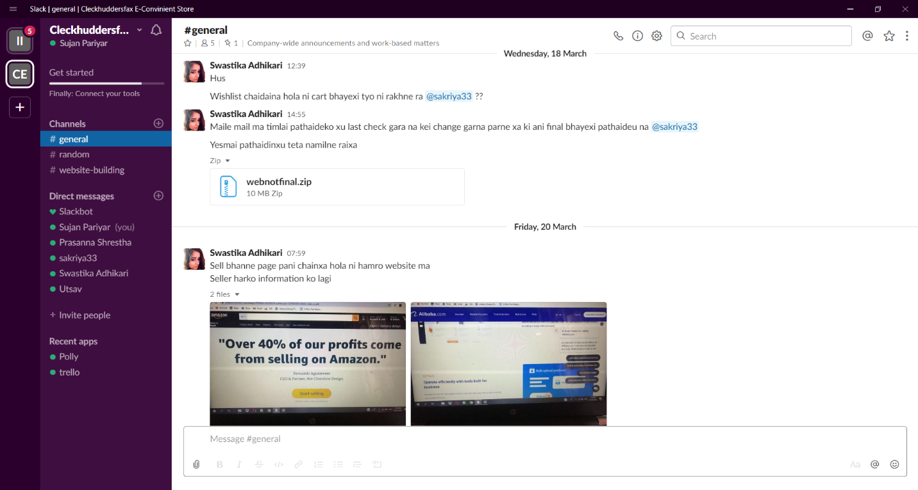

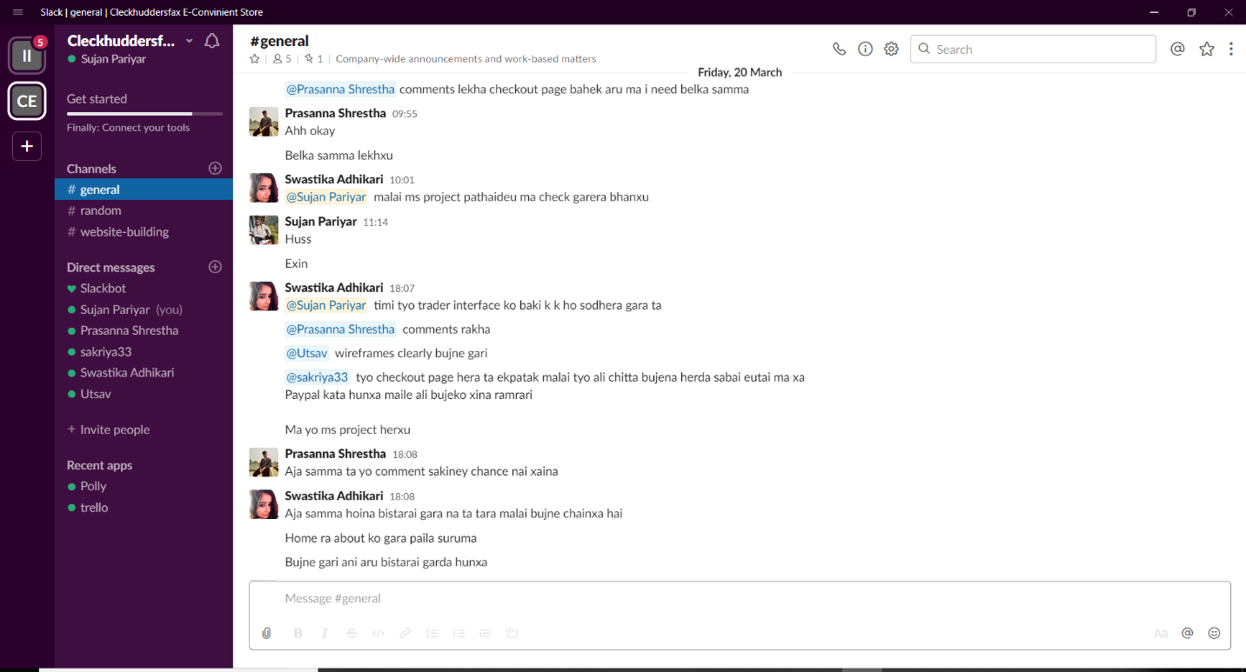

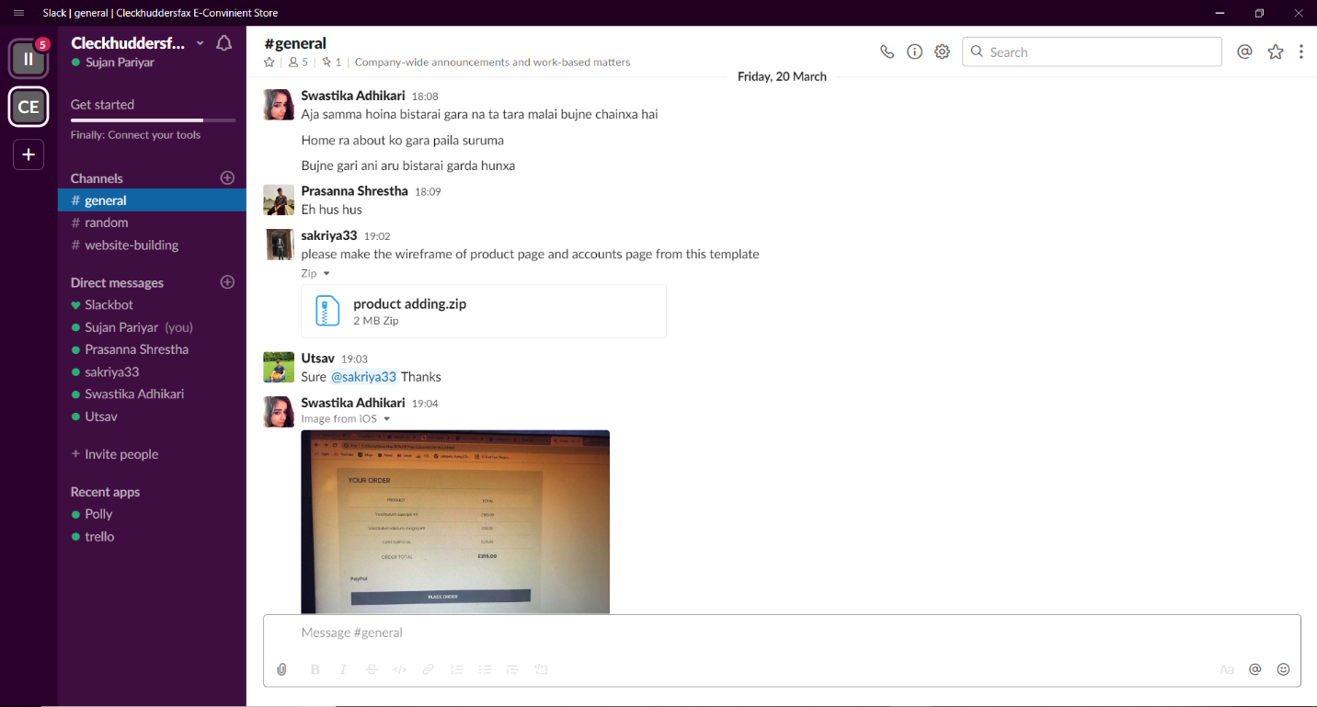

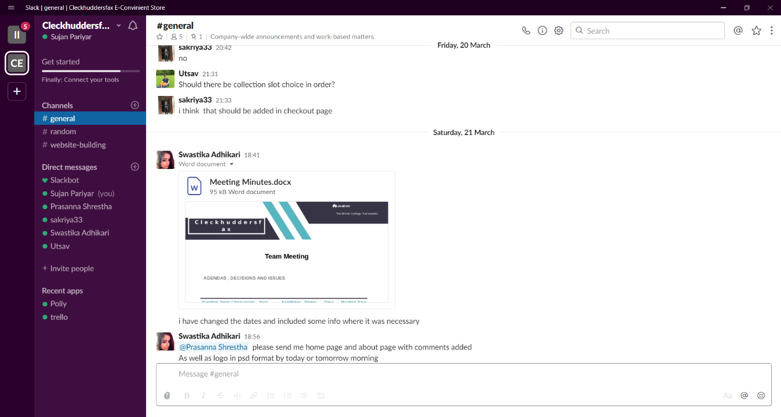

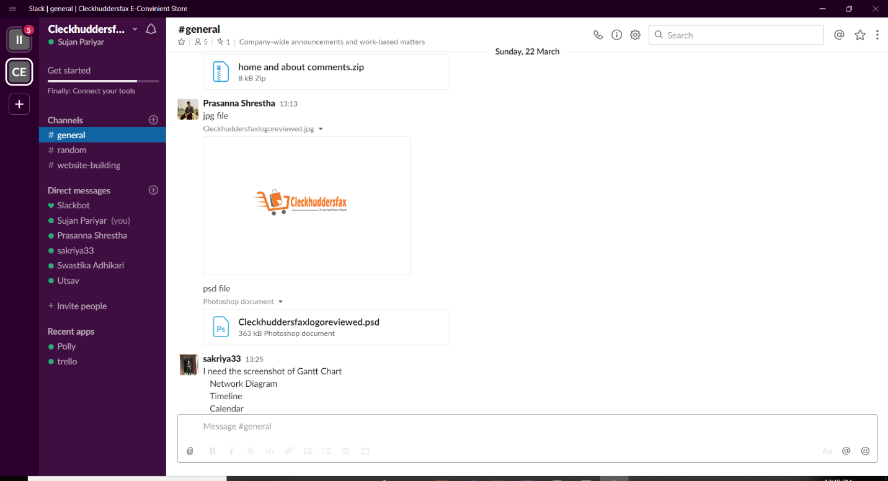

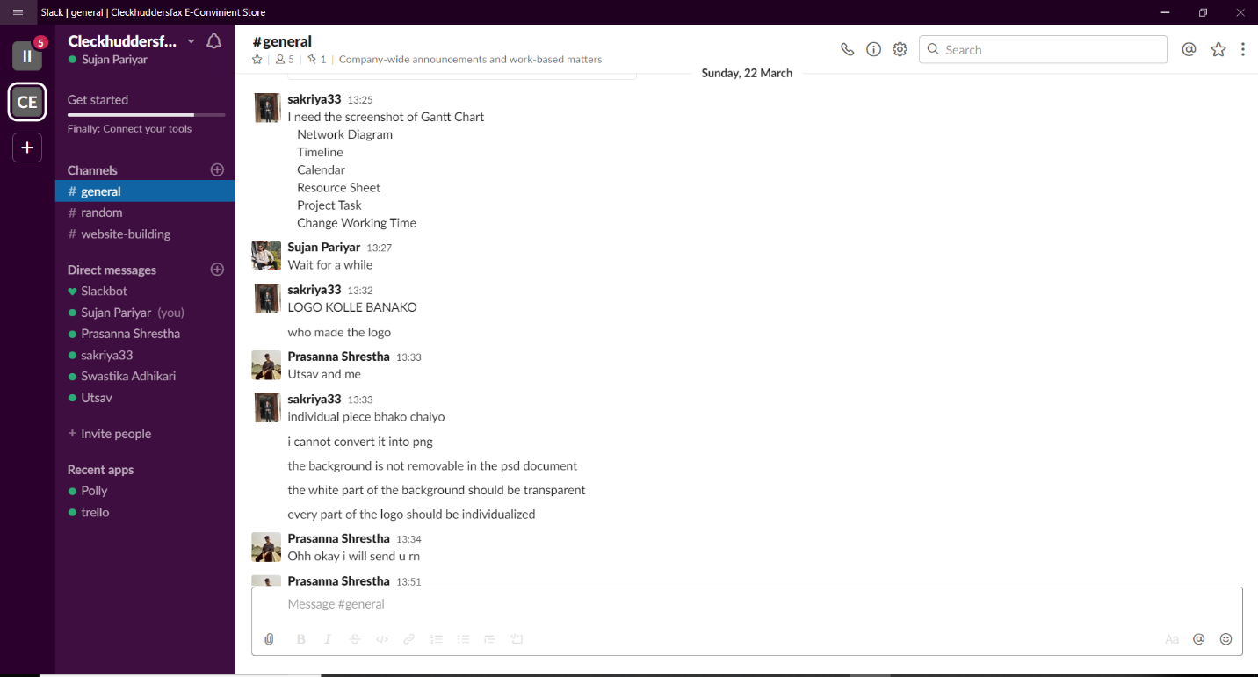

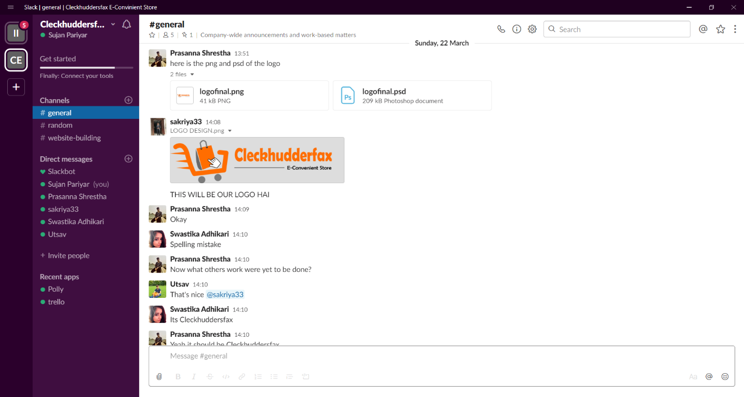

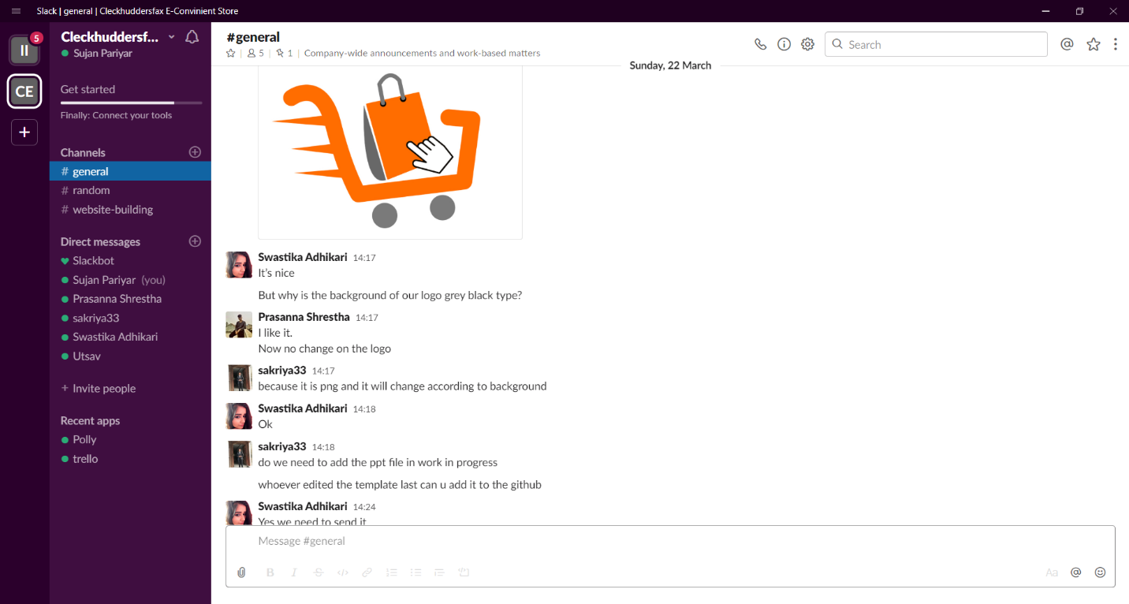

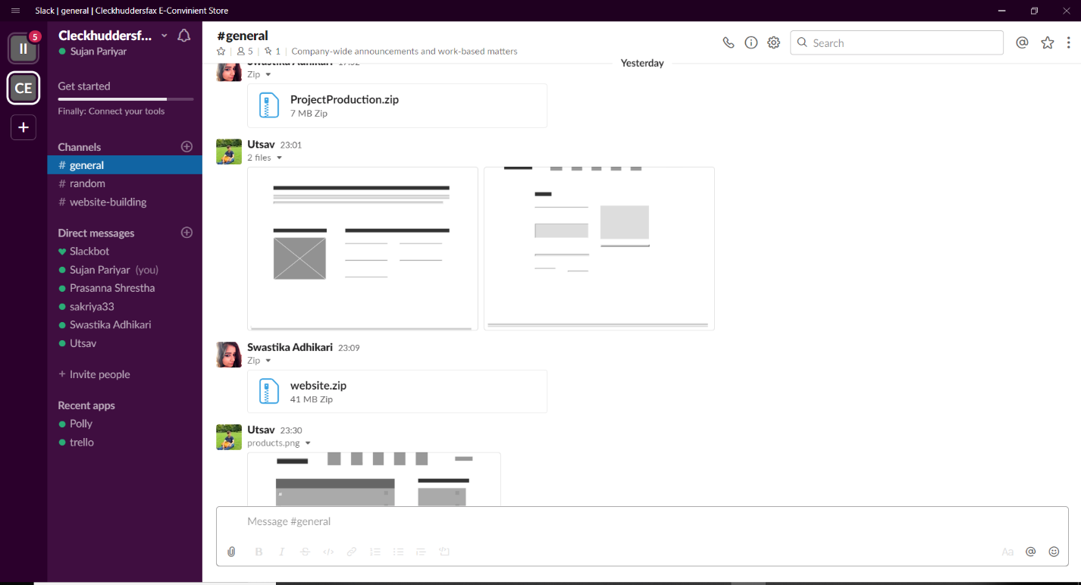

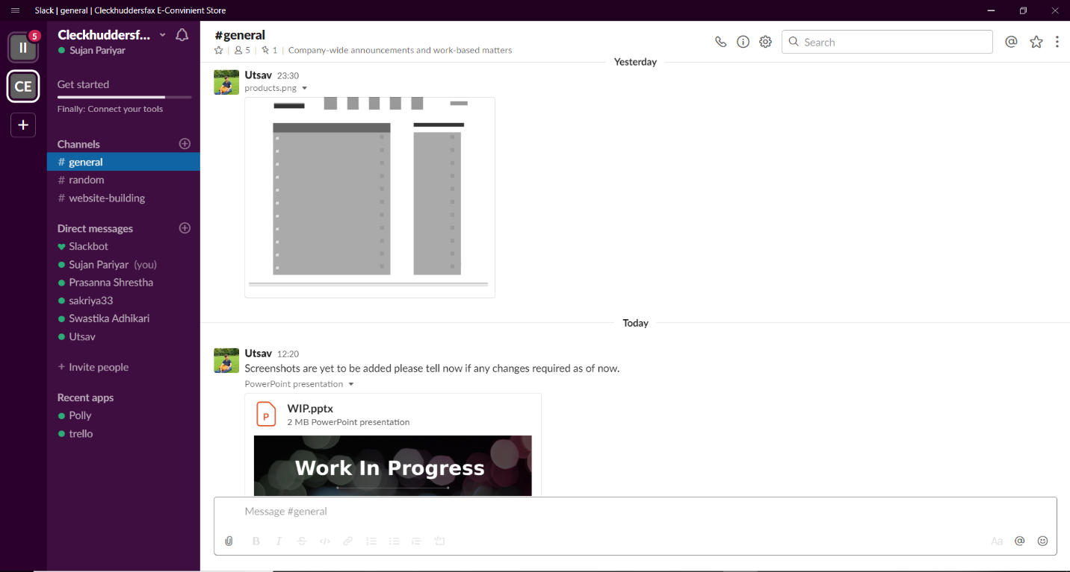

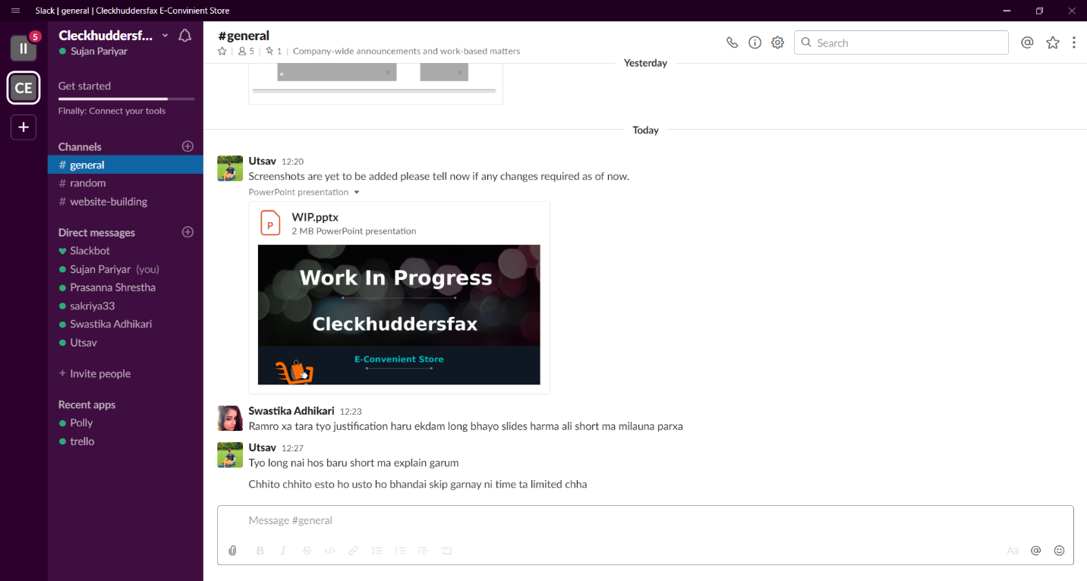

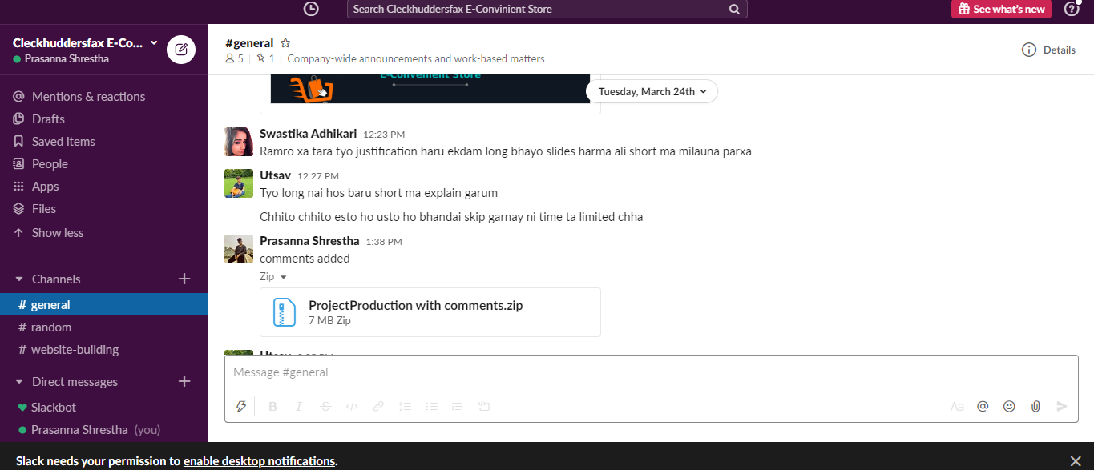

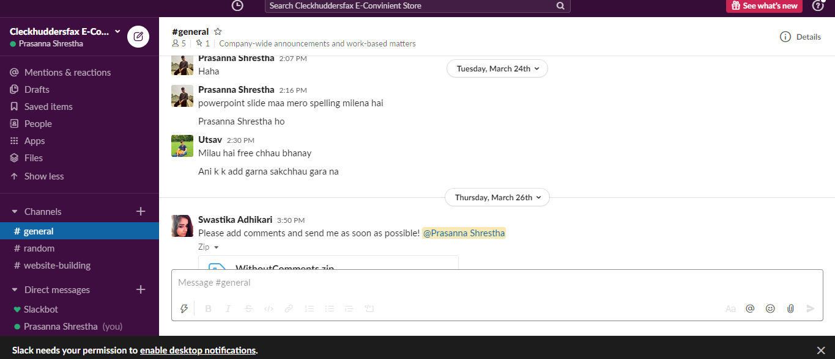

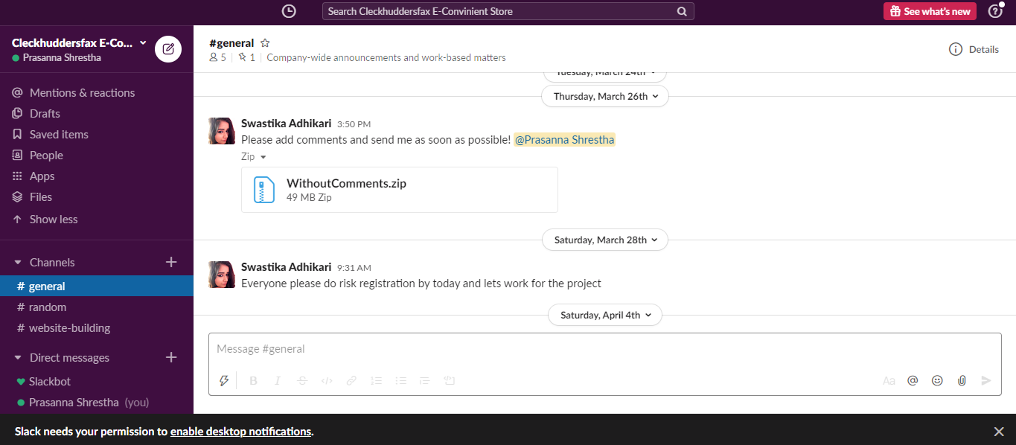

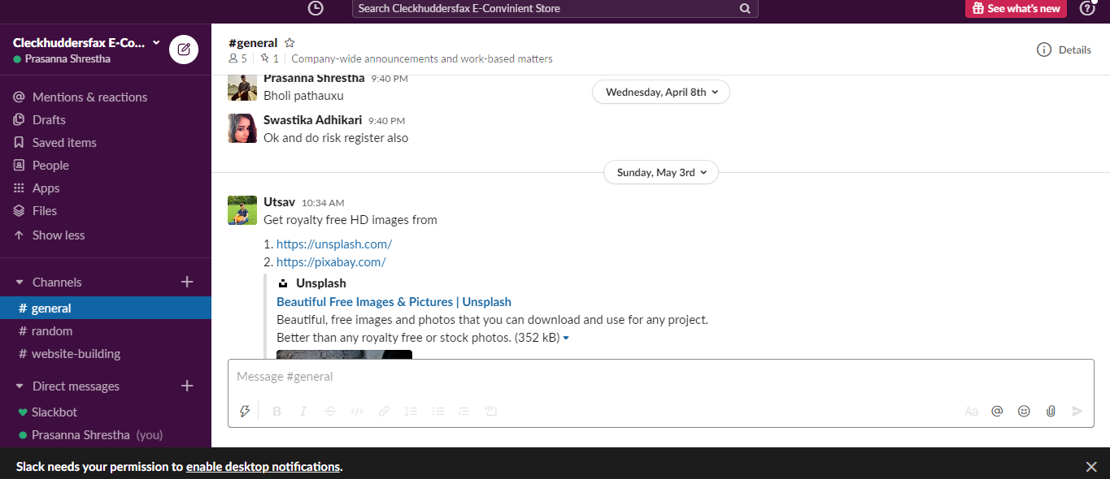



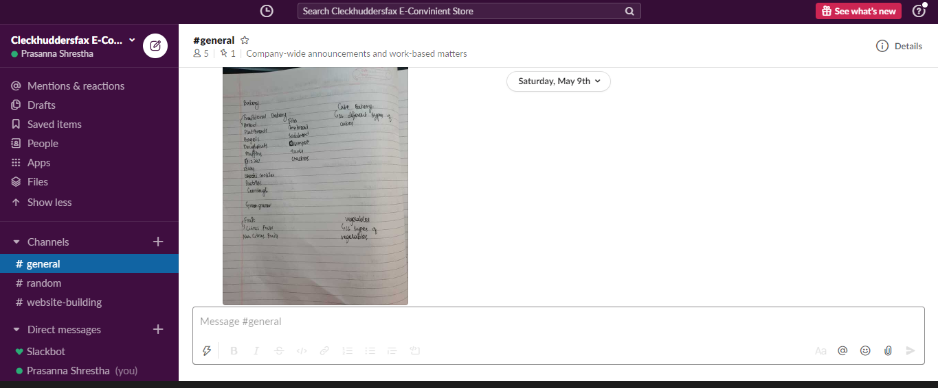

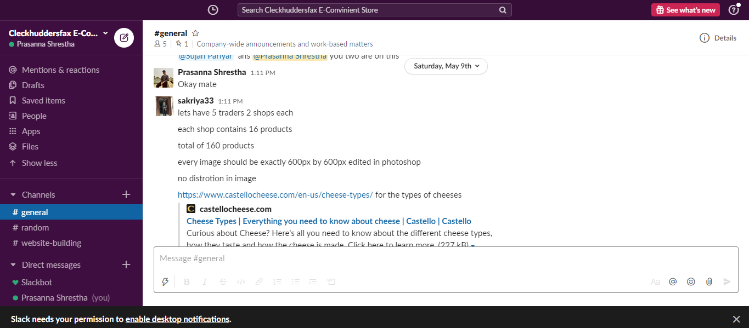

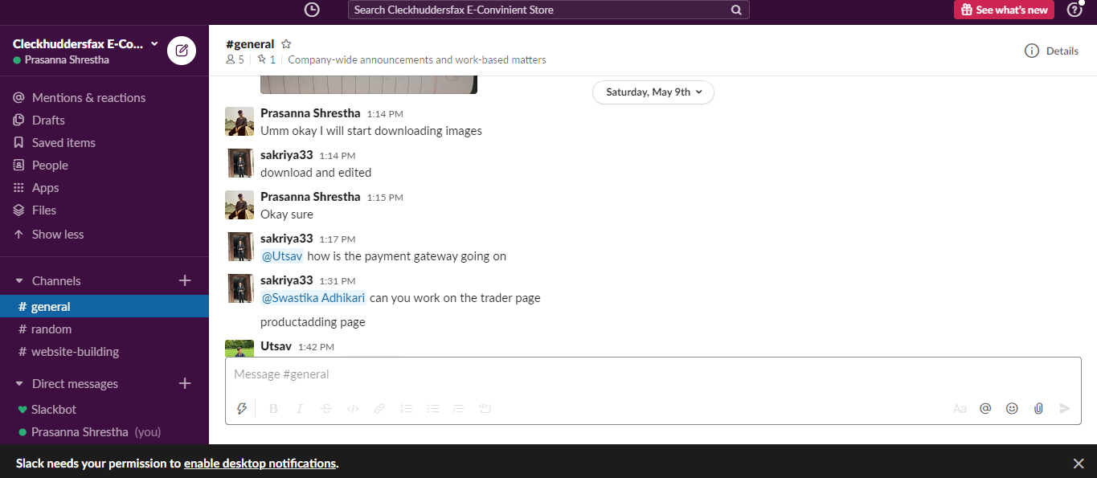

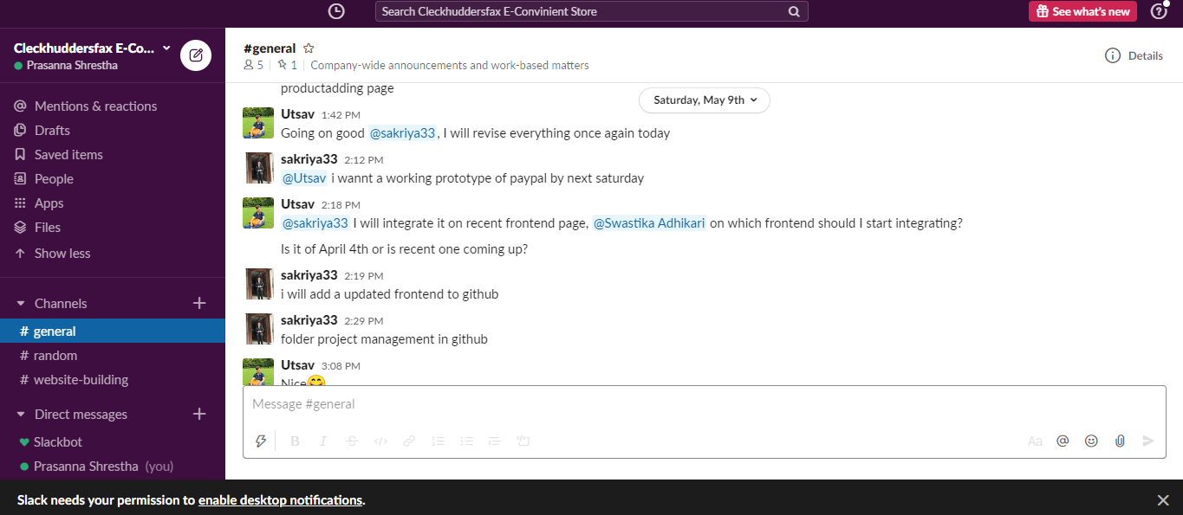

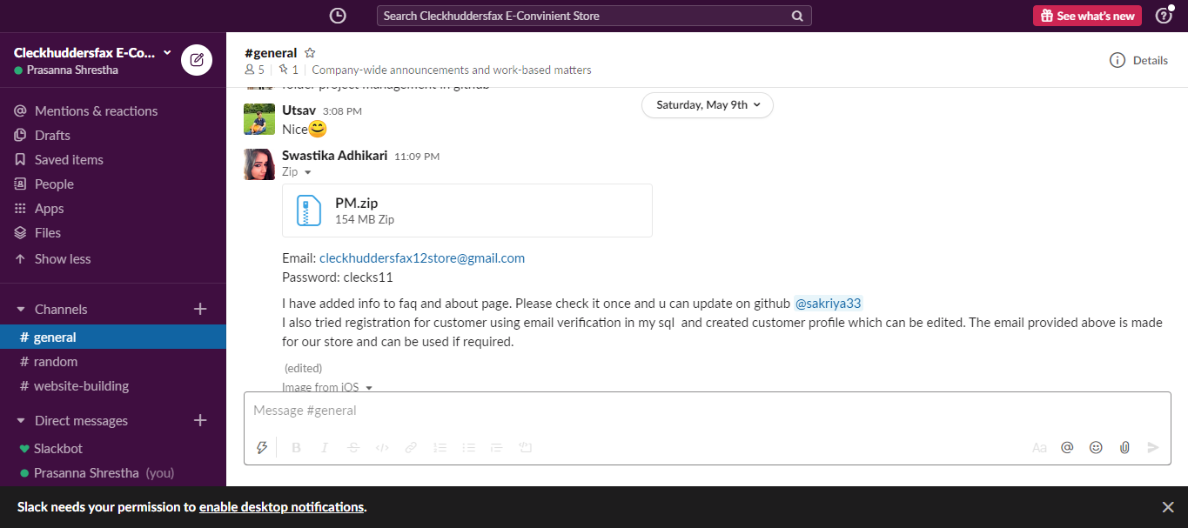

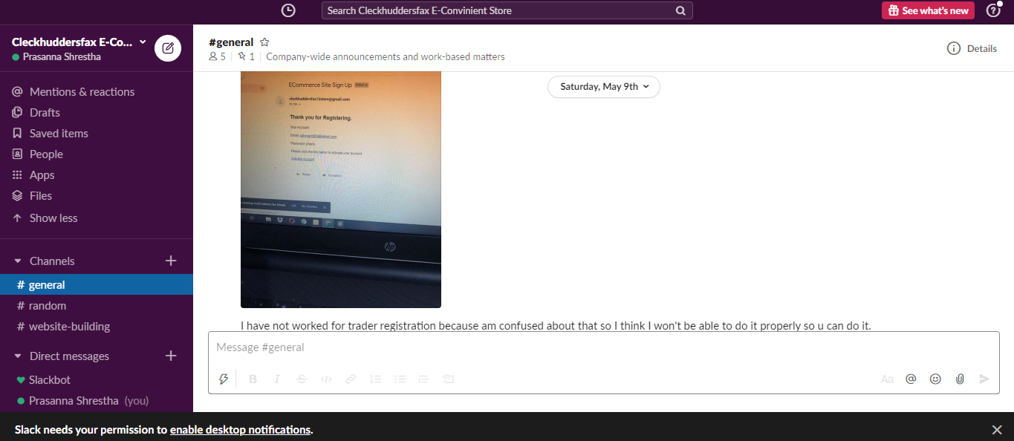

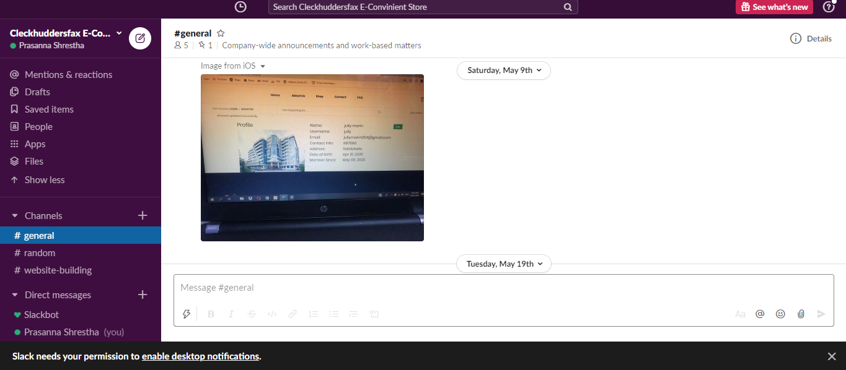

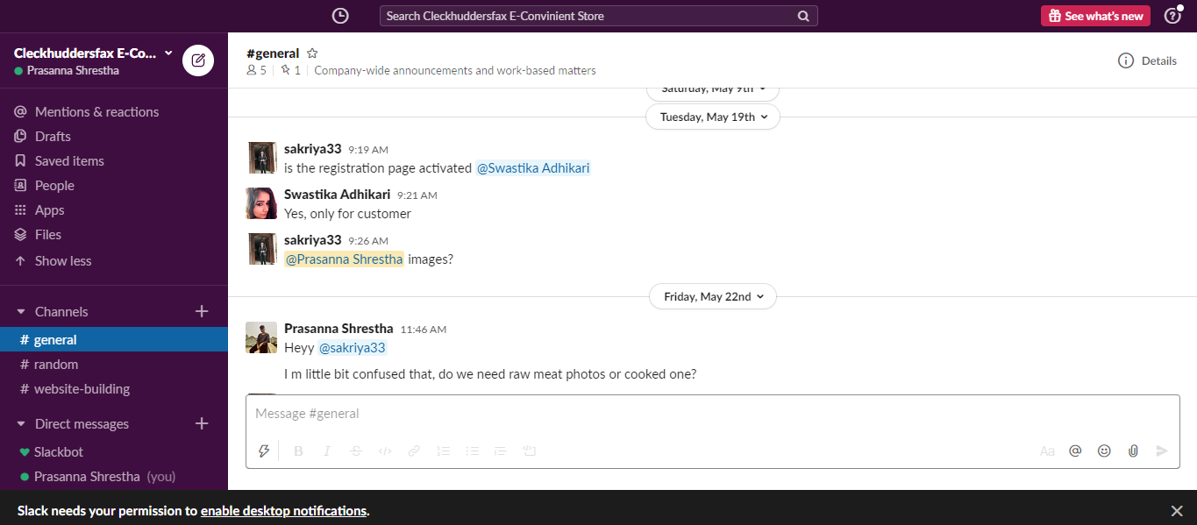

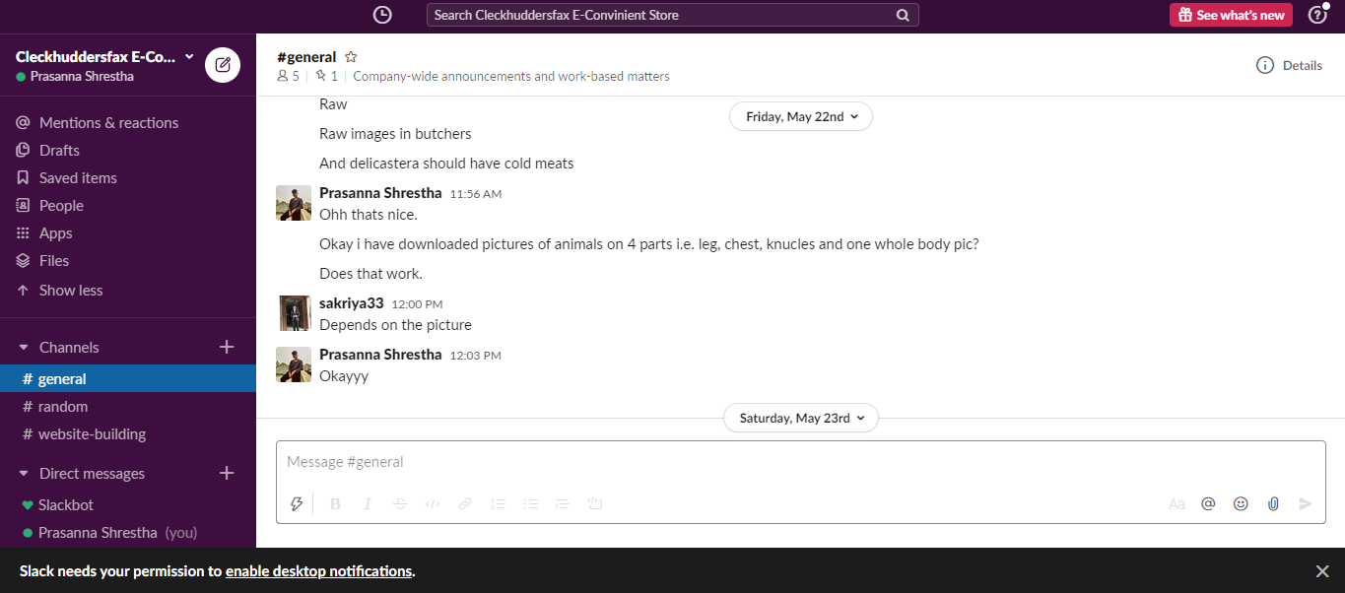

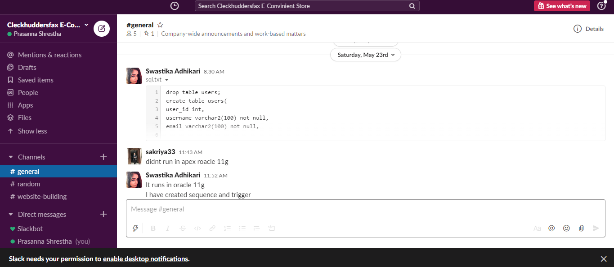

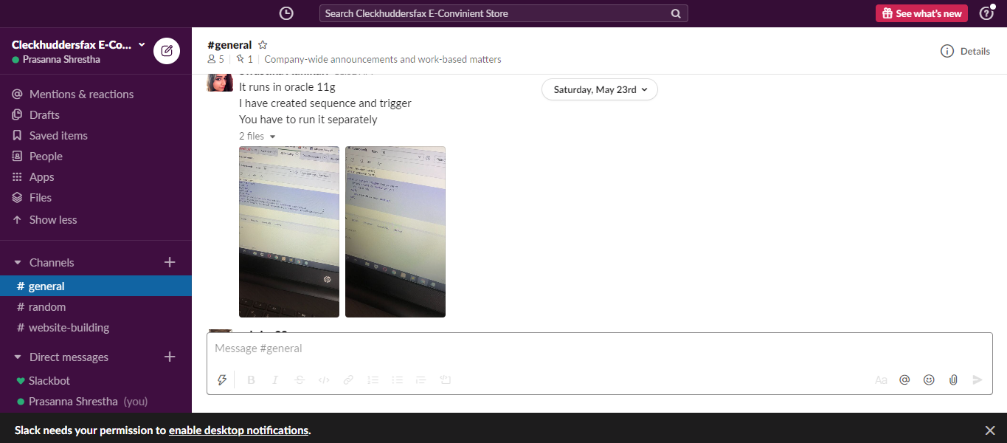

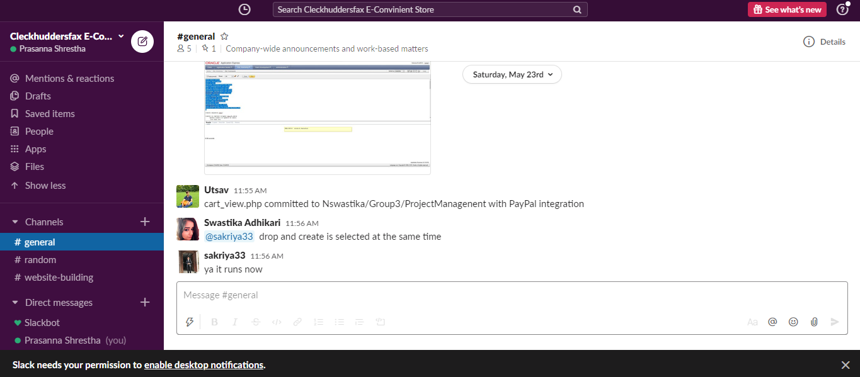



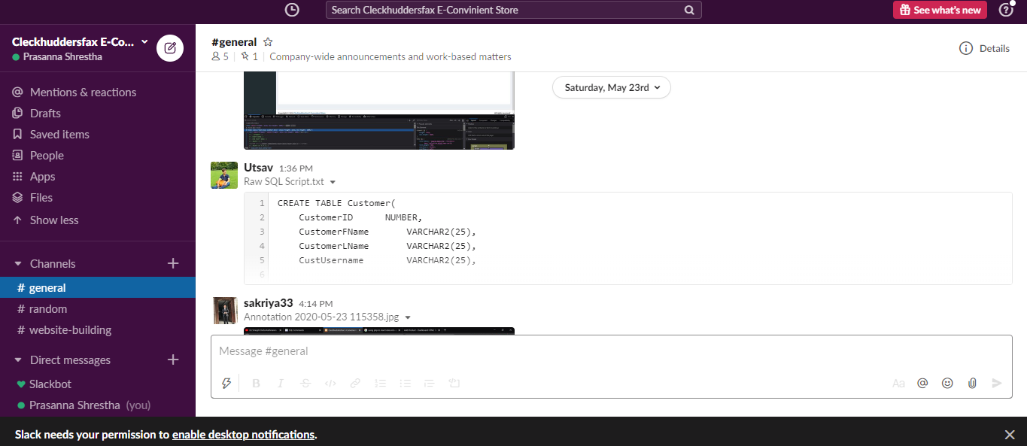

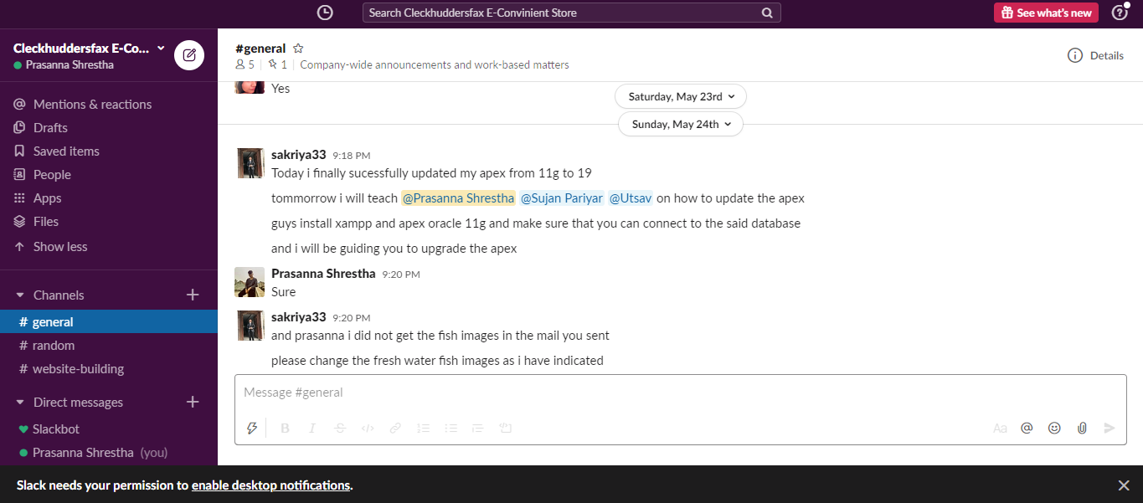



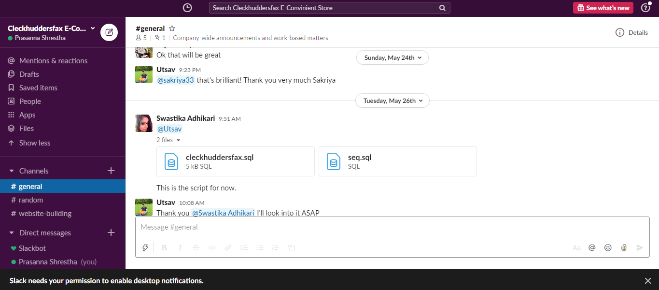

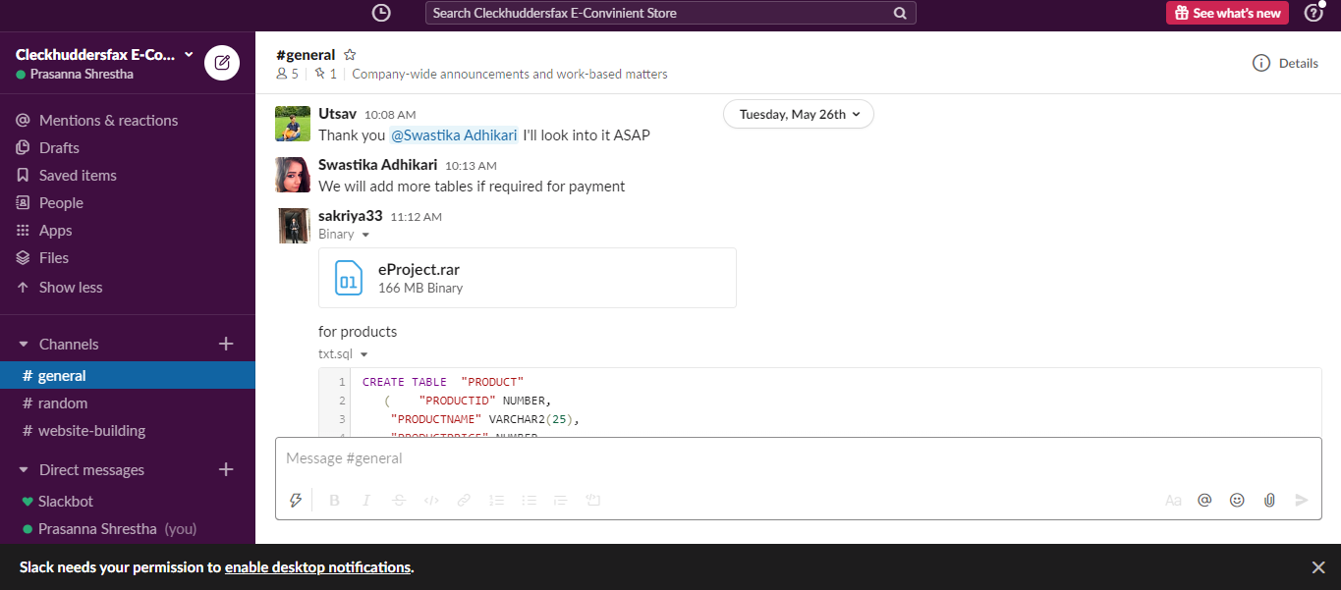

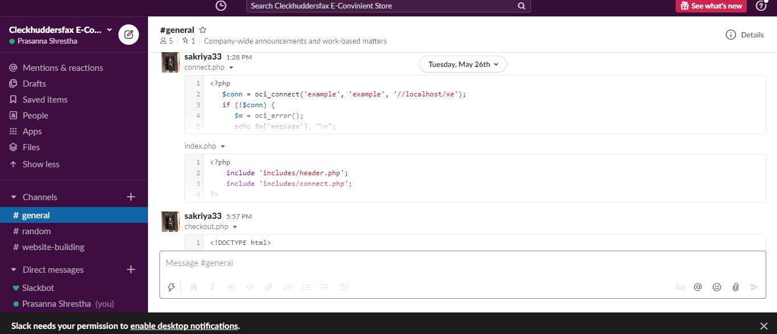

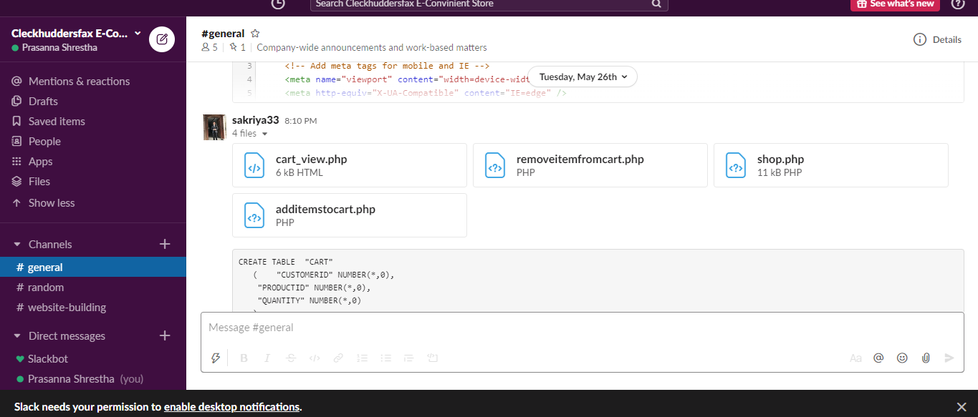

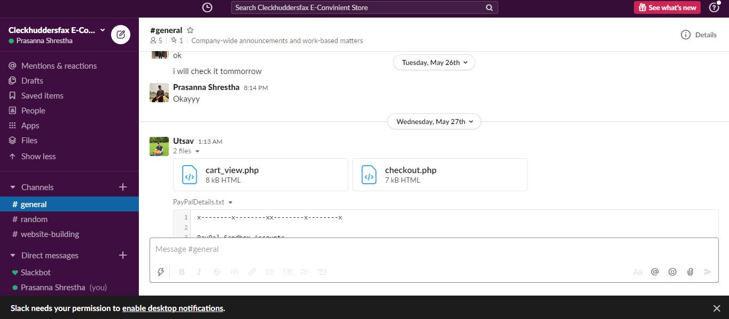

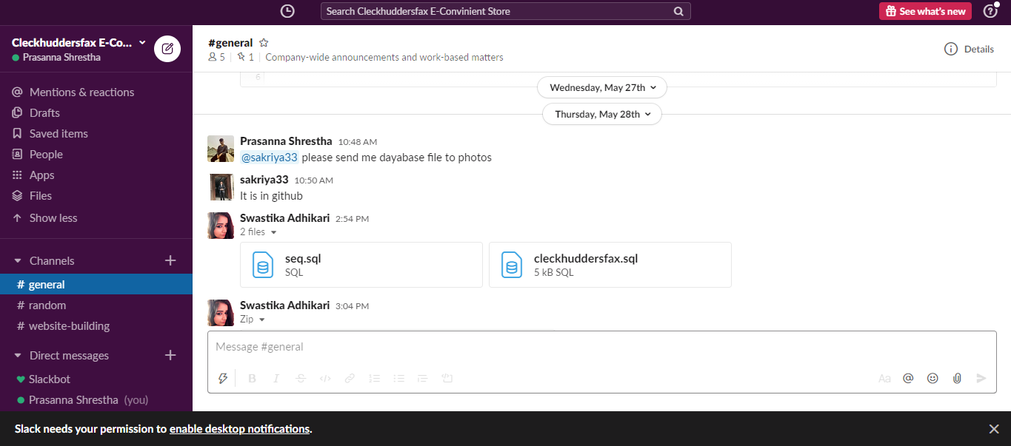

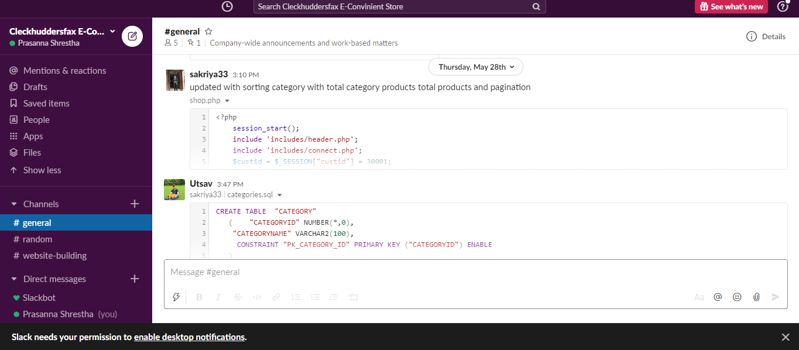

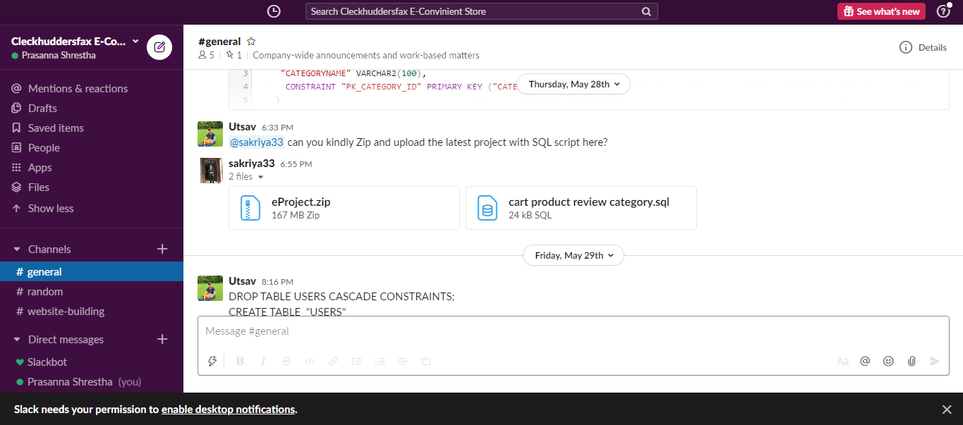

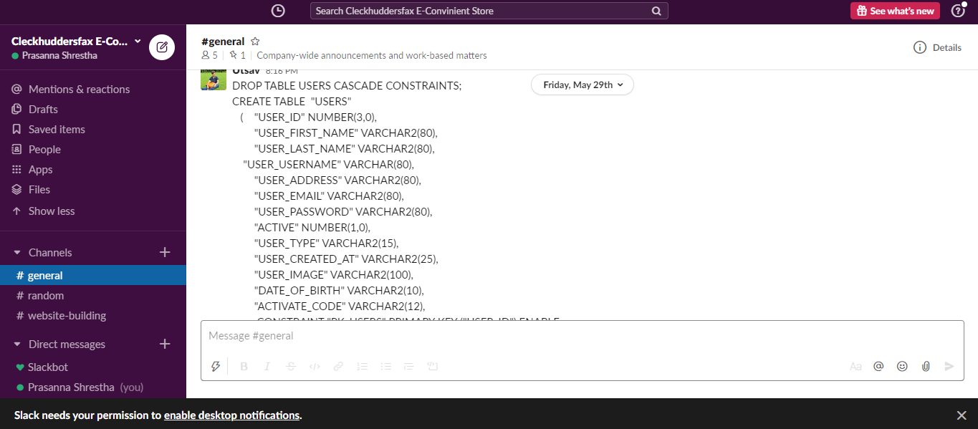

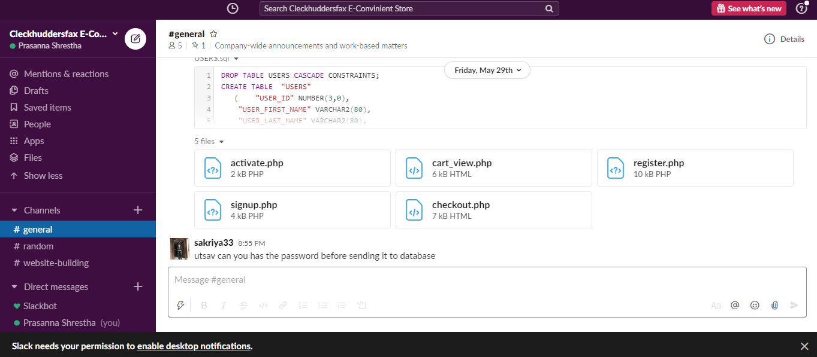

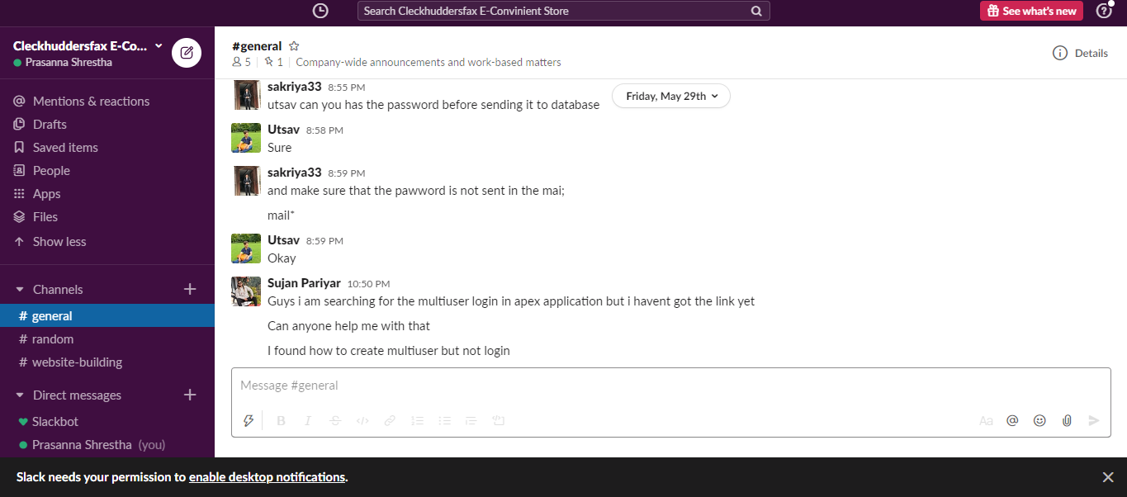

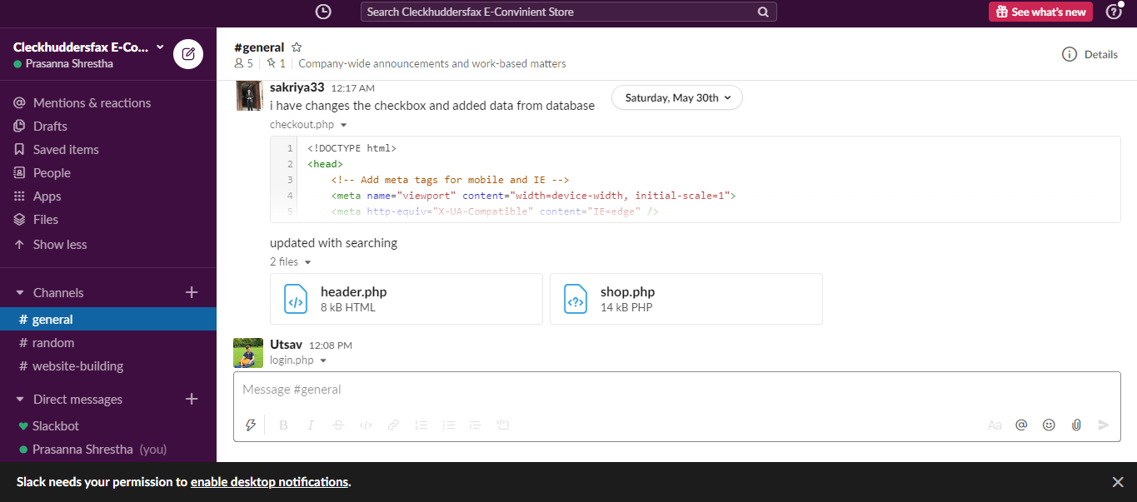

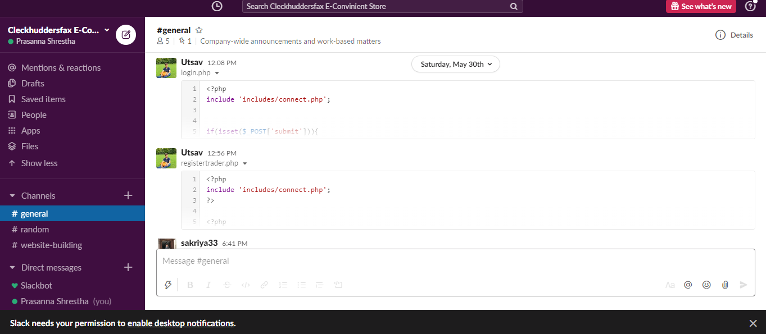

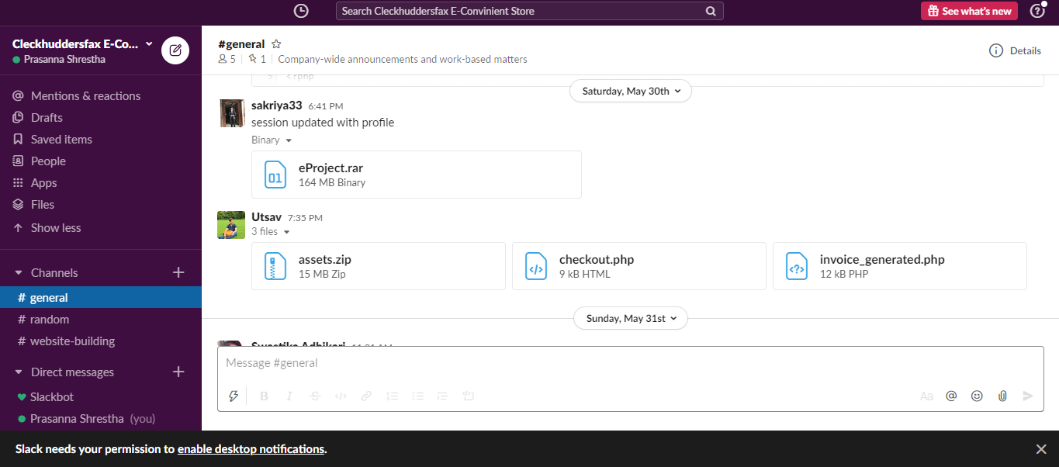

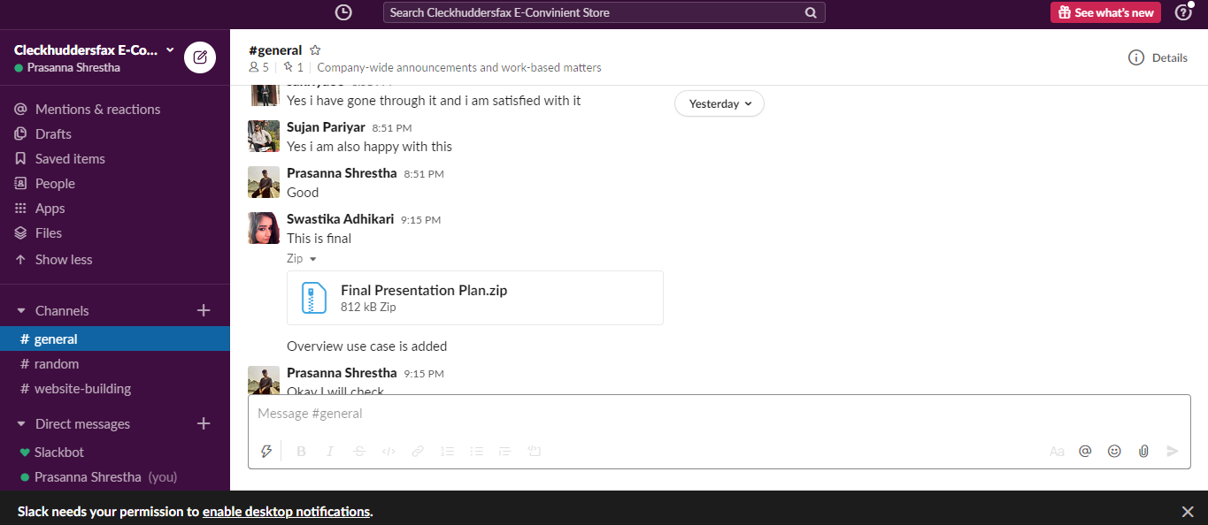

These all are the screenshots of slack which was used for communication by the team members.

**GitHub**

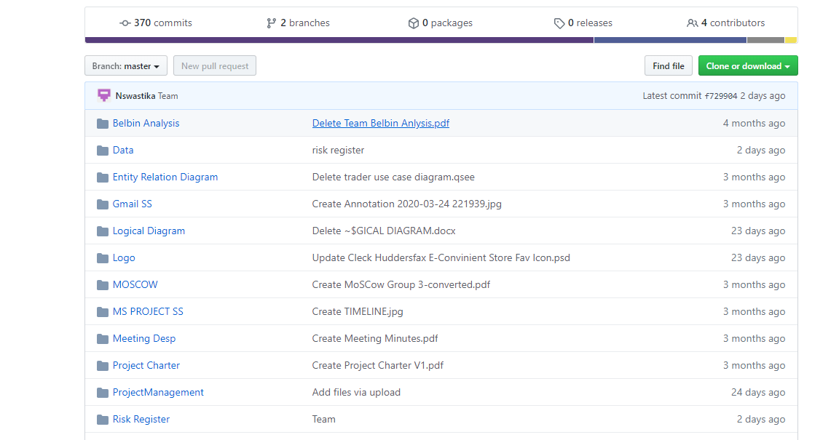

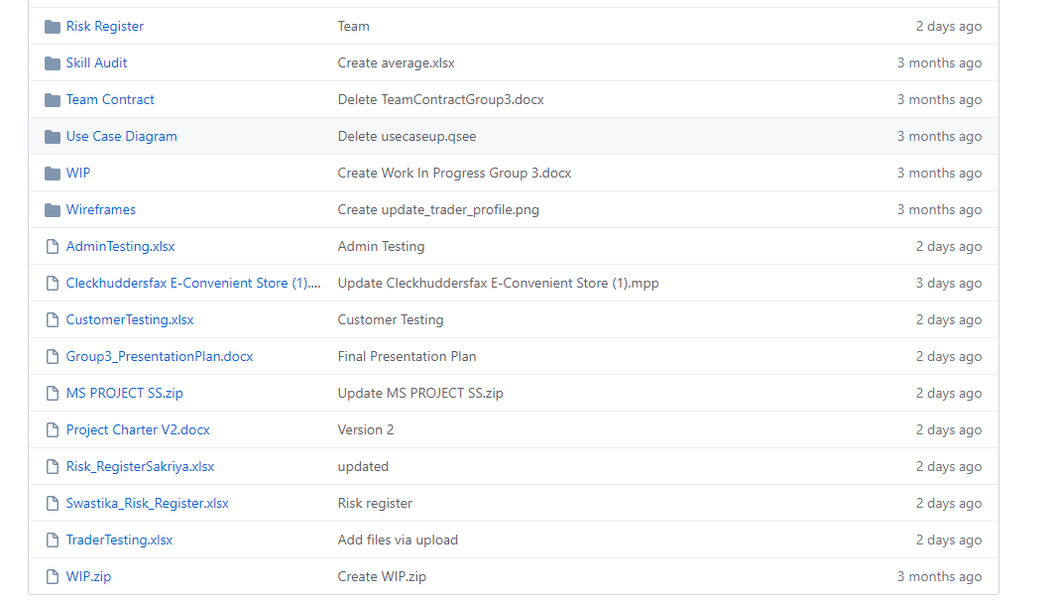

These are the screenshots of GitHub which was used for sharing of folders.

**Gmail**

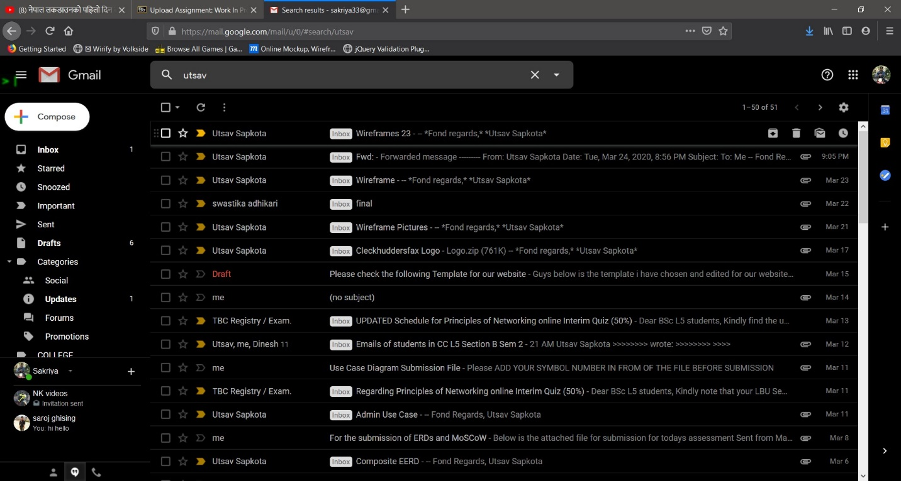

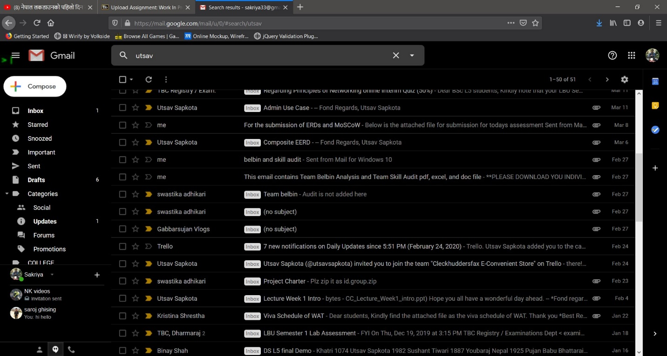

These are the screenshots of Gmail which was used by us to share the folders.

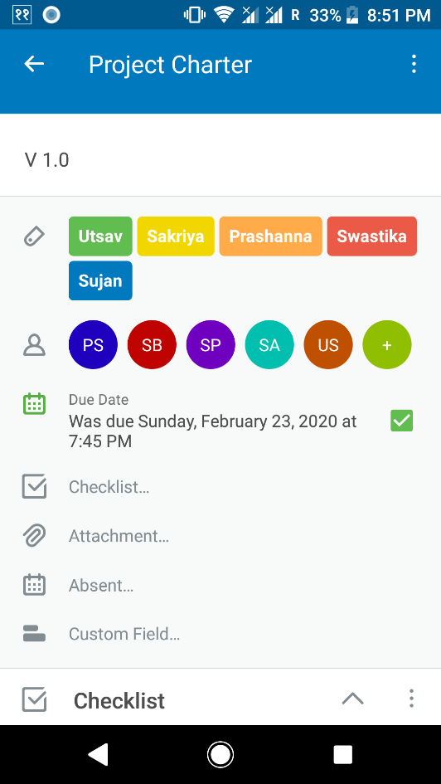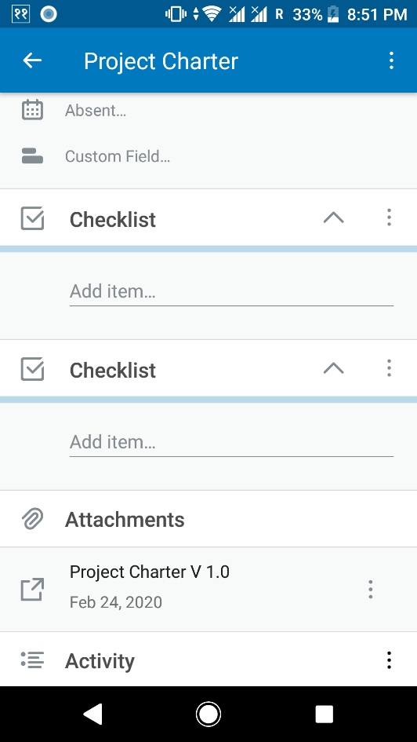**Trello**

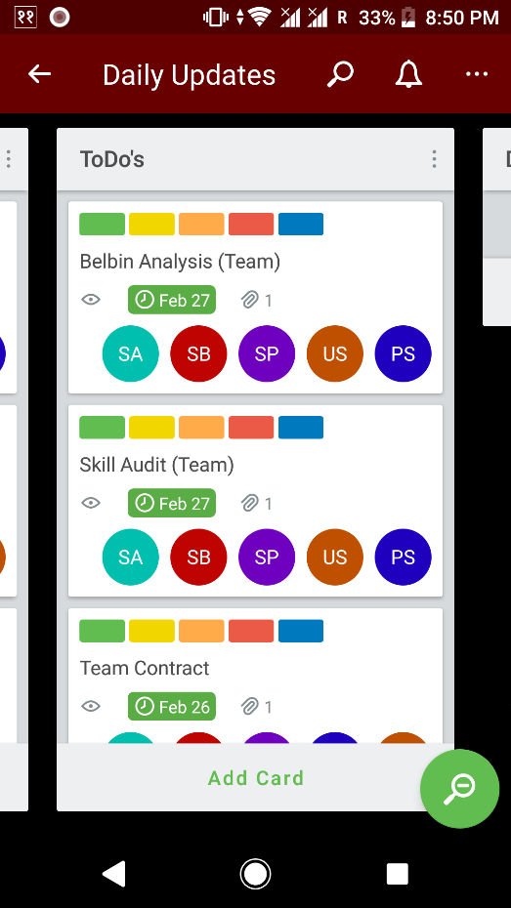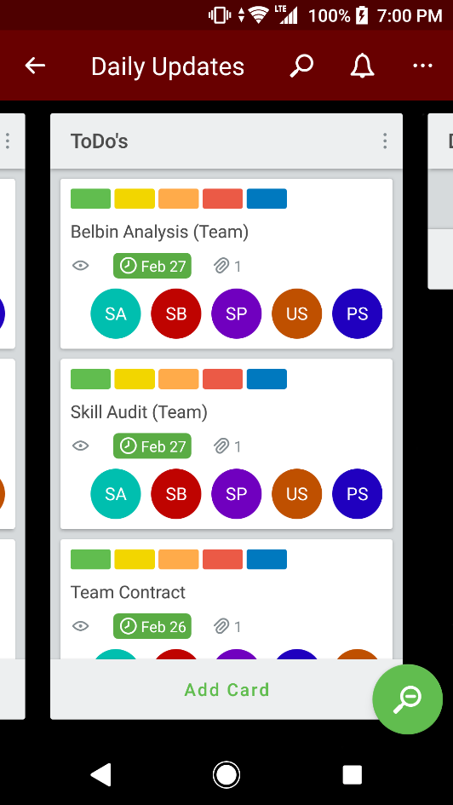

These are the screenshots of Trello which was used by us to trace the progress of the project.

**Risk Register**

**Team Risk Register**

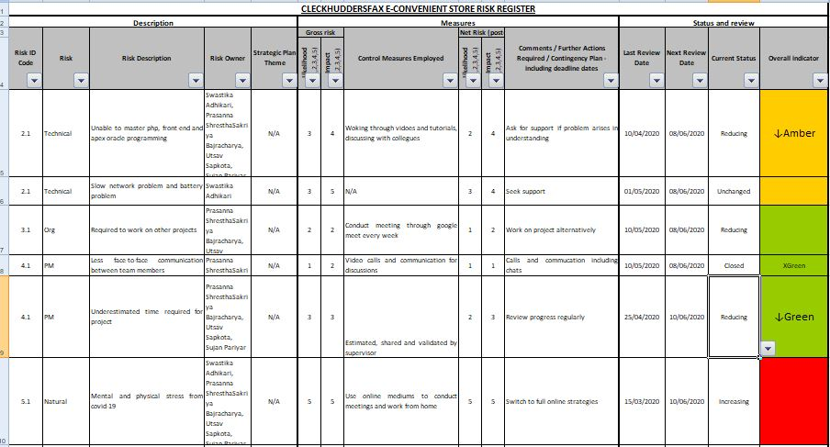

**Individual Risk Register**

Executing Phase

**Entity Relationship Diagrams**

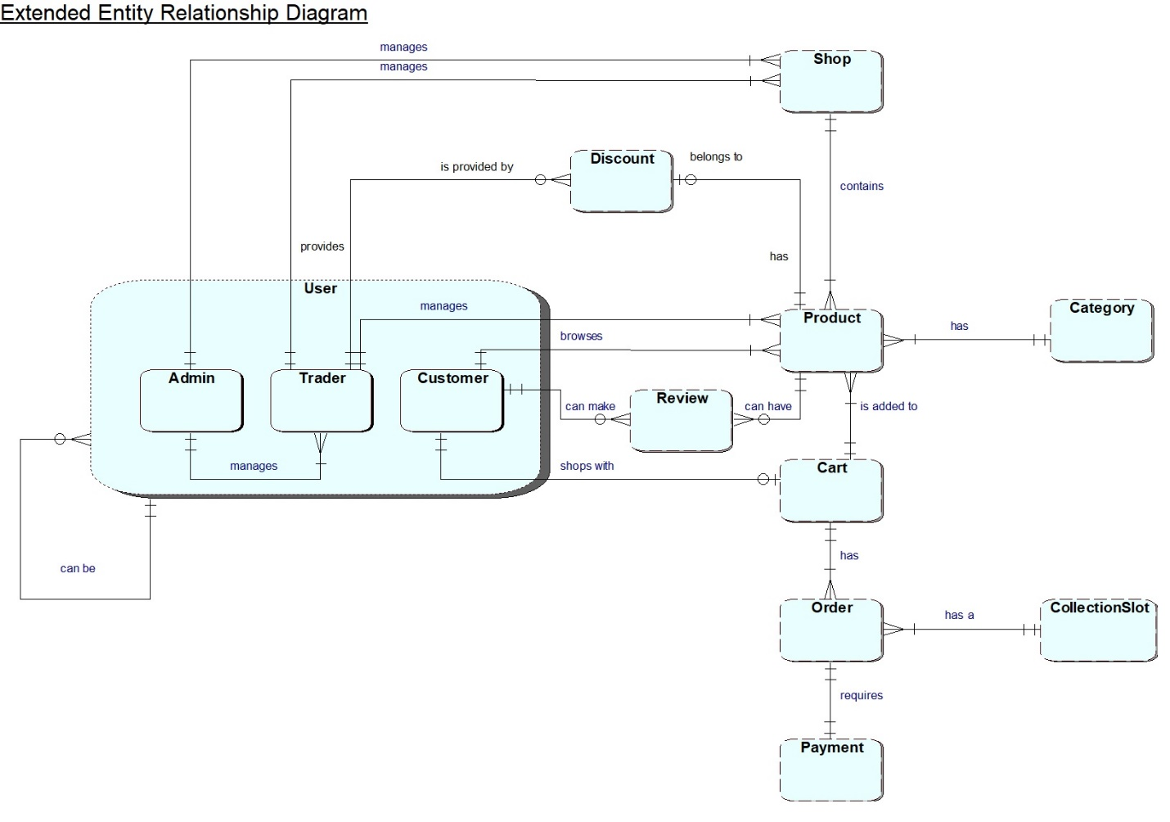 **EERD**

This is an extended entity relationship diagram.

**ERD**

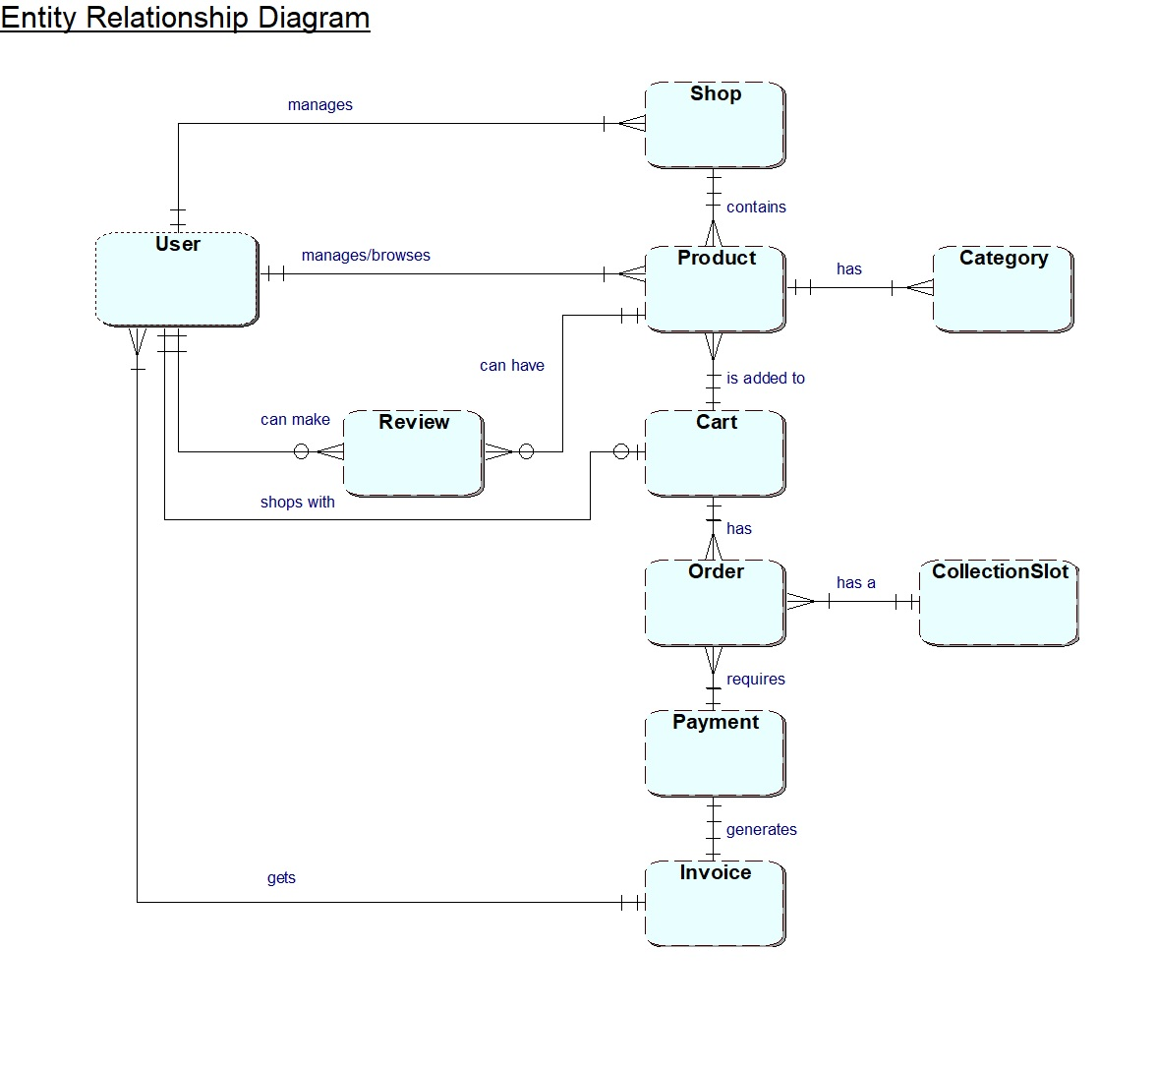

This is an ERD diagram based on our project.

**Composite Diagram**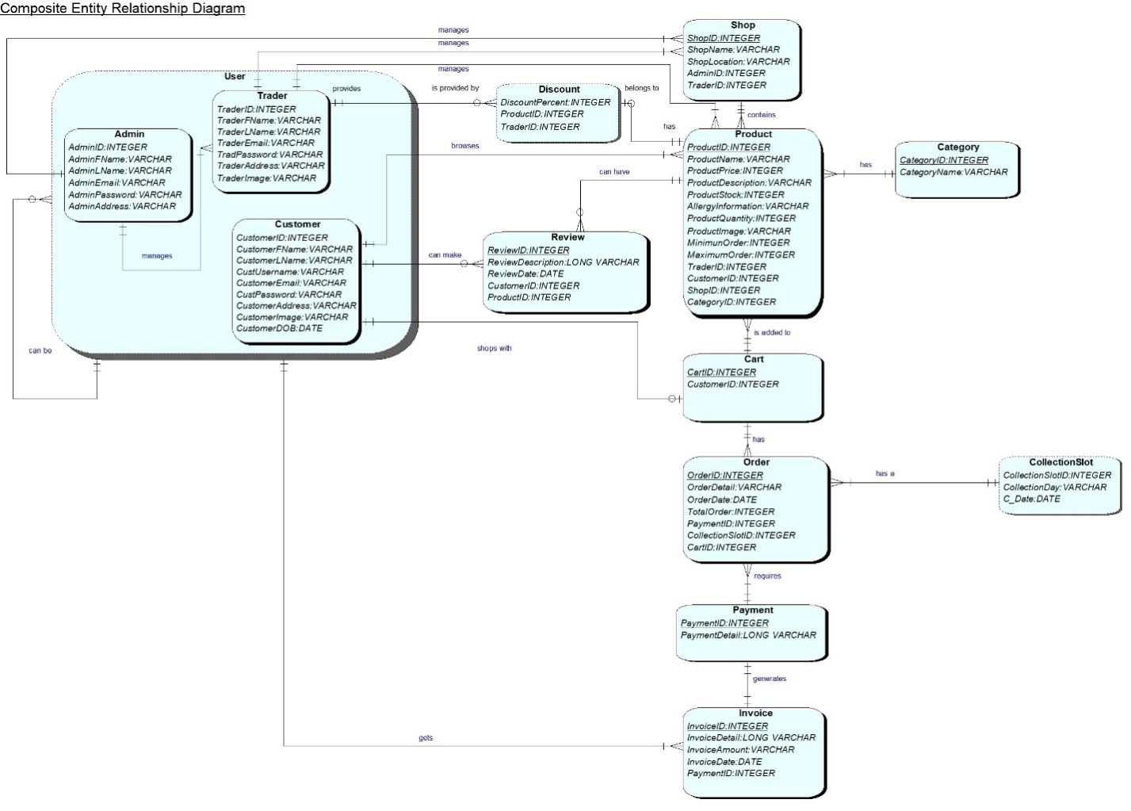

This is composite diagram used in our project.

**Logical Diagram**

* **Admin** (AdminID, AdminFName, AdminLName, AdminEmail, AdminPassword, AdminAddress, AdminImage);
* **Trader** (TraderID, TraderFName, TraderLName, Trader_Email, TraderPassword, TraderAddress, TraderImage);
* **Customer** (CustomerID, CustomerFName, CustomerLName, CustomerUsername, CustomerEmail, CustomerPassword, CustomerAddress, CustomerImage, CustomerDOB);
* **Discount** (Discount_ID, DiscountPercent, ProductID, TraderID);
* **Shop** (ShopName, ShopLocation, AdminID, TraderID);
* **Category** (CategoryID, CategoryName, Category_Image);
* **Product**(ProductID, ProductName, ProductPrice, ProductDescription, ProductStock, AllergyInformation, ProductQuantity, ProductImage, MinimumOrder, MaximumOrder, TraderID, CustomerID, ShopID, CategoryID);
* **Cart** (CartID,p_image, p_desc, p_price, p_quantity, CustomerID);
* **Order** (OrderID, OrderDetail, OrderDate, TotalOrder, CollectionSlot, PaymentID, CartID);
* **Payment** (PaymentID, PaymentDetail);
* **Invoice** (InvoiceID, InvoiceDetail, InvoiceAmount, InvoiceDate, PaymentID);
* **Review** (ReviewID, ReviewDate, CustomerID, ProductID);

**Use Case Diagrams**

**Overview Use Case**

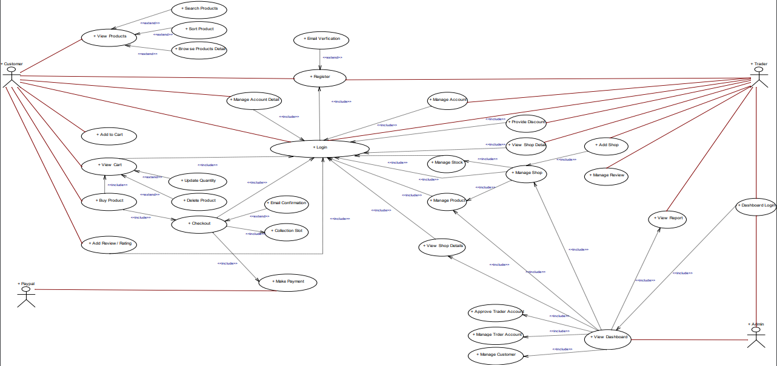

This is an overview use case diagram used in our project.

**Trader Use Case**

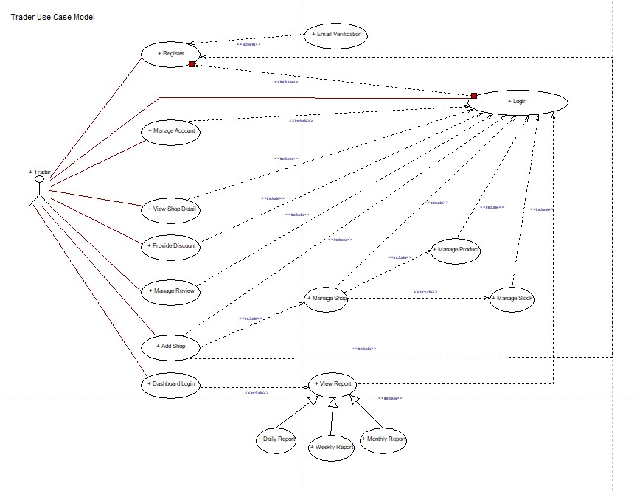

This is a trader use case diagram.

**Admin Use Case**

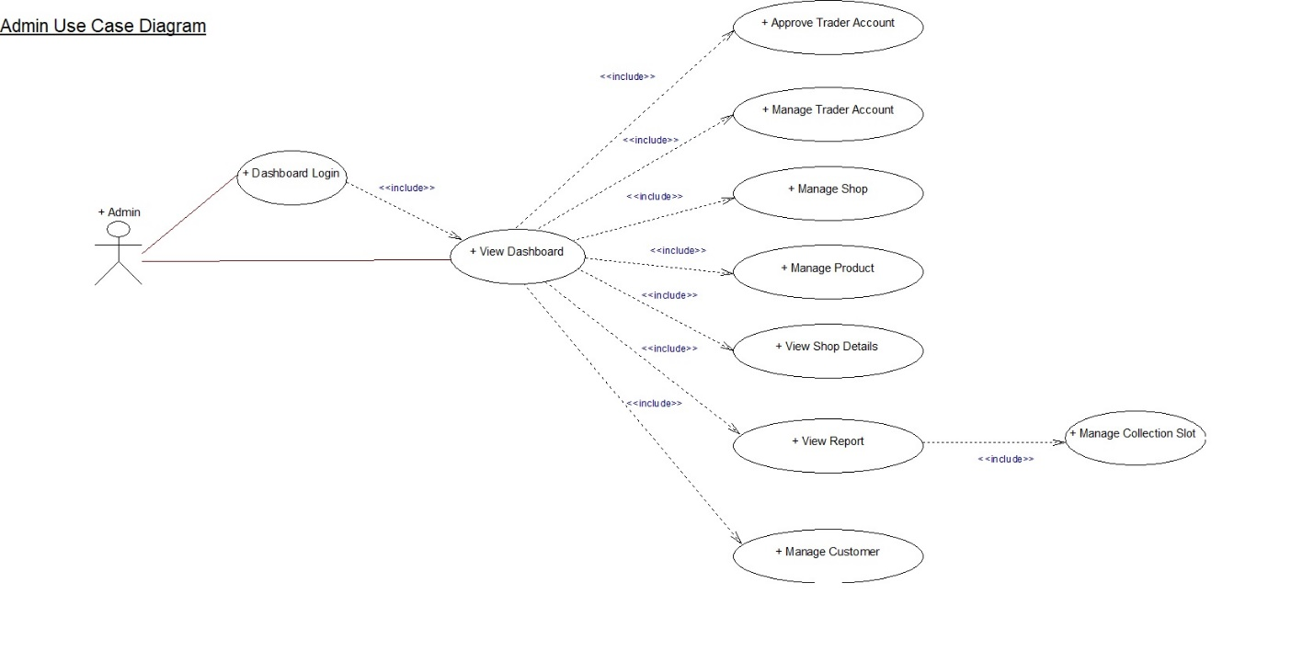

This is an admin use case diagram.

**Customer Use Case**

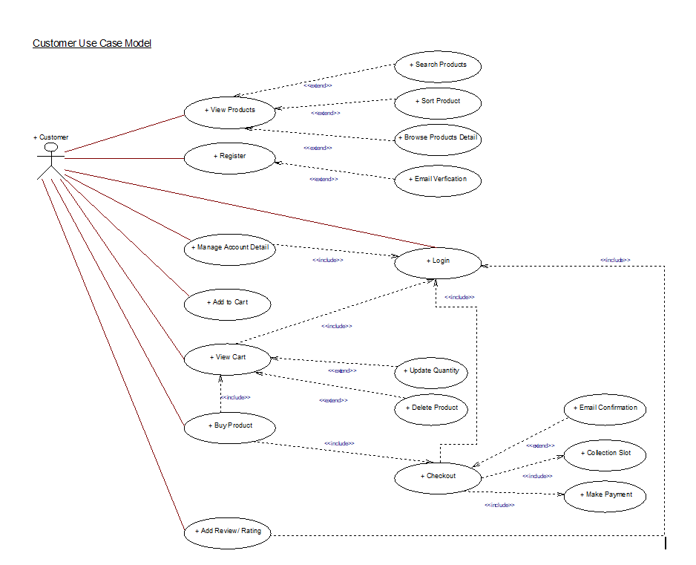

This is a customer use case diagram.

**Functional Requirements**

**Part A: Product Interface**

|  |  |  |
| --- | --- | --- |
| **Requirement ID** | **Description** | **MoSCoW** |
| **A1** | **An interface to allow customers to view products and buy them.** |  |
| A1 – 1 | All products will be displayed with a short name, a description, price, quantity, stock available, min order, max order, allergy information and will be associated with a trader. | M |
| A1 – 2 | Users will be able to navigate to product by shop or by product type. | M |
| A1 – 3 | Users will be able to search for products by open text search. | S |
| A1 – 4 | Users will be able to sort products appropriately. Example: price, alphabets. | S |
| A1 – 5 | Users will be able to search/sort items based on multiple search criteria. | C |
| **A2** | **The interface will allow customers to select products and add those products to cart for checkout.** |  |
| A2 – 1 | Logged in users will only be able to access the cart. | M |
| A2 – 2 | Registration should be done in order to login and add products to cart. | M |
| A2 – 3 | Users will be provided with a single cart to hold goods that spans all traders. | M |
| A2 – 4 | A single cart will have a single payment. | M |
| A2 – 5 | While placing and paying for an order collection slots should be identified in three slots in three different days i.e. 10-13, 13-16, 16-19 in the days Wednesday, Thursday and Friday. | M |
| A2 – 6 | A cart will contain all the products added by the customer with name, short description, quantity and an image. | S |
| A2 – 7 | A single cart can hold up to 20 products and a single payment is needed. | C |
| **A3** | **The interface to allow CRUD operations of products.** |  |
| A3 - 1 | Traders can add, delete and update products. | M |
| A3 – 2 | Clicking the update will show a form pre-populated with all the details of the products. Submitting the form will update the chosen product and display the updated information of that product. | S |
| A3 – 3 | A form will be provided to add a new product including all details and image. | S |
| A3 – 4 | Clicking the delete will remove the chosen product and update the displayed catalogue of products. | S |
| A3 - 5 | Management can delete the products that have very low sales. | S |

**Part B: Customer Interface**

|  |  |  |
| --- | --- | --- |
| **Requirement ID** | **Description** | **MoSCoW** |
| **B1** | **A facility to allow registered users to login** |  |
| B1 - 1 | A login form to collect username and password will be provided. | M |
| B1 – 2 | Server validation that informs users if they attempt to login using incorrect details. | M |
| B1 – 3 | Login link will be displayed on every pages of the site. | C |
| B1 - 4 | Reset password link will be provided if they forget their password. | C |
| **B2** | **A facility to allow new customers to register their account.** |  |
| B2 - 1 | A registration form that collects first name, last name, user name, password, email, address, age. | M |
| B2 - 2 | A user should be able to validate account through email address. | M |
| B2 - 3 | Customer account must be registered before they can place an order. | M |
| B2 – 4 | Username must be unique to each customer. | M |
| B2 – 5 | Account updates should be confirmed through emails. | M |
| B2 – 6 | Validation of all form fields to ensure none of the field is empty or unchecked. | S |
| B2 – 7 | Password must be encrypted before storing in the database. | C |
| B2 – 8 | The password length must be 8-10 length. | C |
| B2 – 9 | The username must have alphabets only. | C |
| B2 – 10 | The password must have at least one capital letter, a number and a symbol. | C |

**Part C: Trader Interface**

|  |  |  |
| --- | --- | --- |
| **Requirement ID** | **Description** | **MoSCoW** |
| **C1** | **An interface to allow trader to register their account.** |  |
| C1 – 1 | A form that minimally collects user id, user role, status, first name, last name, profile picture, status, dob, email. | M |
| C1 – 2 | Username must be unique to each trader. | M |
| C1 – 3 | Validation of all form fields to ensure none of the field is empty or unchecked. | S |
| C1 – 4 | Password must be encrypted before storing in the database | C |
| **C2** | **An interface to allow registered trader to login.** |  |
| C2 – 1 | A trader login that allows them to access to their details only. | M |
| C2 – 2 | A login form to collect username and password will be provided. | M |
| C2 – 3 | Server validation that informs users if they attempt to log in using incorrect details. | M |
| C2 – 4 | Trader should be able to view and update the details of their trader account. | M |
| C2 – 5 | Trader login will allow them to view reports on orders and stock levels. | M |
| C2 – 6 | Reset password link will be provided if they forget their password. | C |

**Part D: Management Interface**

|  |  |  |
| --- | --- | --- |
| **Requirement ID** | **Description** | **MoSCoW** |
| **D1** | **A facility to allow authenticated admin users to manage the activities presented by the system.** |  |
| D1 – 1 | After logging in the admin will have the access to manage the dashboard. | M |
| D1 – 2 | An interface to view the shop of each trader. | M |
| D1 – 3 | Management can deactivate customers account. | C |
| D1 – 4 | An interface will provide the traders access to range of daily reports of orders placed, weekly report of products sold and monthly report of sales. Monthly report will be able to be sorted alphabetically; total numbers of orders per products or total income per product. | M |
| D1 – 5 | Email confirmation should be sent to trader after signing up. | S |
| D1 – 6 | An interface to view the shop details of each trader. | S |

**Non - Functional Requirements**

**Part E: Non – functional Requirements**

|  |  |  |
| --- | --- | --- |
| **Requirement ID** | **Description** | **MoSCoW** |
| **E1** | **The website will have the following non-functional requirements.** |  |
| E1 - 1 | HTML/CSS template suited to the requirements. | M |
| E1 – 2 | The site should be viewable on mobile as well as desktop devices and viewable on the most popular browsers. | M |
| E1 – 3 | Apex Oracle used for the back-end. | M |
| E1 – 4 | Site built for maintainability: Files organized and comments added. | S |
| E1 – 5 | Template applied consistently throughout the website. | S |
| E1 - 6 | Implement Google map to locate the shops location. | W |

**Website Logo**



This is a logo of our website.

**Wireframes**

Home Page About Page

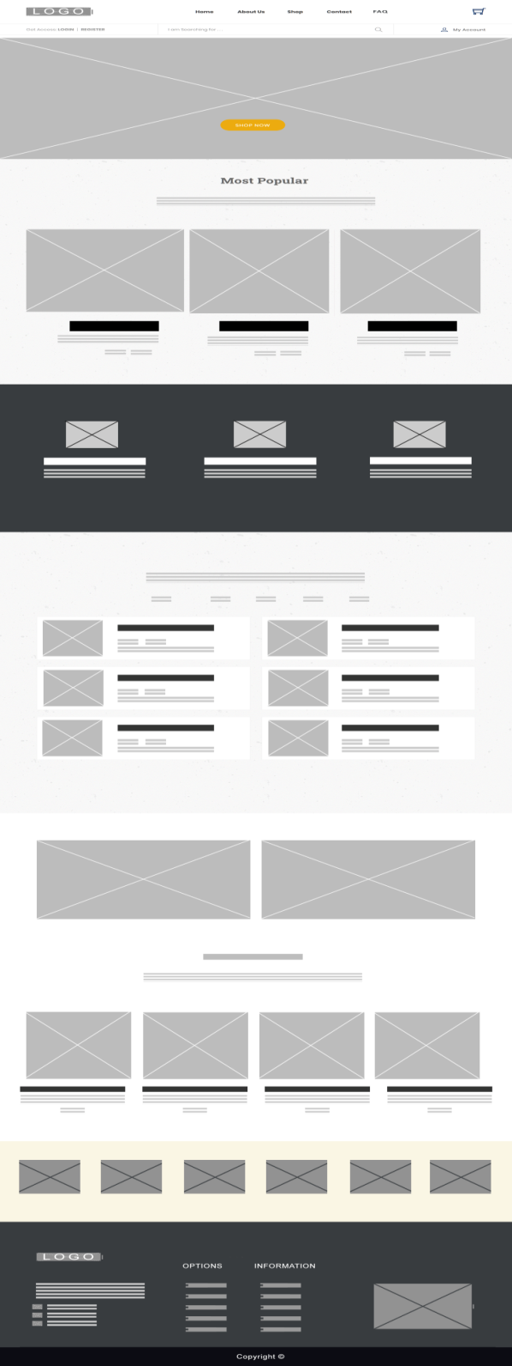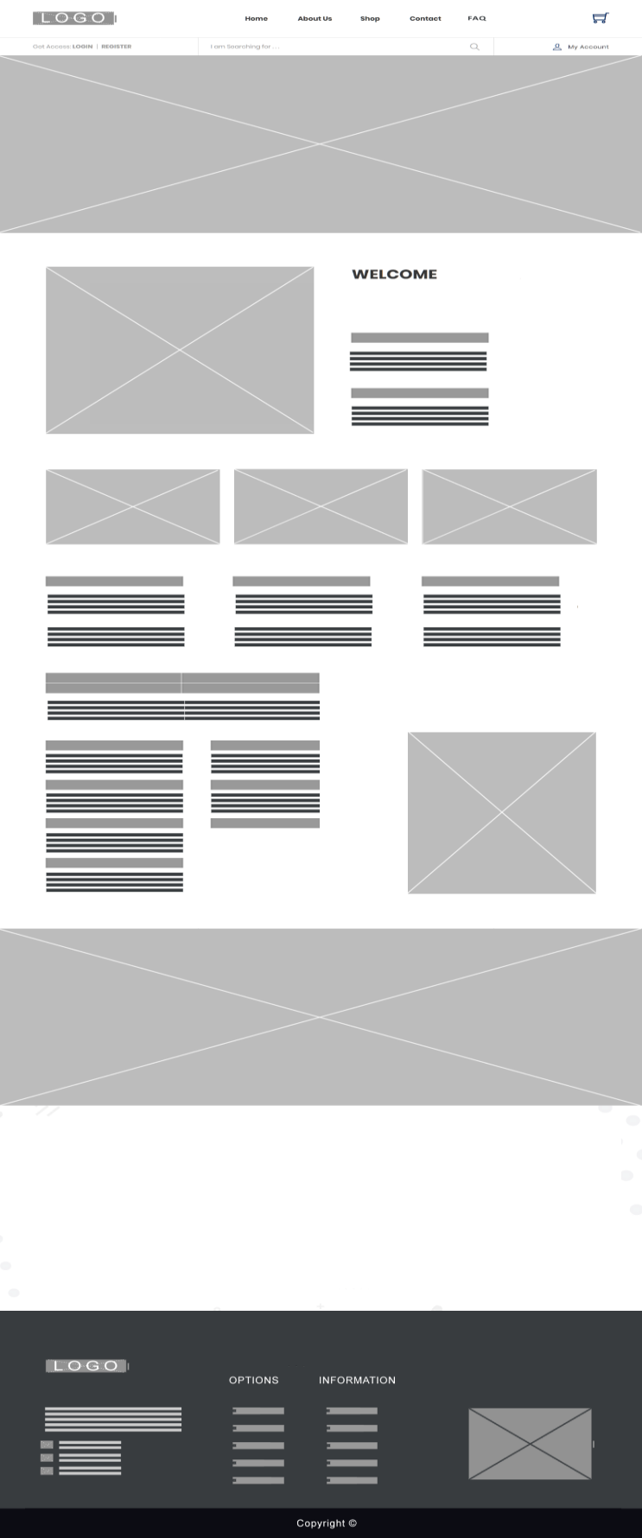

About Page

These are the wireframes of home page and about page of our project.

Login

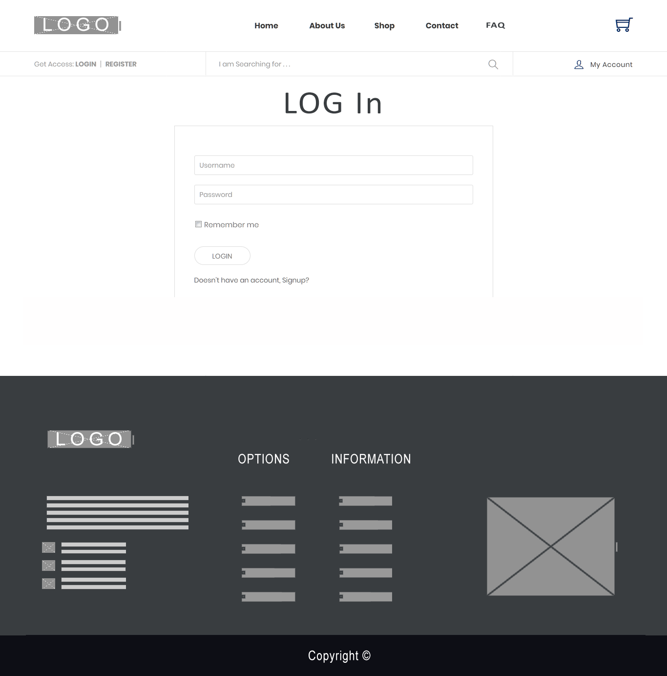

This is a wireframe of login page of our project.

Register

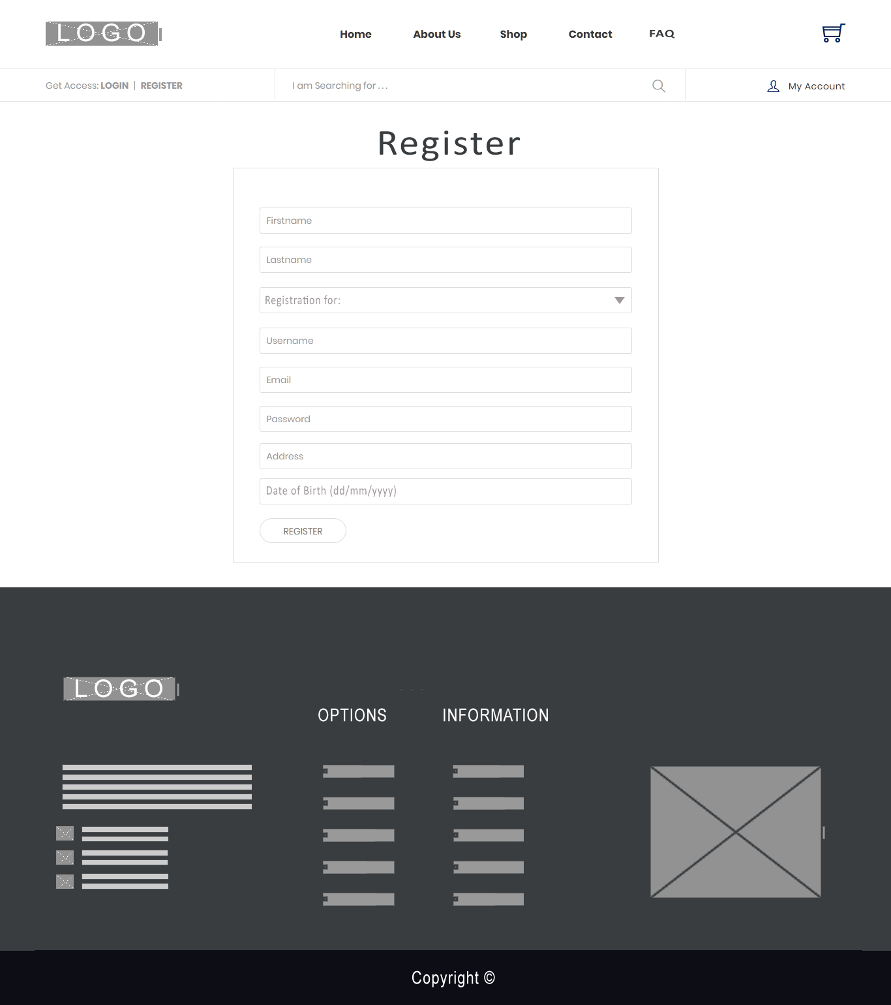

This is a wireframe of register page of our project.

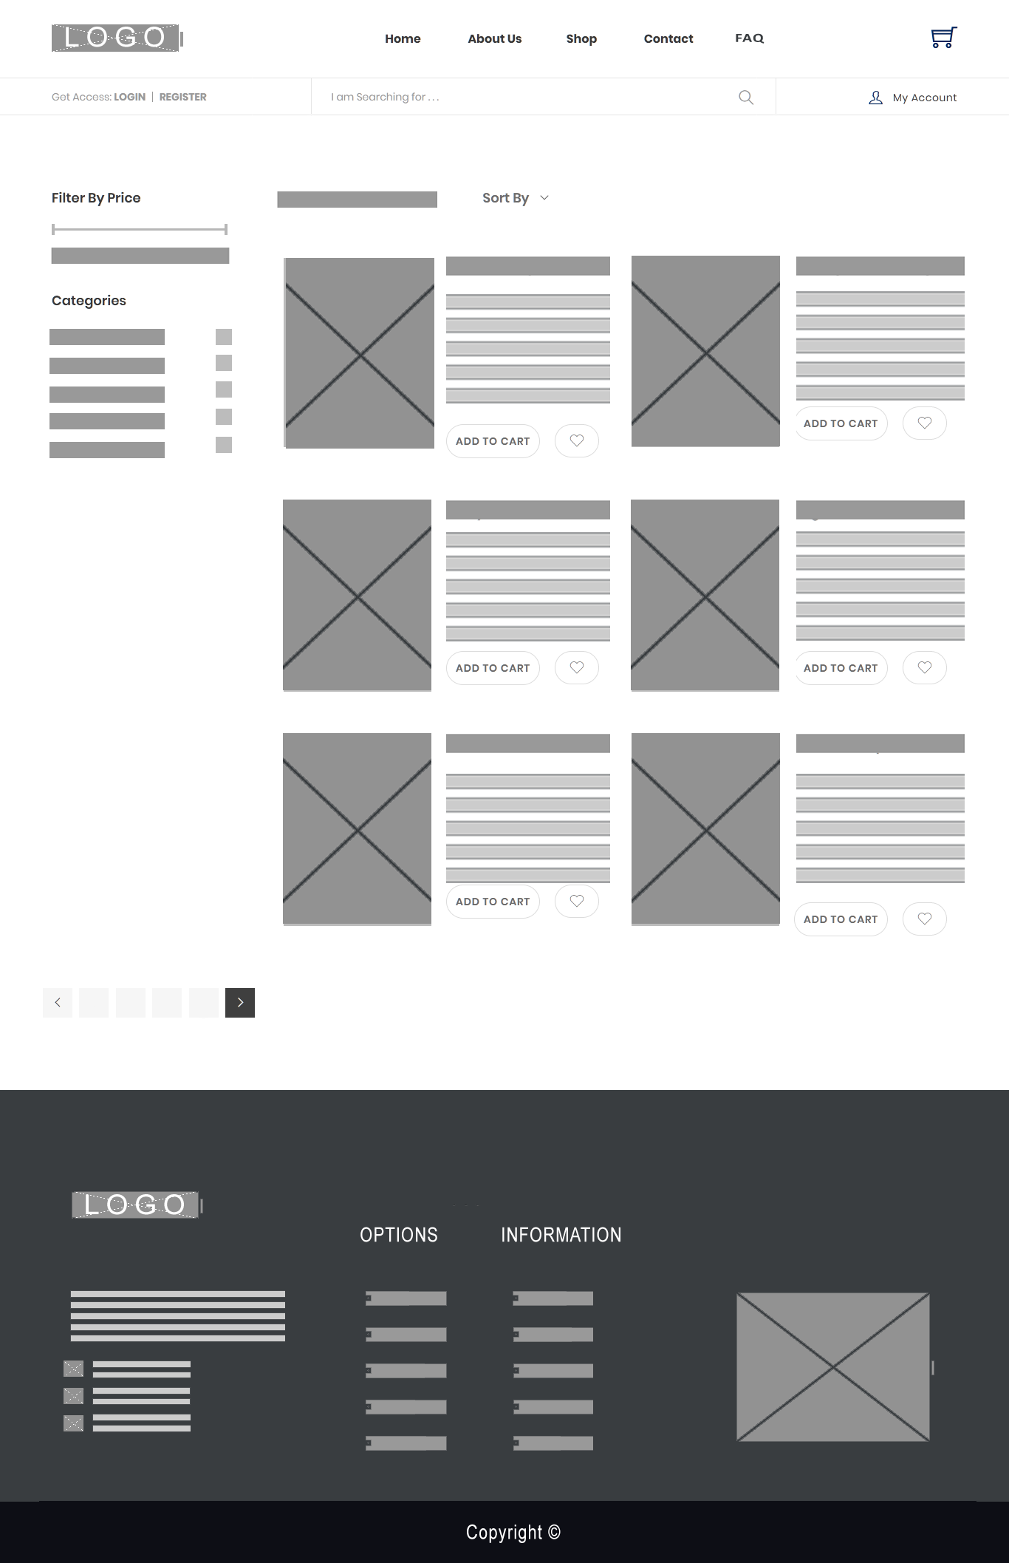Shops

This is a wireframe of shop page of our project.

Product Detail

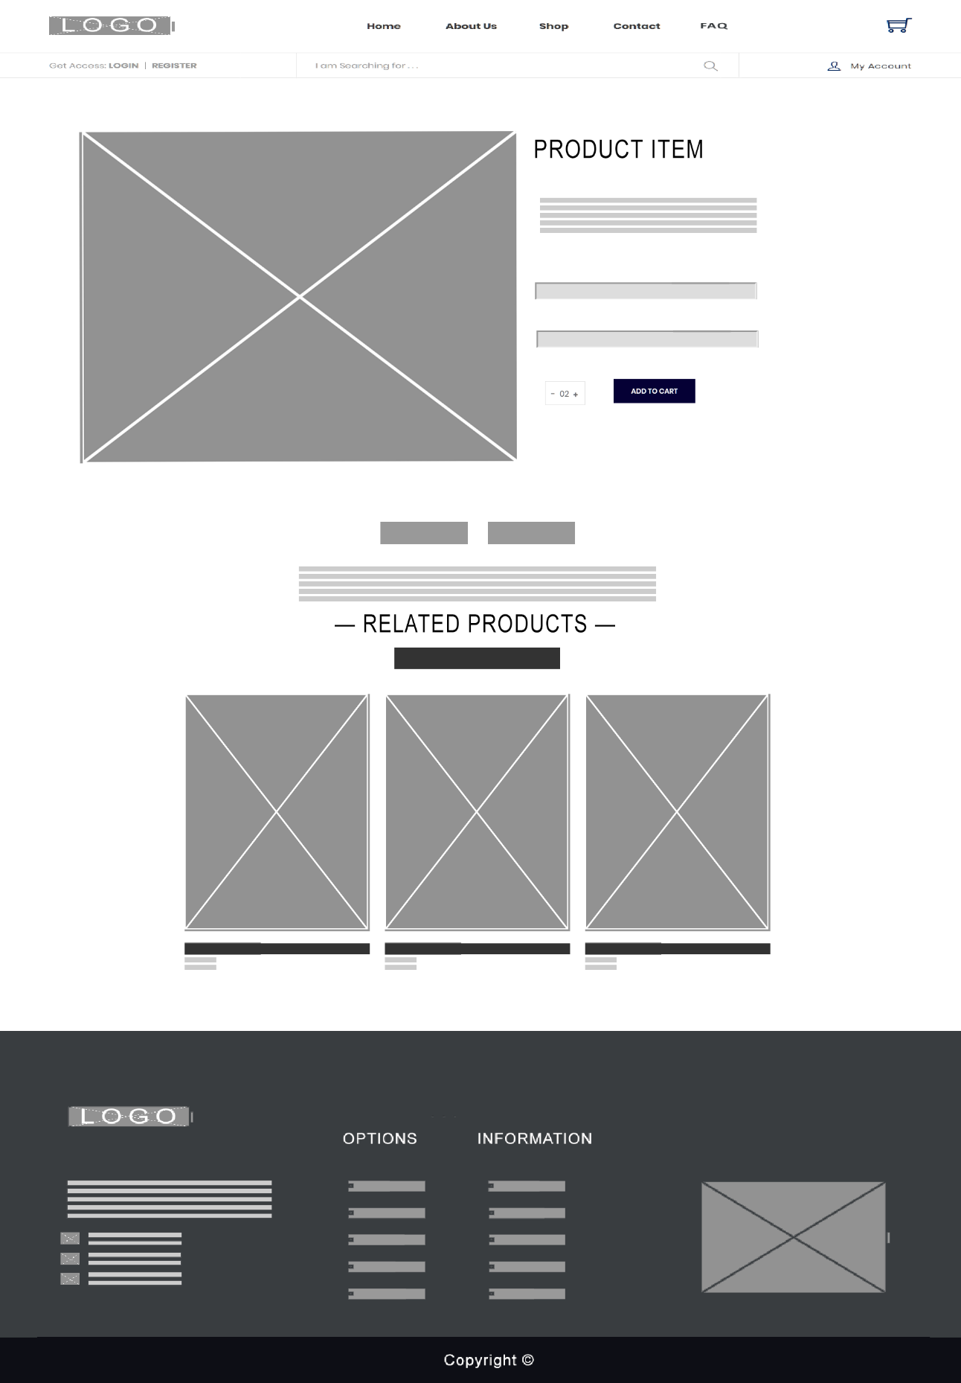

This is a wireframe of product detail page of our website.

Add Review and Rating



This is a wireframe of review and rating form.

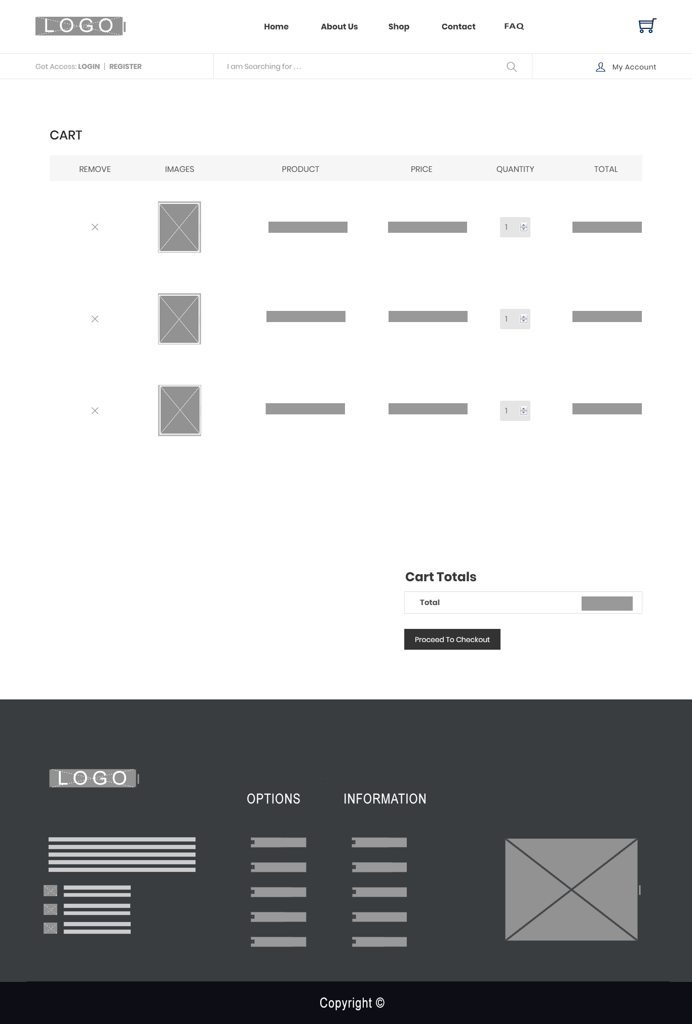Cart

This is a wireframe of cart page of our project.

Order

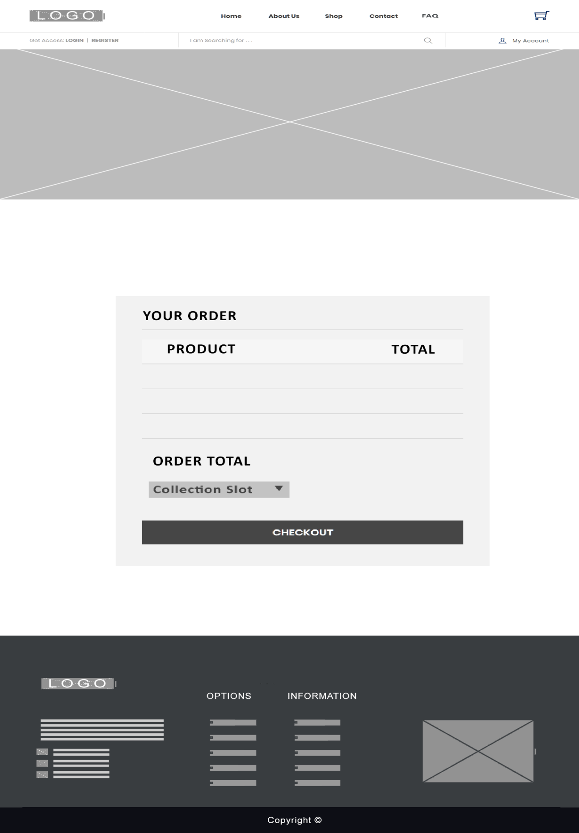

This is a wireframe of order page of our project.

Invoice

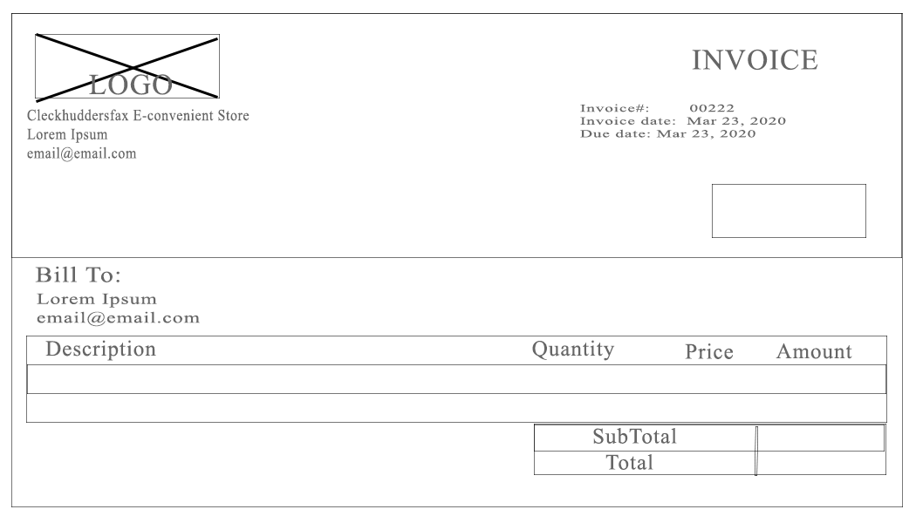

This is a wireframe of invoice.

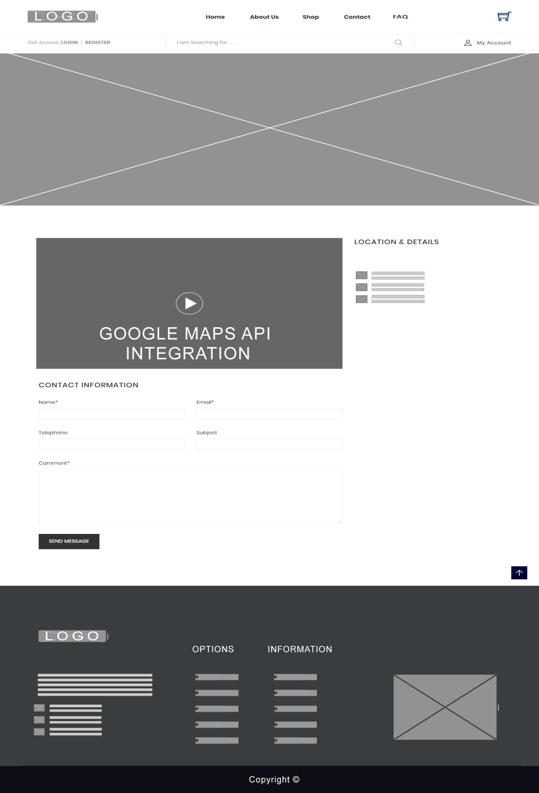Contact

This is a wireframe of contact page of our website.

FAQ

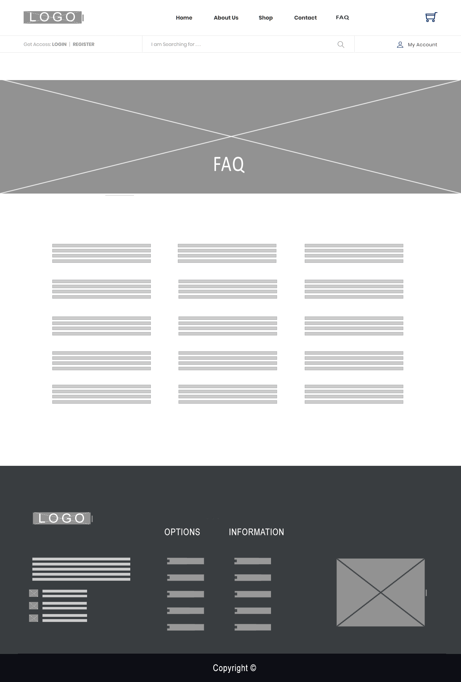

This is a wireframe of FAQ page of our website.

Customer Profile

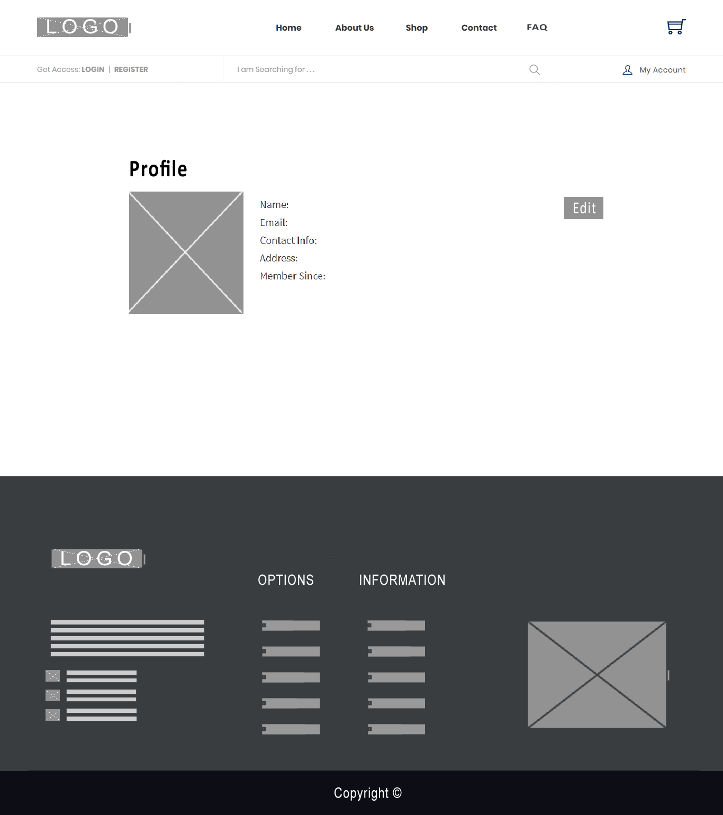

This is a wireframe of customer profile.

Login Customer Profile Update

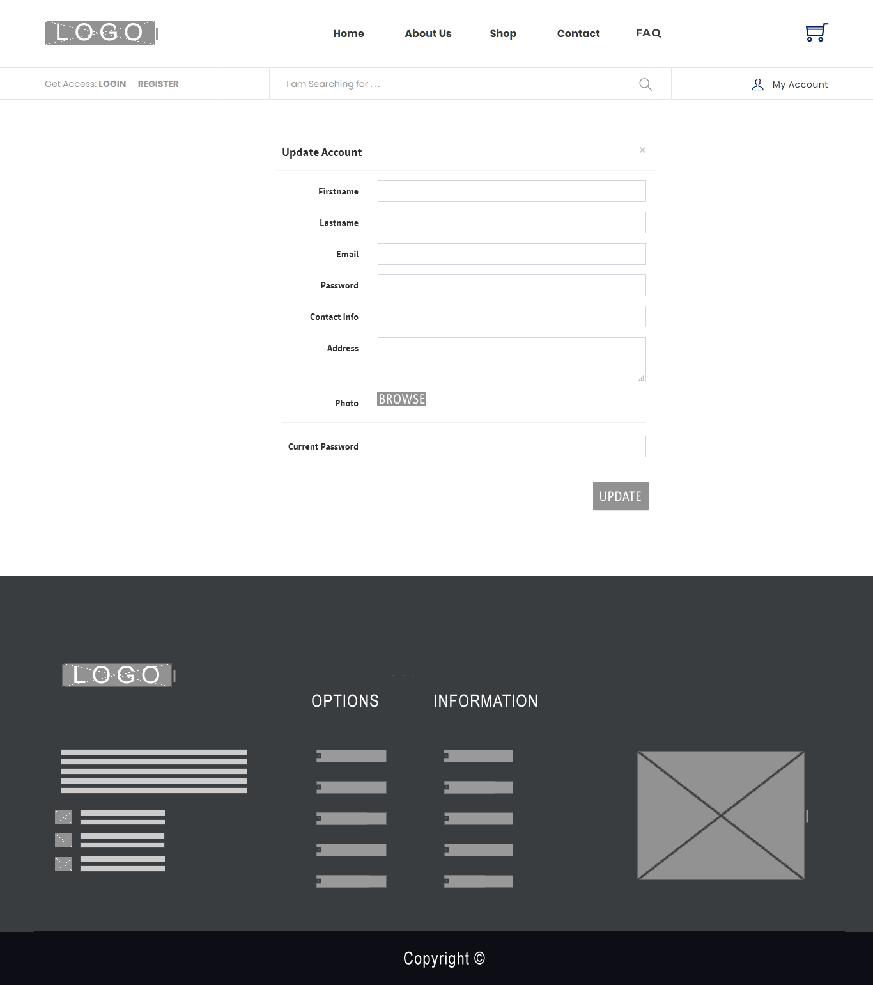

This is a wireframe of customer edit form.

Admin Dashboard

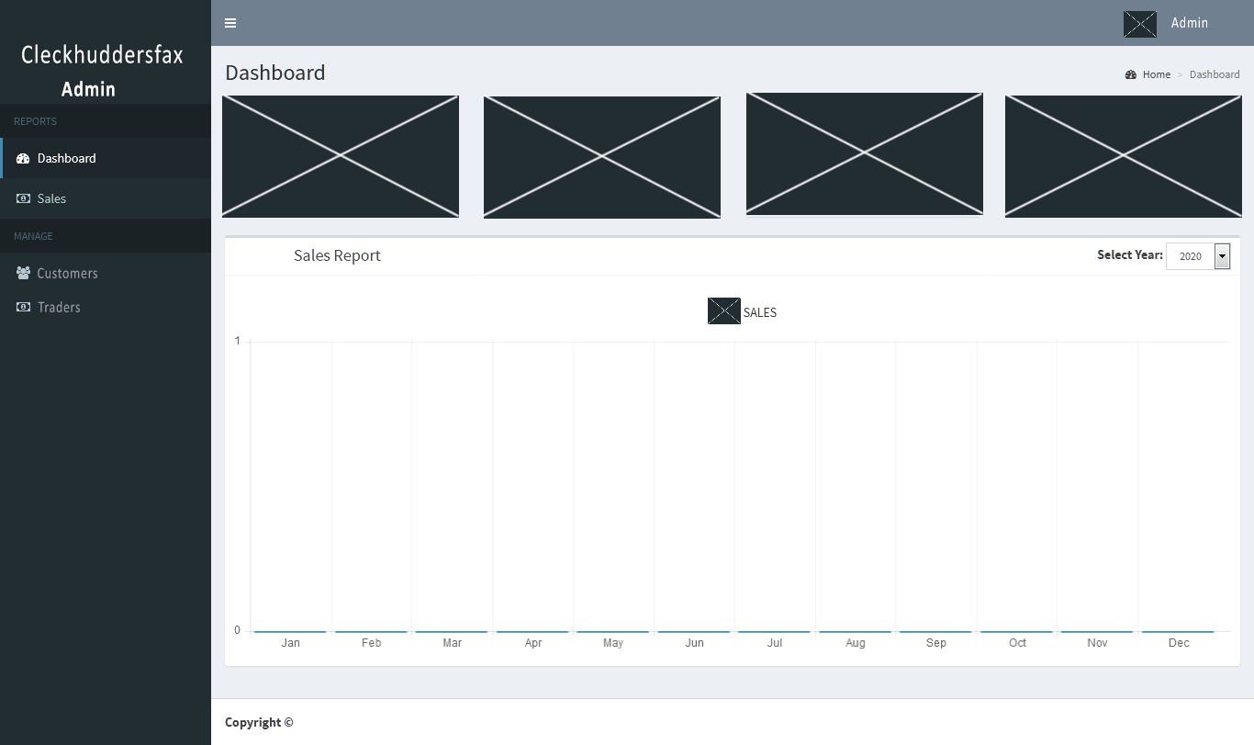

This is a wireframe of customer dashboard.

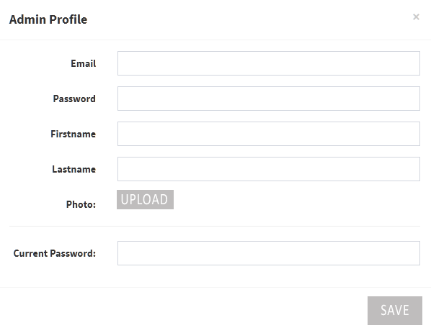Admin Profile

This is a wireframe of admin profile.

Manage Customers

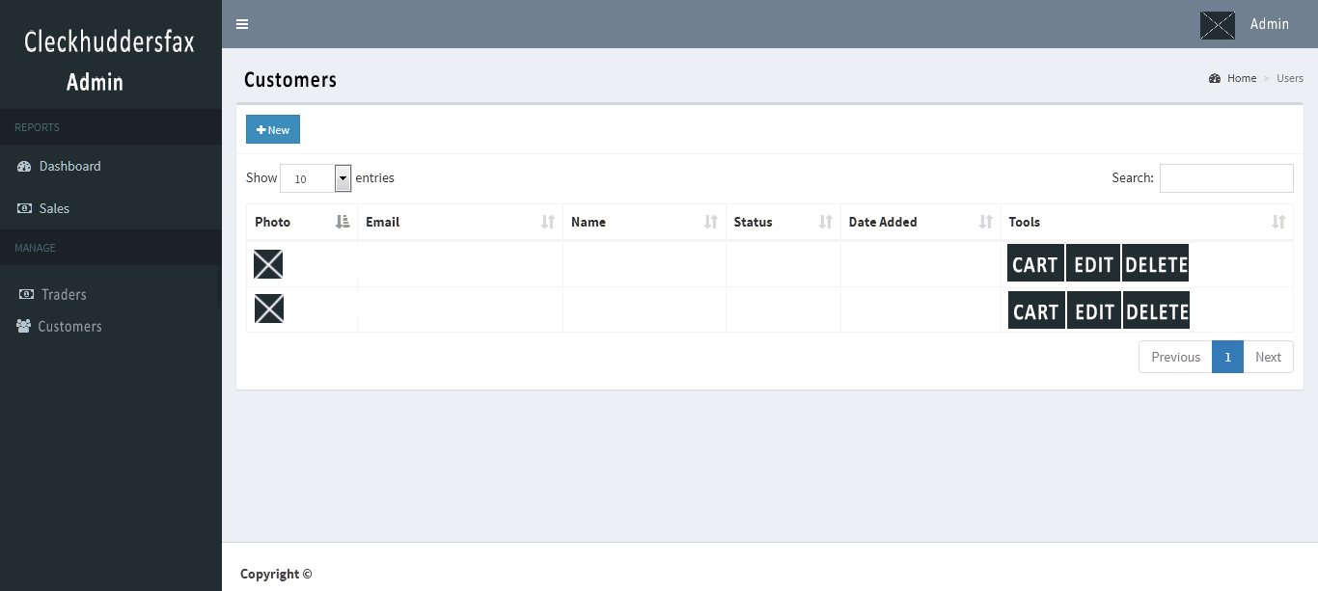

Manage Traders

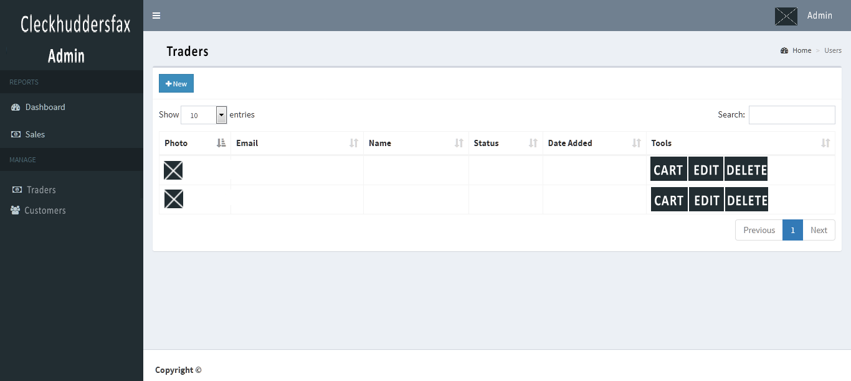

Admin Sales History

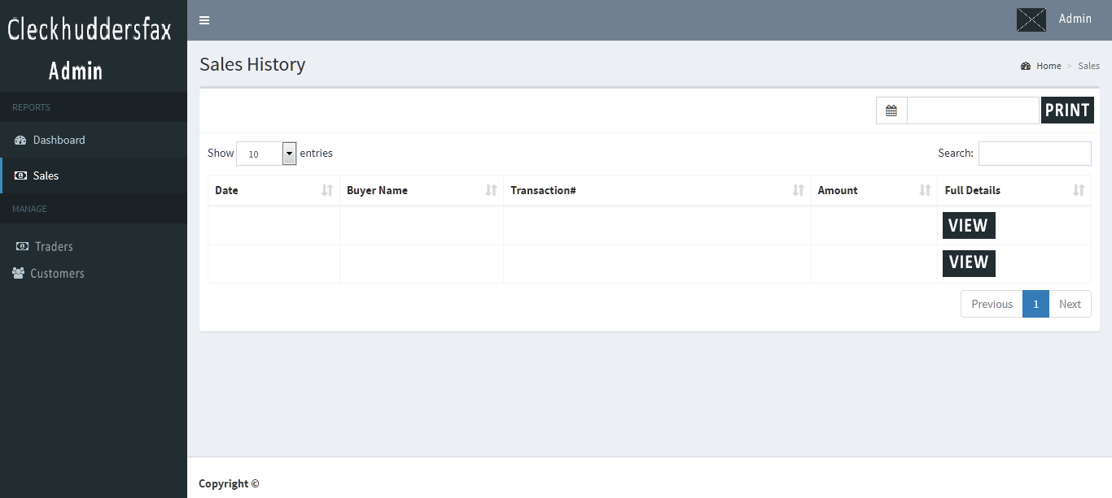

Trader Dashboard

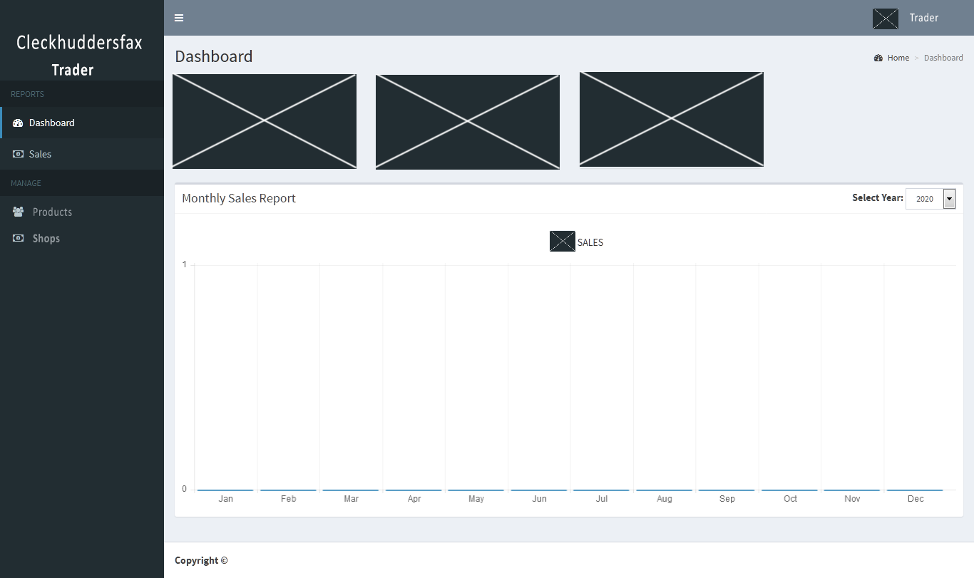

Trader Profile

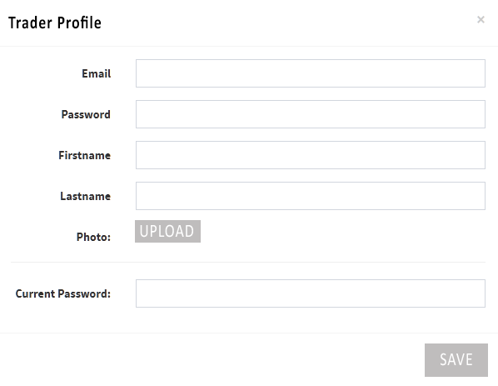

This is a wireframe of trader profile edit.

Product CRUD

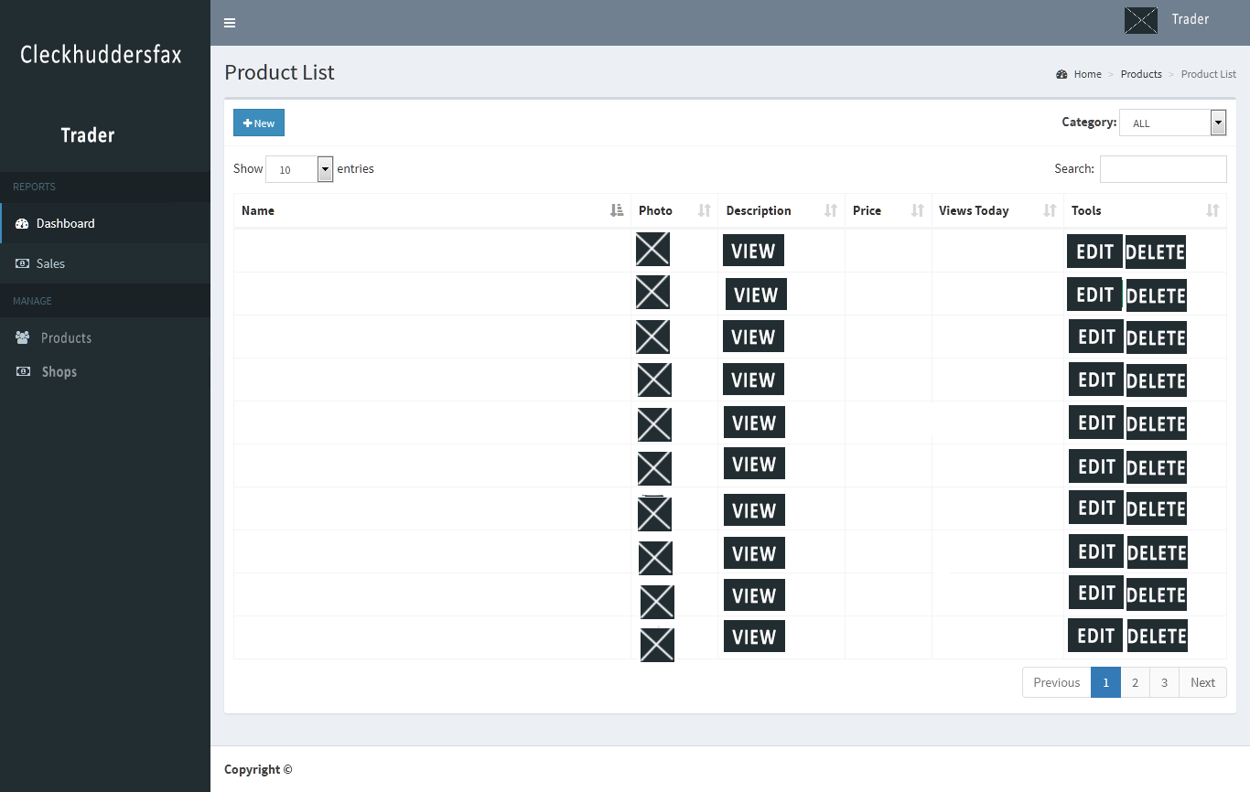

Trader Sales History

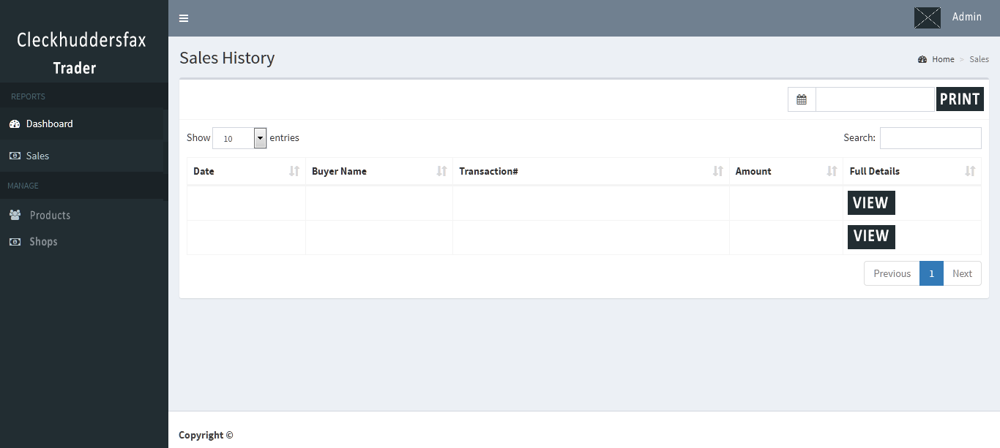

This is a wireframe of trader dashboard.

**FAQ**

* WHAT ARE THE PAYMENT METHODS AVAILABLE?

At the moment, we only accept PayPal payments. Using PayPal may increase financial security for buyers since the seller does not receive bank account or credit card numbers, only the PayPal account number.

* HOW WILL THE ORDERED PRODUCTS BE DELIVERED?

A small area of one of the shops will act as a collection point. There will not be any deliveries. Three collection slots will be available 10-13, 13-16, 16-19.

* HOW CAN A CUSTOMER CHANGE THEIR PERSONAL DETAILS?

After log in, your name appears on the right side of the web page and you should click the view profile button which redirects to your account where you can update your account details.

* DO YOU HAVE THE PRODUTS ON STOCK?

All the products which are shown on our site are available.

* HOW CAN I ORDER?

You can order easily using our online platform. When you find a product you need, you can add it to cart, login and go through the ordering process.

* WHAT IS THE MAXIMUM NUMBER OF ORDERS PER SLOT?

There will be a maximum of 20 orders per slot.

* WHAT ARE THE COLLECTION SLOTS AVAILABLE?

There will be three collection slots available 10-13, 13-16, 16-19 and will be only for Wed, Thus and Friday.

* WHEN SHOULD COLLECTION SLOT BE IDENTIFIED?

When paying and placing an order, collection slots should be identified. Collection slots must be at least 24 hours after placing an order.